Workshop

Heal Your Past Lives
Six Steps to Dissolve Old Trauma for Lasting Happiness
By Sri Jana

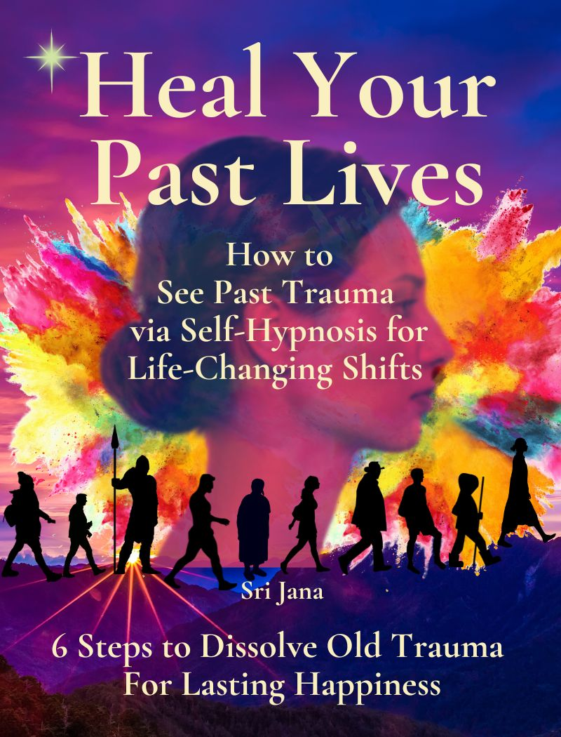
Contents of Workshop in Three Classes:

Class I. Life-Changing Tools
- A Story Within a Story - Why Heal Past Trauma?
- How Past Life Clearings Changed My Life
- Past Trauma Conditions Your Life
- Q&A
Class II. Basic Self-Hypnosis
- What’s Self-Hypnosis?
- Brain Wave Frequencies are States of Consciousness
- Can You Track Your Brain States on a Single Day?
- You are More Powerful Than You Know
- Direct Your Intention, Expand Your Destiny
- Find Health and Wellness Through Self-Hypnosis
- Preparation for Work: Balance, Root, Calm
- Q&A
Class III. The Technique: Six Steps to Heal Your Past Lives
Step One: Trance State, Set a Goal
Step Two: Ask Questions. Body Dowse for Answers
Step Three: Specific Questions. Describe the Lifetime
Step Four: Determine the Specific Emotion to Heal
Step Five: Dissolve the Trauma with Specific Tapping
Step Six: Gratitude and Conscious Closing
Q&A

Class I. Life-Changing Tools
“Some say life begins at birth. Others say it begins at conception.
I say life is the journey of uncountable threads of destiny and dreams
beyond time, converging through each one of us in the present moment.
In truth, life has no beginning and no end, only chapters.”
Sri Jana
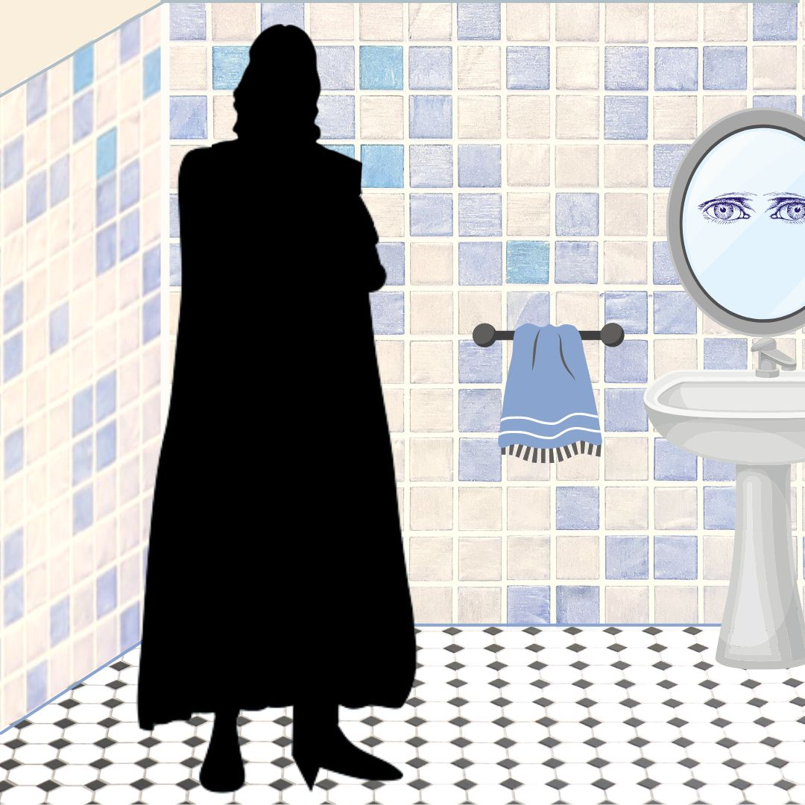
- My Story Begins -Why Heal Past Trauma?

Storytelling is a timeless way to show how things work together. Because, as you already know, life is complicated. A story might have exotic characters and colorful events that stimulate the imagination. A story can show you what is good, what is not good. Or perhaps a story will ask a pointed question and leave you hanging without any answer at all. Today I will tell you a story and the story behind my story, of how this journey began.

I could make up a story for you. I could weave a tale of adventure, love, sex, hardship, success, and all that. But that would be too easy. But I’m not going to insult you or underestimate the power of this moment we share together. I’d rather empower you to step into your true self. So, instead I will tell you a story that is 100% true. This is my way - because then the universe has my back. The power of a true story can never fail to reach its mark. If it is meant for you, a true story is guaranteed to touch that mystery spot of wisdom inside you that knows truth. And somehow, I don’t know how, it touches anyone who hears it, A true story is something so astonishing and unpredictable, it can spark your next brilliant idea. Or stoke the fire of your true destiny.
If you are reading this page, then the story unfolding right now is meant for you. Although it is the true story of my life and my many lives, the story isn’t about me at all. These experiences are shared by everyone. We all feel the heartache, the pain, the excitement, the futility, the joy, and the power of the world we live in. We’re all in this together. This story is about healing the world.
Real life is far more interesting than fiction. My story begins several years ago when I was working as a medical intuitive in Santa Fe, New Mexico. I was beset by bizarre dreams and déjà vu experiences. I suffered depression, panic attacks, food-chemical intolerances, and unknown maladies. A series of life-threatening illnesses came through my life like shadows, including cancer, adrenal failure, chronic fatigue, shingles, and digestive collapse. Life seemed impossible. I continued my work and my daily life as best I could. However I never imagined in my wildest dreams that all this hardship was a perfect storm leading me to a groundbreaking discovery.
I began doing regular self-healings and found that I have over 200 previous lifetimes, many of them traumatic. I discovered how to identify and dissolve old emotional impressions that were causing bad dreams, self-defeating habits, and emotional distortions. I persisted in weekly healings, scribbling messy notes through my astonishment. Under gentle self-hypnosis, I sat and asked questions. This is not channeling, you’ll see it is a kind of body dowsing. As past scenes revealed themselves clearly under self-hypnosis, I could hardly believe the events that I found. I did not find kings or queens, but instead far more surprising: real people.
My journey included many wars on earth and other planets. At my best I was a Buddhist Lama in Tibet and the clairvoyant medieval nun, Hildegard von Bingen. At my worst, I was a Babylonian part God, a cruel mastermind of extermination. With each session, trauma vanished, health returned, and my intuition expanded. I found it easier to forgive everyone including myself. My healings became a life-changing journey to wellness.
This book is for experienced healers and lay people alike. Its single goal is to help you heal your life right now. We don’t need to time travel, wander around in the past, or re-live painful experiences. We may not need to spend thousands on professional therapists. I don’t care one iota if I was once a King, a Queen, or a beggar. The technique that I will show you to heal trauma is simple and uncomplicated. Like Sherlock Holmes, we will pinpoint emotional patterns from the past that are negatively affecting you now. All other issues are extraneous, unimportant, and can only confuse. Our only goal is to discover and clear past emotional patterns that are affecting your present life, in order to move forward in health.
My mission in writing this book is not to entertain or seek notoriety, but to show that it is possible for anyone to heal themselves in body-mind-spirit within this lifetime. I’d like to demystify time-healing, to help others recall their own past lives in order to clear and empower their lives right now. Perhaps these accounts can help us all come together, to unravel our shared mysteries, to find lasting solutions to our personal and global challenges.
How the Book Began
One evening I was in the bathroom when my primary guide appeared in front of me. He seems to show up when my mind is relatively quiet, like when I’m taking a pee or half-asleep. I recognized him, tall, imposing, stern, and loving. He told me in thoughts that he had a warning for me. There were no words. He instructed me in no uncertain terms to begin to do healings on myself. I understood immediately, and I shivered. I had been doing intuitive healings for clients for a long time, but I had never considered doing this work on myself. He instructed me to start immediately and to do one healing a week. Then he vanished. I heard his warning deeply and resolved to begin right away.
My first few sessions were effortless and revealing. I noticed I could relax and go into self-hypnosis quite easily. I would sit on the couch in my treatment room to calm my breath and body as I do before every session. I sank into a deeply relaxed state of self-hypnosis that remained clear and fully aware. I began with a fervent prayer and a wish for total healing of whatever was the highest priority to address on that day. I followed my standard treatment steps and kept a scribbly journal of notes. Surprisingly, in nearly every session, some past life trauma came up as a top priority to heal. I was aware that past trauma can affect our current lives. I knew that we often attract situations similar to those from our distant past. My wish as a healer was only to find and dissolve any traumatic emotional memory that negatively affected my present life. But to encounter a series of gruesome events in every session was a shocking revelation.
The scenes that came in were beyond surprising. Although I was stunned, I did my best to simply observe without reacting. At first a scene would come to me in very hazy images or concepts. As I asked specific questions, soon the patterns became clearer, and I would receive a flood of memories. The lives that came in to heal were not royalty, but a wide variety of people living in different times and distant geographic areas, each one struggling with issues of destiny, family, fears, and upheaval. They showed up as male, female, sometimes children. I simply focused on identifying the emotional trauma and asking for it to be healed. In many lives I was a victim. In several others I was a ruthless killer. I just kept going, determined to clear trauma whatever it was, including anger, grief, self-hatred and shame. When a particular life scene was clear enough to heal, I did the meridian tapping you’ll find in the next pages, just as I do for any client, in order to invite a healing shift. While this required some inner focus and concentration, I found it comforting to embrace all sides of the issues. I was able to forgive everyone involved, especially myself. At the end of each session I always felt surprise, accompanied by a sense of completion and grateful relief.
After each successive session, I felt lighter, freer, stronger, and more fully myself. Within three months I had completed twelve sessions. I knew beyond a shadow of doubt, I had found an important secret that I must share with others.
Human Destiny and Evolution
Like all living beings, humans are constantly changing in response to the environment. Viruses mutate, caterpillars pupate, and humans transform. We are each encoded with memories from other dimensions and other timelines. While this is difficult to express in words, I’ve come to understand that we each hold a record of the entire universe. Lifetime after lifetime we are born into a specific biological and DNA blueprint, representing circumstances and possibilities we may make use of. We sometimes use the word FATE to describe a kind of fixed path, and DESTINY to have a larger meaning that includes transformation beyond the blueprint.
Life endures. Life evolves in response to the environment. Humanity’s fast-track healing now involves tuning into universal cycles deep within our subconscious memory to harmonize and balance ourselves to a new reality. Is our chain of lifetimes strung together into an overarching existence for a specific purpose, a destiny? Is it possible that we are meant to discover that destiny now? I don’t have the answers, but I’m pretty good at asking questions.
What is trauma? Trauma represents highly concentrated toxic energy, like a knot at the root of stress. Trauma holds you back from achieving your highest destiny. Every trauma you carry divides and fragments your consciousness, as if a piece of your awareness is tied up in the memory. When you deal with the trauma, your consciousness opens up. Your intuition wakes up.

Trauma is a burden. Trauma creates holes in your auric field, the protective energy called Wei Qi in Chinese medicine. Old traumatic memories show up as wounds or a knot in your light body. Each trauma is tethered to specific memories and to a body part. Think about a pain in your body. When you release the root of trauma, you dissolve a physical knot. You expand your inner awareness. And the pain is gone.
For example, a person who suffers panic attacks for no apparent reason, may carry an old pattern of fear, or activation of the autonomic nervous system (ANS), increasing the likelihood of a fight-fight-reaction. It’s as if PTSD from the distant past seeps into our subsequent lives, bringing with it physiological as well as psychological distress.
When I began doing self-healings, I never imagined that this process would change my reality. Looking back, it’s as if I managed to “upgrade” my physical health and my awareness of each experience. Past traumas dissolved, and my health challenges disappeared. Soon I began to see difficulty as an opportunity, a useful lesson, or cleaning the slate. As old self-defeating habits began to fall away, I could more easily accept my new inner reality. I started to trust the intrinsic wisdom of my chain of existences. It was as if a timeline that was once my indelible, unavoidable FATE, merged into a happier, fulfilling DESTINY that I never could have dreamed, and defies explanation. I often wondered: “How can I possibly describe this to others?” I decided to try to document my changing awareness, to teach readers how to step into a multi-dimensional game of evolution. It’s so much fun! And we have nothing to lose, everything to gain.
As you embark on this technique, it is very important for you to ground yourself in your deepest reality, the beautiful, positive multi-verse of light. You may find it helpful to shelter yourself to become less affected by little disturbances and challenges. These can include worry about money, family dissonance, electro-magnetic frequencies, disagreements, opinions of others, poisons in food, water, etc. As your root into this new reality grows stronger, you will become more resilient, even tolerant to static distractions. Just like the pot of gold at the end of the rainbow is guarded by a tricky leprechaun. You may need to overcome some very tantalizing distractions to claim a great treasure.
What is your treasure? Our great treasure is freedom, health, and peace of mind. Visualize what you want every day. Describe it and ask for it clearly. Let this practice fill your days, as we recreate the world together in the image of truth and goodness.

- How Past Life Clearings Changed My Life
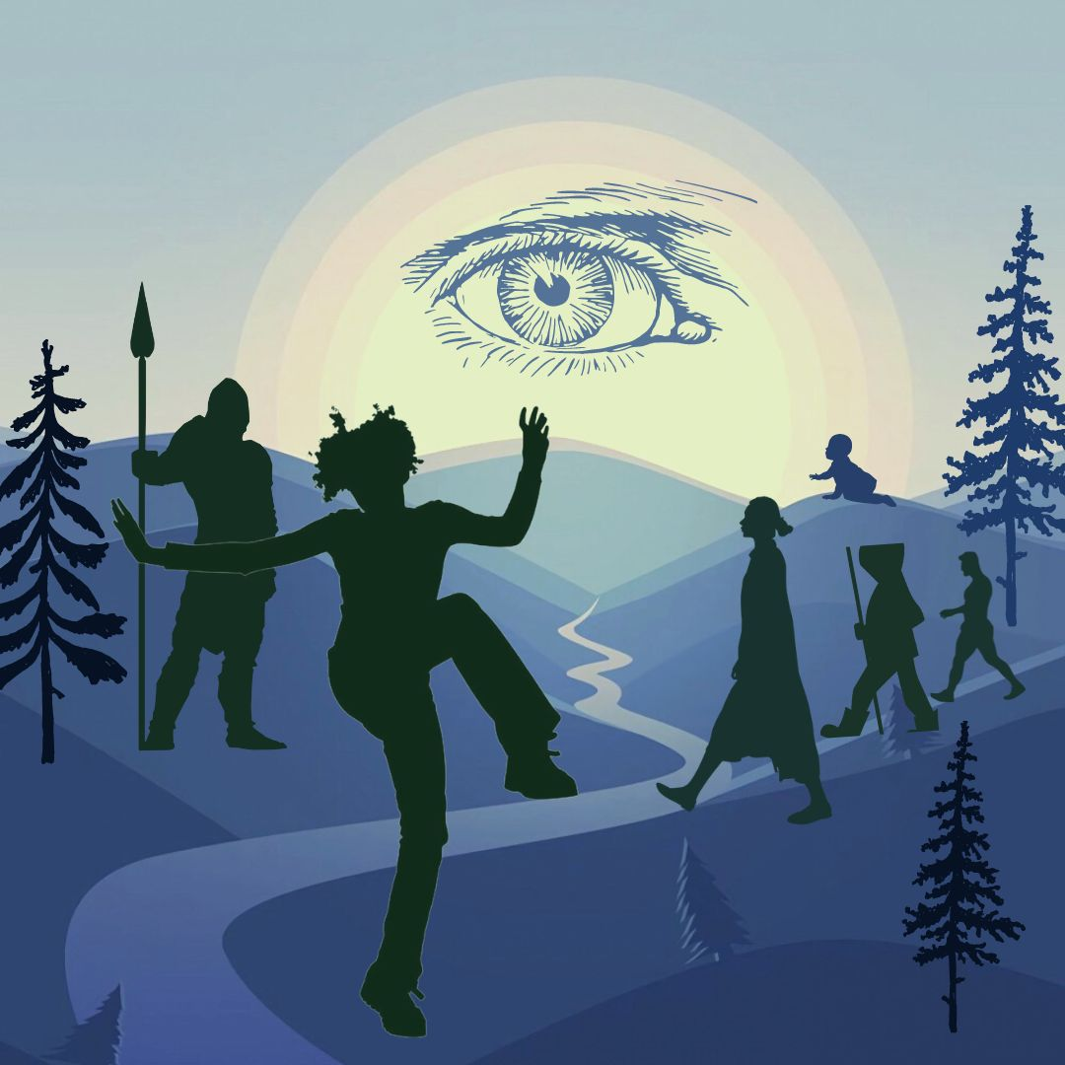
Over a three-year period of doing past life healings, the resulting changes in my life were nothing short of amazing. My physical strength returned, and my medical healing practice got busier. I felt less fear and more acceptance of the world around me. My usual negative reactions to people melted into patience and compassion. I began to savor each moment, viewing surprise as a pleasant gift, instead of an inconvenient discomfort. My mental clarity improved, and my resilience to stress increased exponentially. My food intolerances vanished. My experience of life transformed and self-corrected in ways I could never have imagined.
The most significant emotional change was to eliminate fear. While fear can be based on rational self-protection in situations of danger, I was feeling utter terror most of every day for no reason at all. Although I was smart enough to compensate and fool everybody including myself, I felt panic at the simplest things. Getting on the London underground petrified me - it literally took me two weeks to gather the courage to go. Making a phone call to the utility company or going to the bank required extraordinary self-reassurance and mental determination. After suffering food intolerances for decades, just sitting down to eat a meal cooked by someone else was a cause for alarm. Walking through city air with exhaust fumes and cigarette smoke made me sick for days. The underlying emotional fear and wariness represented such a huge energy drain on my body and nervous system, that I was exhausted midday. As I performed the healings, over time my fears slowly melted. Soon I could look forward to the London underground, walk calmly down the street, and enjoy eating in a restaurant.
The second most important shift I experienced was more trust in my environment. I noticed that when I had a clear intention in advance, when I could visualize things as I might have them happen, and be willing to accept whatever took place, events would usually unfold in a positive way around me. It was a feeling that the universe was looking out for me, that I wasn’t isolated and alone. Someone had my back. Soon my days became filled with joy and unexpected serendipities. This was a huge change in my world outlook. Of course there were surprises, but they didn’t shock me into terror like before.
This book represents the culmination of research into my past and the clearing of many burdens. The themes of my different past lives seemed to be linked somehow in a progression, as if I was destined to learn something in each life. This journey of uncovering just a few of them has utterly changed my life. Now I feel freer and less stressed. I fear death much less, perhaps because I see that life continues even after death, always giving you a second chance, an opportunity to learn and polish your best qualities. Now I can enjoy each moment without carrying past fear reactions into every experience. This is a tremendous relief!
Positive change starts on the energetic level, on the inside. Eventually it comes to the surface to manifest in physical reality. In a relatively brief period of time, my life utterly transformed from the inside out. You probably know the rest of the story. I overcame my fears, set an intention for a transformational life, took a world tour to the Himalayas, met my future husband, Lama Dungtsho, and moved to Bhutan. We later relocated to Bali, and now, I enjoy a rather pristine environment, a relatively balanced state of mind, excellent health, an online teaching presence, and a beautiful sharing life with my new friends. I got certified to teach English as a foreign language, and I teach classes. Now I can offer my favorite workshops anywhere in the world. This is a totally unexpected turn of events that a few years ago would have been utterly impossible.
The past life healings journal is arranged by date in the order the sessions took place. This allowed me to observe changes and health improvements over time. However, if you wish to see where I was at a particular date in history, please refer to the Chronological Timeline.

- Past Trauma Conditions Your Life
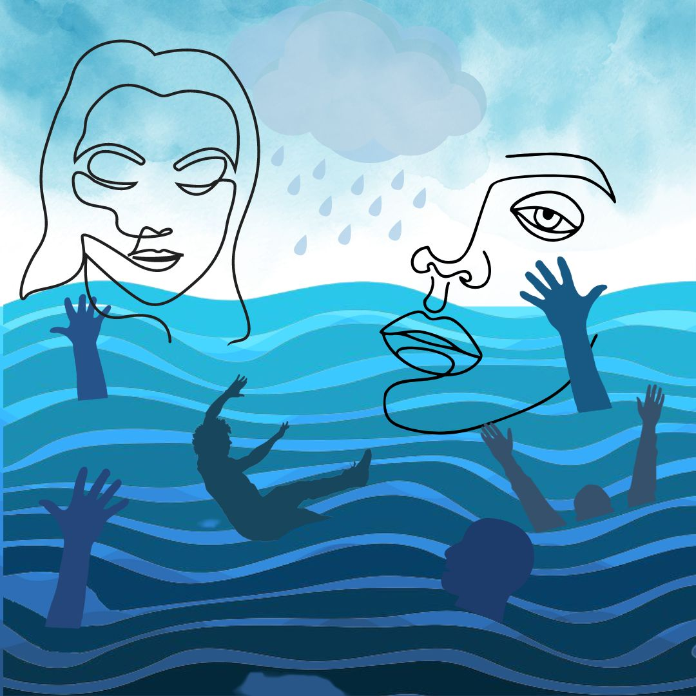
Do Past Lives Really Exist?
My journey began with a series of déjà vu experiences, dreams, and distinct feelings that I had lived through a similar moment long before. Meeting a person for the first time where I somehow remembered them - sometimes felt like a warning, sometimes infused me with intimacy like falling in love. These are signals. I do not even know what actually gets passed from one life to the next. Some kind of essence of a person remains after death. Buddhists say the mind and the soul continue infinitely after the body dies. Fortunately, I don’t have to answer these questions. I simply want to dissolve old trauma, and to be free and happy now.
Past Impressions and Memories Create Your Reality
Your body holds impressions from life experiences, memories and emotions. These impressions influence your everyday reactions, emotions, and actions. One could safely say that ALL of your responses to daily experiences are rooted somewhere in your past. Some of these memories are from your current life, and some may be from your more distant past. Your experiences are unique to you, therefore your reactions and your path to healing will be personal and individual.
We are conditioned by what we’ve been taught to believe by the society we live in. Our conditioning may help us, and it can also obstruct us. We are both guided and limited by our past, by what we expect to experience through our five senses of sight, sound, smell, taste, and touch. But life is far bigger than our five senses and our conditioning. We are deeply influenced by invisible forces within us and outside us. Most people go through life focusing on simply finding physical enjoyment and avoiding painful experiences. However, this approach of love vs. hate, desire vs. avoidance slowly isolates you in fear and steals your energy. It takes a toll year after year, until you end up living a self-created illusion.
The Pope Made Past Lives Illegal in 545 CE
“You only live once”, we say in the West. But it wasn’t always true. Early Bible manuscripts and the Gnostic texts expressed a firm belief in rebirth. However, during the 6th century many church leaders were excommunicated by the Catholic Church for their belief in reincarnation. Roman theologian, Origen of Alexandria, in 250 CE wrote extensively about the pre-existence of the soul and reincarnation. He taught that the soul’s very source was God and that the soul traveled back to oneness with God via reincarnation. However, his teaching was outlawed in 545 CE when Roman Emperor Justinian summoned the Second Council of Constantinople, demanding all church leaders sign the decree that anyone who asserts the “preexistence of souls” would be punished by death.
The Emperor’s only obstacle was the powerful Pope Vigilius, who believed in rebirth and refused to sign the papal decree. The plot thickens here. Emperor Justinian had Pope Vigilius arrested. He convinced the other ecumenical leaders in the Pope’s absence that the papal decree was authentic, effectively forcing the Pope to swallow it against his will when he was released from jail. Pope Vigilius was killed soon after, under suspicious circumstances.
The Roman Emperor reasoned that if common people understood they were forever children of God and part of God, they might no longer need an Emperor, or pay taxes, or obey the Holy Roman Church. Soon people were required to be baptized by the Catholic church, or they would be forever “cut off from God and doomed to Hell.” This did the trick, and now our modern belief that “You only live once” is fundamental to Western thought. I wonder – how does this impact our attitudes toward God and our human destiny?
Many people experience constant stress and anxiety in their daily lives. Where do these difficulties spring from? Do they come from outside us? Or inside us? Or is it both? The worries that we carry from the distant past are often a repeating pattern, an unnecessary burden, and a drain on our energy. All these concerns, hardships, and stress make a heavy burden to carry.
Memories from the distant past may condition your experiences right now. For example, some people fear rejection in groups as a result of persecution or past punishment. Many people carry anger from one life to another, as if continually trying to fight their way out of an old emotional pattern. Many people have a fear of sex. In my case I discovered past life sexual experiences that brought shadows of fear and shame into otherwise happy sexual relations in my present life. Disease in this life can be influenced by having suffered it in the past, giving a predisposition, or a tendency to suffer the same disease again. I discovered food intolerances, back ache, dental pain, indigestion, neck trauma, and shingles that all had roots in a previous life. A pattern of self-doubt or self-hatred may be related to an experience of failure many lifetimes ago. However once the negative charge of the trauma is dissolved, it can no longer imprison you.
Your life is always trying to heal you. An illness is often a message from your body’s wisdom. To get well, you need to listen. What is this issue trying to tell you? When you can face your difficulty straight-on with an open mind, then you are ready to heal. If you have the courage to live, you can be brave enough to die, then you can summon the fearlessness to look at your past and clear it while you can. When you use this technique to dissolve past trauma, you will be able to enjoy life right now without the stress of carrying heavy burdens every moment. To dissolve old patterns of pain and fear will re-orient your life toward joy. It’s that simple.
I know many people are wondering - Can I really do this? I assure you that you can. There are a few prerequisites:
- You must be a human being with a soul.
- You must be willing to accept yourself completely, the good, the bad, and the ugly.
- You must believe in a universal consciousness greater than yourself – call it by any name.
- You must be willing to empty your mind of emotions, limiting thoughts, and assumptions.
- You must be physically and mentally stable and balanced enough to focus and follow the technique with mental clarity.
- You must have a deep internal wish to heal yourself.
Free Yourself from Past Life Trauma
To reclaim your happiness and gain control of your reactions, it all starts with your mind. Using this simple self-hypnosis technique, you don’t have to travel back in time or re-live painful experiences. Instead, you can observe them from a safe distance and dissolve the pent-up emotional content that affects you now. The only requirement is that you must be willing to see and accept all of your emotions, even the difficult, uncomfortable ones.
A sixth sense is the birthright of every human being. Anyone can develop their intuitive abilities if they are willing to be quiet and see things simply as they are. It helps to be relatively free of distractions, mind chatter, and stress. Stress comes in different forms, such as physical toxins in food, air, water, or medicines. It can be from people, situations or electric fields. It can be our own internal stress such as mental confusion, addictions, habits, opinions, or emotions.
Now you can strip away the old barriers to your happiness. You can simply remove the heavy obstructions from your past lives one layer at a time, to be free in body, mind, and spirit.
Class II. Basic Self-Hypnosis
- What’s Self-hypnosis?
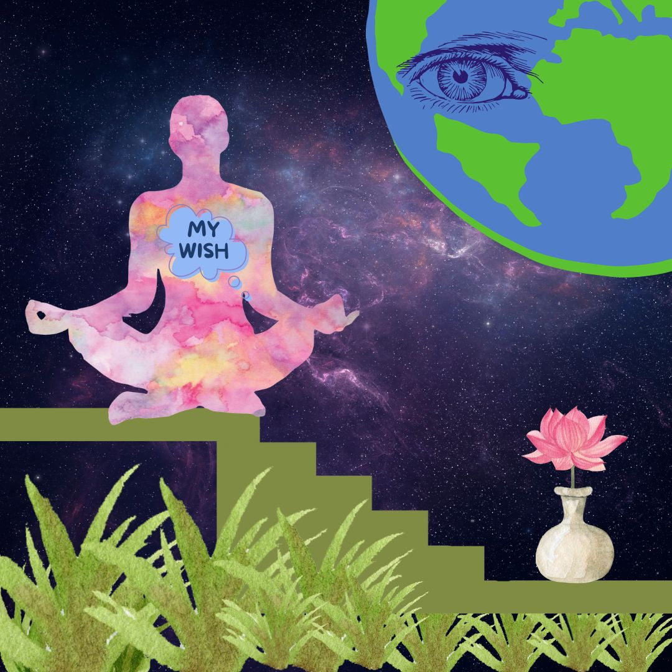
Back in 1774 a German Doctor Franz Mesmer proposed that health was a result of balanced frequencies in the body fluids, while illness was caused by a blockage in the “tides”. He theorized a magnetic energy that could be exchanged through the air between people, objects, and even planets with the capacity to heal. Does that sound familiar? His “mesmerism” sessions were held in incense-filled rooms, where patients sat in a trance circle, hands linked, receiving healing frequencies accompanied by a glass harmonica. Mesmer was blacklisted by the medical establishment as a charlatan for exploiting women with nothing more than the “art of suggestion”. But eventually his theories became widely accepted as “hypnotism”. Nowadays hypnosis is used to induce a relaxed state of mind or trance to heal negative habits like smoking. Likewise, meditation was once viewed as a mysterious Asian practice of Sanskrit mantras by an exotic guru. Now meditation is an accepted tool to calm the mind and reduce stress.
SELF-hypnosis means you do it yourself. You are the practitioner. You consciously relax your own mind to access deeper parts of yourself in order to heal. We all naturally experience varying emotions, attitudes, and mental states every day. Simple self-observation will confirm that you constantly jump from one level of consciousness to another. We can learn to observe these states with calm clarity and control them to live in a state of joy. Then we can use this clarity to quiet the mind through gentle breathing to harness profoundly powerful parts of ourselves.
Many people go through their lives with no concept of how to relax. As a result their experience becomes a tangled mess of undigested events that build up like silt in the body, mind, spirit. Just like a river can be dredged of silt to allow the water to flow easily, we all need to release our mindset and let go of body patterns occasionally. This means we drop anything we don’t need and allow ourselves to be redirected. What is YOUR favorite way to empty your mind and recharge yourself?
In the following section on self-hypnosis, you will learn step-by-step techniques to relax yourself into a state of trust and openness, yet with precise clarity at the same time. You are a multi-dimensional being, with capacity for a vast expanse of awareness. And simultaneously you can drill down to a single point of utter precision. The key is to use your breath to relax into a deeper and deeper state of quiet. I suggest you study this technique and master it, because it will serve you in every phase of your life. Take your time to refine and develop this skill. The deeper you relax, the more expansive your field of vision to know the truth.
Once you are in a state of deep relaxed self-hypnosis, then you can ask questions through body kinesiology. And somehow, you will know the answers. I call this body dowsing, which is using your body like a pendulum to answer yes-no questions. But I’m getting ahead of myself. First I want to talk with you about brain waves and levels of awareness.

- Brain Waves are States of Consciousness.
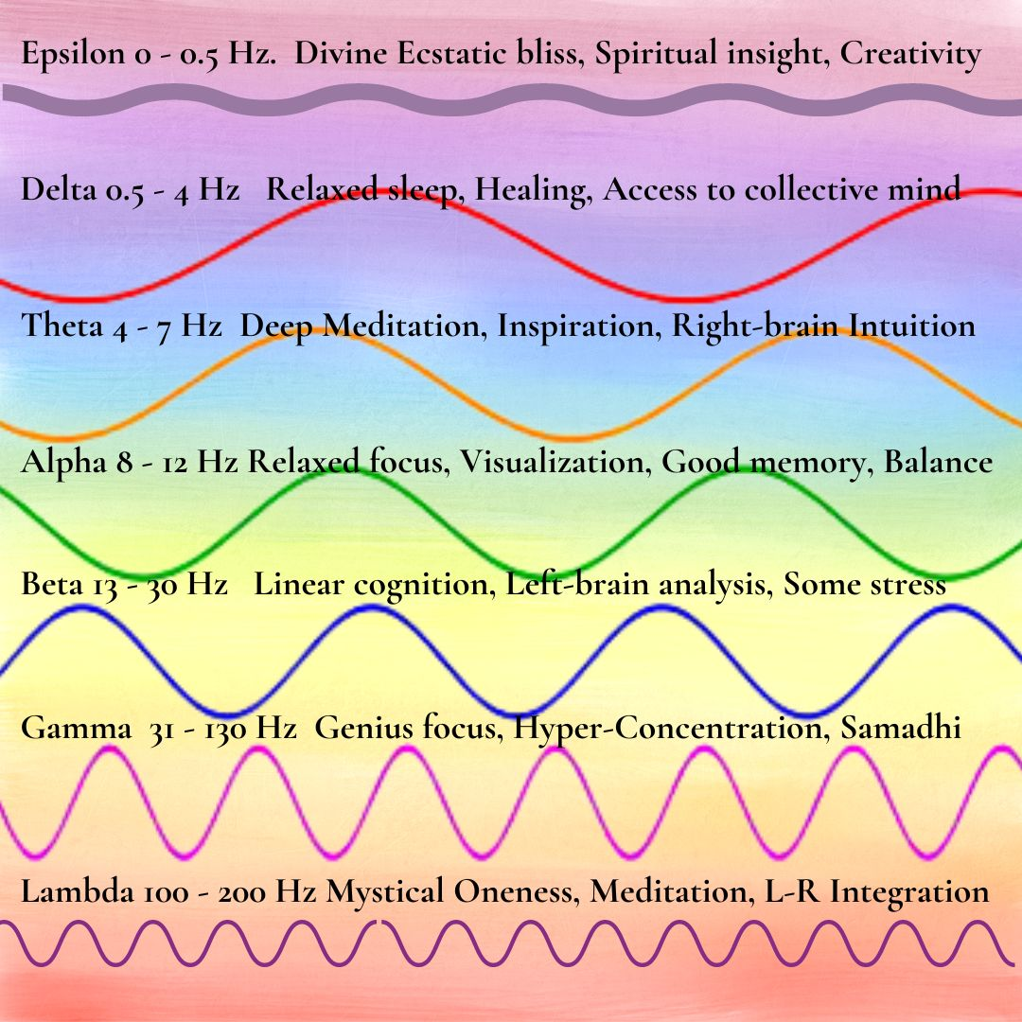
Brain waves are one indication of your level of awareness, health, and happiness. Brainwaves can be tracked by EEG, which measures electrical activity in the brain using small, metal discs (electrodes) attached to the scalp. Brainwaves can also be remotely detected via satellite or computer networks. It’s one thing to get an electroencephalogram EEG test to observe brainwaves. However, very few scientists have any idea how to interpret them correctly. Even AI computers have difficulty trying to accurately categorize our erratic electrical brain patterns into recognizable thoughts or levels of awareness.
Brain frequencies are associated with different states of consciousness, so they are very relevant in accessing higher states of awareness in self-hypnosis. However, your brainwaves are so unpredictable and diverse, they would defy the most skilled scientists to identify your thoughtforms or level of realization. Perhaps these categories are real and mutually distinguishable. Or maybe they exist as a continuum of frequencies. Personally, I’m not ready just yet to call this real “science”, as more analysis is needed. I discuss it only to invite you to consider brainwave frequencies as a bare starting point for you to observe and track your own mental-emotional gyrations.
What Are Common Brainwaves?
Gamma Waves (38 To 42 Hz) are fast, subtle, high-frequency brain waves. In experienced meditators, Gamma waves are said to be often present all the time, indicating a relaxed state of expanded awareness. They indicate complex integration of both hemispheres and various brain centers when you are very quiet. Gamma waves are defined as short duration, like a burst of genius, such as when you find a brilliant solution to a problem but don’t know quite where it came from. Even higher brainwave frequencies exist above 40 Hz, which are sometimes called “Hyper-Gamma” states.
Beta Waves (12 To 38 Hz) occur in a normal waking state of faster brain activity such as when your attention is focused on everyday talking and linear cognitive tasks. You might be listening to a lecture on body anatomy or designing a website. The Beta state gives you focused mental activity, problem-solving ability, judgment, and decision-making.
Alpha Waves (9 To 14 Hz) are associated with quietly flowing thoughts, when we are fully present in the moment and the brain is calm. You could be relaxing on a beach drinking a cup of Kombucha, listening to gentle music. Alpha waves are characterized by relaxed focus, ease, good memory, alertness, mind-body balance, and some types of meditation.
Theta Waves (4 To 8 Hz) happen during sleep, deep meditation, and hypnosis. In this state the senses are somewhat withdrawn from the external world, and you are more focused on inner signals. Theta is said to be our doorway to learning, memory, and intuition. Theta is the twilight intermediate state that you might feel when drifting off to sleep, waking up, or in hypnosis.
Delta waves (.5 to 3 Hz) are very slow and deeply penetrating, found in deepest meditation and profound dreamless sleep. Delta waves are essential for healing, cell regeneration, and access to the collective awareness.
Two Extraordinary Brain Frequencies! Lambda and Epsilon have recently been discovered: Scientists identified two more exceptional brainwave frequencies at the extremes of the spectrum: Extremely high frequency brainwaves of 200 Hz are called Lambda, associated with wholeness, integration, and mystical out-of-body experiences. These super-high frequency brainwaves seem to ride on a very low frequency wave of less than 0.5 Hz called Epsilon. Scientists observe that the high frequency Lambda waves occur simultaneously with very low Epsilon waves.

Significantly, researchers also notice that whenever extraordinary meditation states are present, electrical activity between right and left hemispheres of the brain tends to synchronize and balance. Balanced hemispheres usually indicate special heightened awareness, inspiration, and total-body wellness.
It seems highly relevant that different groups of EEG researchers, independently found the same two states of consciousness of widely divergent parallel brainwave activity. They also observed a reciprocal link between these two extreme frequencies and states of consciousness of the highest levels of meditation, deepest insight, original creative problem-solving, balanced brain hemispheres, and high degrees of self-awareness.
Lambda waves are triangular, sharp waves occurring over the forehead with eyes open. Lambda waves occur with abrupt, jerky eye scans, but disappear when eyes are closed and in sleep. Lambda is best elicited when we scan a complex picture visually in bright light. You might think Lambda waves would make you feel wired and hyper, but in fact, the effects of Lambda feel more like slow, deep healing Epsilon waves. More study is needed.

- Can You Track Your Brain Waves on a Single Day?
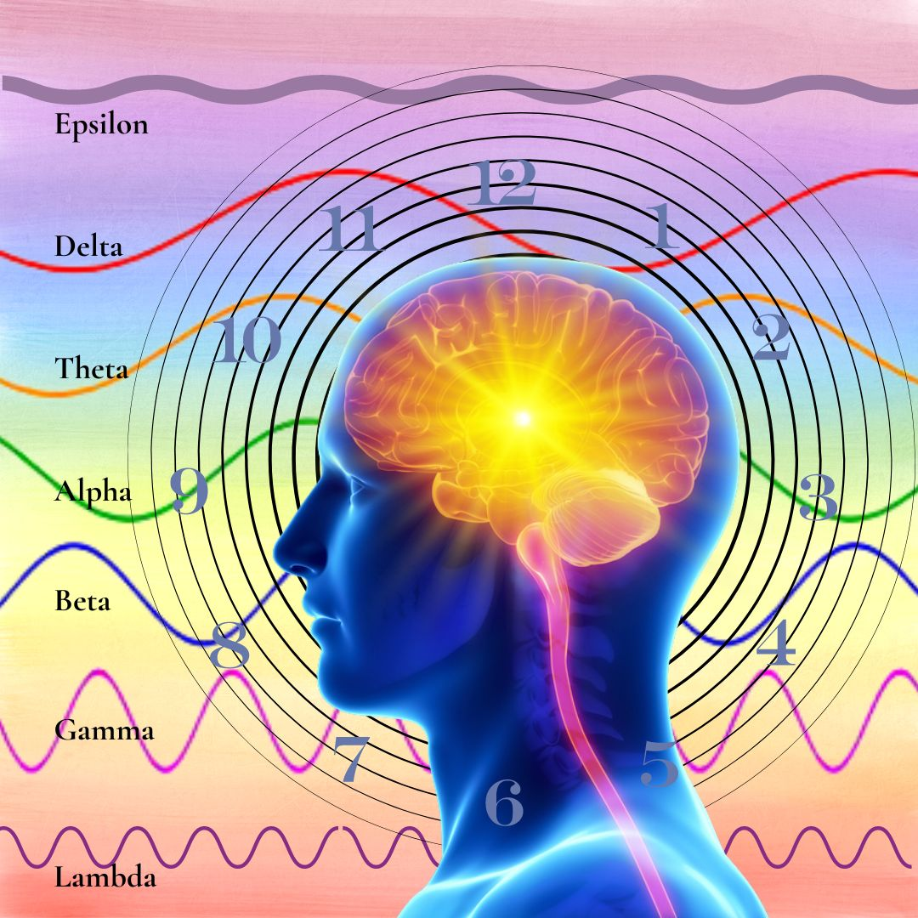
Brainwaves are a fascinating journey. However, it doesn’t end there. We are so much more. As a multidimensional being, we also ride a roller-coaster of emotional highs and lows. We remember past traumas, triggered by seemingly innocuous events. We are aware of other times and realities that somehow penetrate this realm. On a given day, how many times do you drift up, down, and around through uncharted dimensions and states? Just for fun, shall we track a hypothetical day?
In the early morning hours, you’re sleeping soundly in the Delta state. As you awaken slowly, you drift up through Theta, in which you feel subtle intuitions about the day. Your morning meditation is filled with light, bringing you a few precious minutes of heightened awareness in the Lambda-Epsilon state. As you drive to work, you descend peacefully into a relaxed Alpha state, listening to music, as you breathe deeply and contemplate a few raindrops on the windshield. Soon the day is upon you, and you rush to your office computer, where you strategize, fully awake in the conscious Beta state. Suddenly, a brilliant insight in the highest Gamma state, a surprising genius discovery, completely changes the trajectory of your project. Immediately, you reorganize your staff schedule for the project, working carefully in a problem-solving Beta state.
At 10:30 am you walk out for a cup of tea and a snack, drifting briefly into relaxed Alpha. A female colleague says something that echoes your mother’s constant criticism of your creative thinking style compared to your obedient older brother. Irrational anger and frustration spring up from nowhere, and suddenly you’re in an agitated high Beta state with no way to cool down. You’d like to punch this woman in the face, but you use your best meditative skills and deep breathing to restrain a violent response and calm down to a strained Alpha. In this somewhat instable tranquility, you happen to watch a brief video about Bengal tigers snuggling with their owners, which finally puts you into a state of Theta harmony and oneness.
At lunch with a friend you hardly notice your soup and salad as you discuss your upcoming projects in full Beta awareness. A brief off-the-charts ecstatic moment of joy invades your senses as you inhale a piece of chocolate cherry cheesecake. Well, maybe this could be defined as a “High Gamma Spike” of bliss. I don’t know.
On the way home, you see a forlorn woman with a flat tire and three children at the side of the freeway. You successfully replace the tire, and she is so grateful to you, her adoring gaze shocks you into a déjà vu memory of your younger sister in a past life in Sicily, where you loved her beyond measure and would do anything in the world to help her. Never mind the frustrated motorists all around you, you’re deep in a daze of newfound love, feeling profoundly nourished by the meeting. You follow your usual route home in a semi-hypnotic trance, arriving without the foggiest idea of how you got there. Dinner prep and discussion is a busy Beta cognitive time with family talking about the day. After dinner you watch a movie in a quiet, Alpha state, still pensive about your surprising encounter. But a funny and skillfully hypnotic TV ad for cookies, tempts you to open a bag of chocolate Oreos and eat them all without noticing. Gradually you get sleepier, drifting down from Alpha, through relaxed Theta, and finally into deepest restful Delta sleep. How many altered states did you experience in a single day?

- You are More Powerful Than You Know
We can observe our brain waves and states of consciousness constantly shifting up, down, and around the cosmos every day. We are almost totally unaware of these changes, because we may be tuning in to outside stimuli and reacting to them. But what if you could use your mind to observe and direct your states of consciousness in the moment? You would possess the key to untangle every obstacle in your life! By using your mind to relax deeply, you could observe things without emotional attachment, find the secrets to your health, and dissolve all the old trauma held in the body-mind. You could remove the negative effects of stress, handle traumatic events, prevent overwhelm, to feel safe and secure every moment. With this self-hypnosis technique, old traumatic memories are stripped of their emotional intensity and dissolved, leaving you healthy, free of the past, and able to gain self-mastery right now. This is the essence and power of self-hypnosis.
As a unique, multi-dimensional being, you're constantly tuning in to multiple frequencies. You naturally sense different dimensions as you eat, sleep, learn, digest, process, and express yourself into the collective. Some say there are 12 levels of density in the known cosmos. Others say there are 15 or more densities, plus infinite parallel realities. Some densities are said to be physical, some non-physical, some just light and sound. Perhaps your density is your layer of reality in this particular life, and a shift happens if we move from one density to the next. As we navigate the various levels and permutations of spirit, we can only ask: Are the dimensions really numbered? Or is this also a continuum that invites us to find our highest integrity each moment in synchronicity with universal Oneness and our personal evolution?
You are powerful. So, what do you want? Just ask for it. Use your heart and mind to manifest a new world. Your heartfelt passion is like the “juice”, a kind of fuel to manifest your thoughts in the physical realm. Creative children do this every day in their imaginations. All successful people share this manifestation skill. However, very few people ever get beyond selfish goals of money and power. The ability to manifest with the mind gives you even more power. And it is even more potent to merge the power of the mind with the heart. Here we are learning the skill to manifest from the heart for all sentient beings in the universe.
The techniques I am teaching require an awareness of discipline and integrity. Tuning into multi-dimensional frequencies is powerful, and comes with added responsibility. For example, we don’t invade the privacy of other people without their permission. We don’t aimlessly wander around in the multiverse without a specific intention to heal. When we have integrity, and work to benefit all living beings, then the universe will protect you and help you. But if you misuse your newfound ability, you will meet a very bad result, you will become twisted, and your powers will disappear. I also want to clarify that healing past lives, is very different from past life regression. We are not asking what happened in the past. We are looking for a specific point in time for one sacred purpose, and that is to heal a trauma that is affecting your life right now. It’s like a laparoscopic surgical removal of a traumatic charge that is minimally invasive. We dissolve the charge and get out. We’re not wading into the dramatic swamp of the past. We’re not engaged in the theatrics. Just grab you prize and get out.
In healing past trauma, we often deal with transmuting fear. Fear is a misunderstanding of a person’s own worth and security. Fear, blame, and resentment are a terrible waste of our valuable energy. Fear drains our lives both spiritually and materially. Fear destroys everything in its path; it can never create anything.
As a healer, your role is to recognize fear and transmute it with loving intent. You will need to have a clear conscious process of generating that intent. For example, we might create a completely new concept called “dissolving fear to heal past trauma in the multi-verse”. Once it is defined, this idea has power, because it is full of intention. As a learned skill, this concept has the power to invoke and to literally bring another reality into existence. I hope this nugget of an idea can help you to refine your own power, to know yourself, and transform the quality of all life.
- Direct Your Intention, Expand Your Destiny
Intention is the primal force of creation. We are taught that the universe is made of spinning electrons, protons, and neutrons, which somehow manifest into molecules and matter. But excuse me, how can matter can manifest matter? Did science forget somewhere along the line to include the intention of the Supreme Almighty Spirit? Maybe it is the Will of God that creates all physical matter and all dimensions. And perhaps this is what makes it possible for you to explore your own personal path to complete your destiny.
When you look in the mirror what do you see? Maybe your body electrons, atoms, and molecules are just the spinning intentions of God creating a miracle of cells and flesh. That makes you, me, and everyone a timeless spinning network of intentions or desires.
We go through life asking for a miracle, when in fact we ARE exactly that. From beginning to end, physical matter is an intelligent grid of intentions. The Supreme Spirit then adds a touch of consciousness into molecular matter, and the result is LIFE. Yet what we see and feel is just a tiny fraction of our whole being. What we see in the mirror is the outer expression of an inner event. Our form is created from Spirit, and the body is a collection of intentions, coming together to build and sustain our human life.
“No matter what he does, every person on earth plays a central role in the history of the world. And normally he doesn’t know it.”
Paulo Coelho, The Alchemist
Imagine the power you will have when you are able to balance your mental states and direct your own intentions in harmony with that power of the universe. Consider this as a way to navigate the myriad experiences of daily life. When you learn to observe and control your thoughts, your experiences will unfold in harmony. Instead of reacting to internal or external events, you will be your own driver, better able to maintain a constant, balanced state of health and well-being.
One of the big secrets to integrating ALL your power is to learn to RELAX. Study your reactions. Use your power of intent. Take responsibility for your conscious intentions. When you encounter something you’re not happy with, make an intention to change that situation. This creates a sphere of conscious positive energy which is already spinning all over the world. Ask for what you need. Then the tools, people, opportunities, and knowledge will come to you and to all of us. Trust that.

- Find Health and Wellness Through Self-Hypnosis
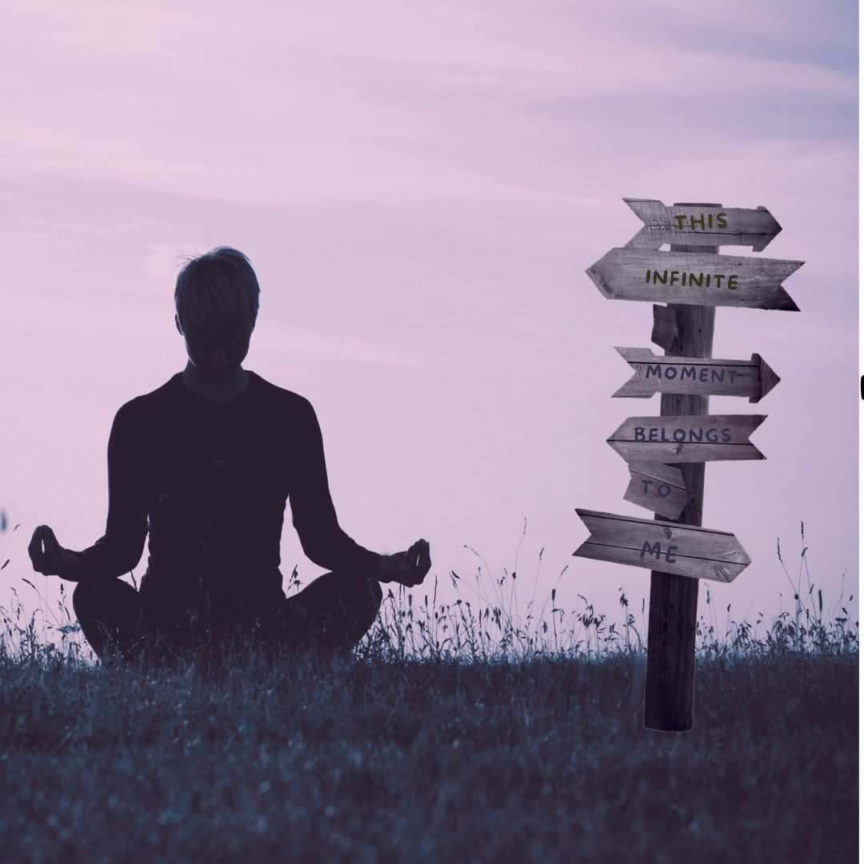
In self-hypnosis, like meditation, you set aside a quiet time to invite yourself to deeply relax, where you will not be distracted by the usual stimuli. The step-by-step instructions in the next chapter will show you how to practice self-hypnosis. I like to begin with slow breathing to move gradually from wakeful Beta alertness into a more tranquil Alpha state. Then I relax into Theta in which I begin to feel tranquil yet totally aware and not sleepy. It’s not important to identify the states, just keep relaxing deeper and deeper with each breath.
If you’re an experienced meditator, then self-hypnosis will very likely be much easier for you. But there are so many meditation techniques and misconceptions, I prefer to avoid the term altogether. Some techniques use deep stillness, others use specific thought forms, while others are visualizations, chants, or mantras. If you’re new to meditation, maybe you’re lucky, as you won’t have to battle old preconceptions. Just observe yourself mindfully to find moments in which you become truly tranquil, open, and joyful in your body and mind. Then gently extend the length of their duration to several minutes or even hours as you go through your day.
Many of our most challenging experiences are directly connected to traumatic memories somehow held in the body tissues. Without the ability to consciously relax, your body remains stuck in tension and hypervigilance, so that safety, calm, and intimacy are never available. Factual knowledge and medical training are of limited value in healing you fully, until you first develop the skill of embodied relaxation. When you can relax yourself deeply, without depending on external events like music, food, alcohol, or your mother, you will feel grounded and safe. You can trust the present moment. You can feel connection and joy. This is the benefit of self-hypnosis. You can have full access to your inner power.
As you practice self-hypnosis, notice your mind will become more tranquil. Observe the brain moving to a deeper state in which you can more easily access information about the distant past. Your body-mind is more suggestible. This receptive state will allow you to ask questions and accept changes, so that old patterns can come up and be dissolved. Get ready to take simple notes with paper and pen, because when you come out of this state you may not remember every detail.
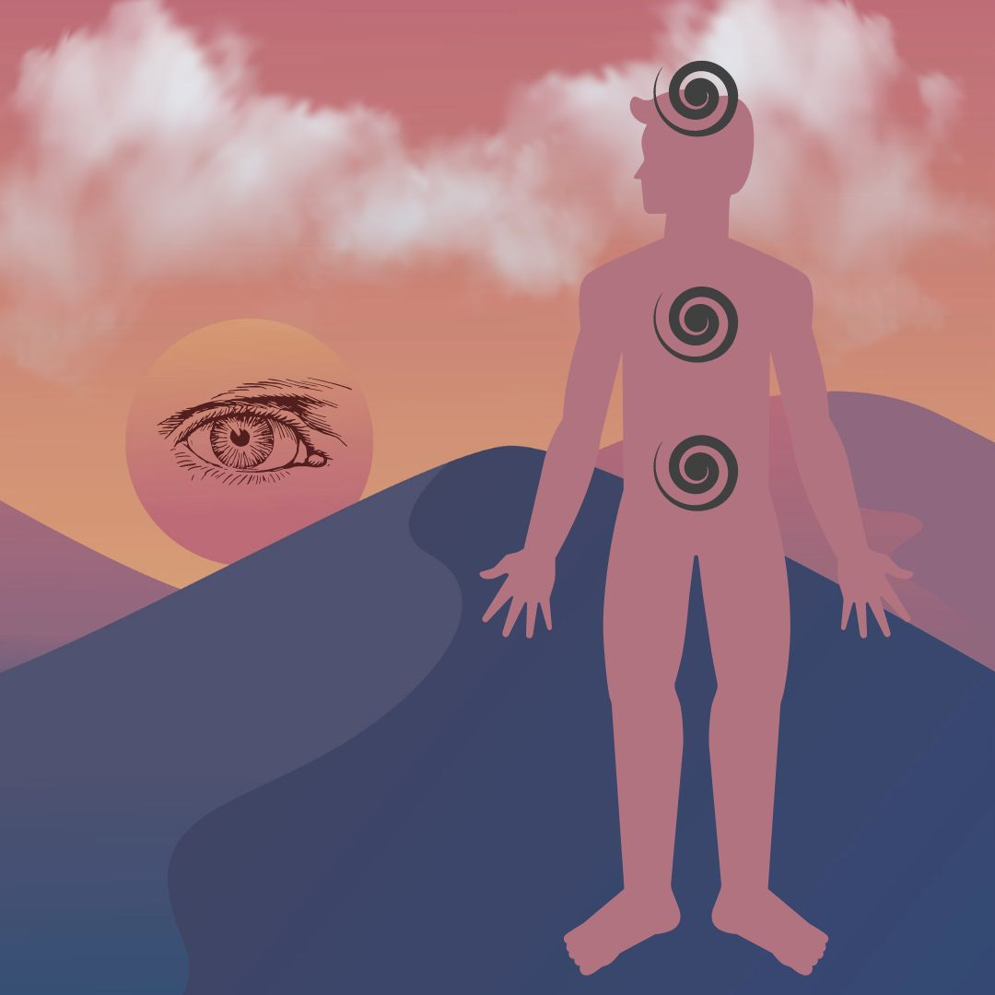
- Preparation for Work: Balance, Root, Calm

Before you begin your healing session, prepare yourself with these simple steps. Preparation is especially important when you are working on yourself. You can begin to set the stage a few days ahead of time by balancing your lifestyle habits. Eat a simple diet of mostly unprocessed vegetables. Walk in nature to attune and balance your meridians. Try to get lots of deep sleep at night. Before your session do these steps:

1. Take a small drink of clean, filtered water, and keep it handy to stay hydrated.
2. Breathe comfortably three to six times until you feel calm.
3. Root your imaginary grounding column deep into the earth, and extend your column up
to the center of the galaxy overhead.
4. Empty your mind of thoughts, and let them sink down into your heart.
5. Be kind to yourself. Accept yourself completely just as you are right now.
6. Do the following brain-balancing sequence:

What is Brain Balancing?
Brain balancing is a huge key to optimizing awareness. As you probably know, our left and right brain hemispheres are mostly separate and perform distinct functions. Both sides are equally important and must be synchronized. By balancing left and right brain cortices, we are able to utilize our WHOLE BRAIN. We can merge big-picture awareness on the right with precise logic on the left. Don’t let anyone tell you one side of your brain is better than the other. It’s your brain! You can develop your left brain, your right brain. Or even better, develop both. Use this simple tapping exercise to gently reset the left and right brain hemispheres to work together to supercharge intelligence and harmony. Otherwise, old synapse habits largely determine all your brain and body processes. This tapping exercise helps to keep you flexible, clear away accumulated debris in the neural pathways, to open and calm the nervous system before we do important transformational work.
Brain-balancing resets your nervous system and optimizes all body functions, so you can stay relaxed and grounded. This immediately boosts brain clarity, calms emotions, and resets the nerve pathways. This gently synchronizes body functions in all organs. Do this every night before sleep, before a meeting, a performance, or healing session. You’ll feel cumulative benefits every time you do it.
The SWEET SPOT of the Pineal is your Root of Super-Intelligence. The Pineal Gland is located in the very center of the brain, between the two hemispheres. The Pineal Gland sits in the third ventricle, a protective cavity of brain fluid. It contains tiny crystals that respond to piezo­electric frequencies. Just like an antenna, the Pineal Gland receives frequency vibrations. It produces hormones that affect mood and biorhythms of day, night waking, and sleep.
Left and right brain hemispheres are like any polarity in nature, such as Yin-Yang, Male-Female, and Positive-Negative electricity. When these dual energies are in balance, there is maximum freedom and connection. Left-Right Brain Balancing is the root of the current trans-humanist battle in the world today. We are free to choose our own path.
Pineal gland micro-crystals are very sensitive to tapping, as we synchronize the two brain hemispheres. The purification and activation takes place in the background while you sleep. The pineal gland is damaged by electromagnetic energy, so it’s best to sleep with no WiFi. You can turn your router off at night. If you do this pineal activation and tapping before bed, the pineal gland will clear co that the energy center of higher intelligence called third eye will awaken while you sleep.
How to do Brain Balancing
Take a deep breath in – and out. Keep the tip of your tongue on the roof of your mouth behind your front teeth, to connect the meridians.
As you breathe normally, place one hand low on the back of your head by your neck, so it touches both sides. With the other hand, spread the fingers and tap three to six times gently on the head (both sides), the heart, and the belly. The three tapping points are the top of the head, heart, and belly from Chinese medicine.
Now move the hand on your head one hand-width up the back of your head, and with the other hand tap three to six times on the head, heart, and belly. Move your hand again one hand-width up the back of your head and tap on the head, heart, and belly. You’re creating a gentle wave around your brain from back to front.
Move your hand one more hand-width around your head and tap head, heart, and belly. When your brain hemispheres are balanced, left and right sides of the body can synchronize. Move another hand-width around your head and tap head, heart, and belly. When the brain cortices are integrated all your body systems line up in health.
Move one last hand-width around your head almost over your eyes and tap head, heart, and belly. This lowers stress, calms the mind, and reduces the effects of EMF’s electro-magnetic frequencies. Good. Last step – place both hands gently on the sides of the head. It should feel very calming. Tap with either hand on head, heart, belly. This helps line up all the meridians, so we can respond intelligently in any situation. Now replace that hand to the side of your head. Then tap with the other hand head, heart, belly. Finish with both hands on the sides of the head. Good job. Take a breath.
Body Relaxation Exercise
When you are in a state of deep relaxed self-hypnosis, then you can ask questions, and somehow, you will know the answers. You have an almost infinite capacity for right-brained big-picture awareness. And simultaneously you can drill down to a single point of left-brain utter precision. The key is to balance your brain hemispheres and then use your breath to relax into a deeper and deeper state of quiet.
Now we’re going to do a full body relaxation. I want you to learn to relax yourself into a state of trust and openness, yet with precise clarity at the same time. You can play with this technique and master it, because it will serve you in every phase of your life. The deeper you relax, the more expansive your ability to know the truth.
The purpose of a body scan is to relax and pay attention to how your body really feels. Bring your attention into the present moment, back from any distractions or worries, let go of thoughts, and even my words. Sit with your back comfortably straight with both feet on the floor and your hands comfortably in your lap. Or you can lie down.
Close your eyes and listen to your breath. Your goal is to relax every muscle and sinew of your body one body part at a time, using your breath, and allow every tension to release. Direct your awareness to your belly as it rises and falls naturally with each breath. Feel your body become a bit heavier as it sinks deeper into the mat or your chair on each exhale.
This is your relaxation technique, so you can do it in order you want. The secret is in your breath. I usually start with the little fingers, because if I’m afraid or revved up, there is tension in my hands. If I can release all tension in my little finger, then I have won the battle, and every part of my entire body will fall in line. I’m sure you already know this exercise. You can develop this as a skill, and get really efficient to relax your whole body in a few minutes. Everyone should do this once a day – it’s the best ant-aging secret in the world, and it’s free! Go through each flange of each finger, wrist, then tendons in your hands, the lower arms, elbow, upper arms, shoulder, using your breath and releasing ever more on each exhale. Use your intention to love yourself with each breath as you and relax your neck, throat, your scalp, your face and especially your mouth. Move down your spine to relax the shoulder blades, collar bone, shoulder joints, chest, belly, relaxing deeper on each breath. Next I usually go to my toes, relaxing each flange starting with the little toe, just like we did on the hands. Move up the feet, tendons, heel bones, ankles, lower legs, upper legs hamstrings and quads. Then the hip joints, belly, lower lumbar, and especially the diaphragm. Any area you feel tightness, focus your breath intentionally with love to release it.
Now expanding your awareness, feel your breath move easily through your entire body as you rest here. Notice the movement of the breath through the entire body from your head to toes. Notice how the breath moves freely and easily from your feet to the top of your head. Be fully aware of your body – whole, complete, strong and at ease. Open your eyes, and notice if your awareness has changed in any way.
In conclusion, when we use our mind to relax deeply, we can observe things without emotional attachment. Then the secrets of the universe make themselves available to us. We can dissolve old trauma held in the body-mind, and even eradicate pain. With this ability, you can dissolve stress, handle traumatic events with ease, eliminate overwhelm, to feel safe and secure every moment. With this self-hypnosis technique, old traumatic memories are stripped of their emotional “charge” of intensity, and dissolved forever, leaving you healthy, free of the past, and able to gain self-mastery right now. This mental discipline is the essence and power of self-hypnosis.
Open the door to your true destiny, and step into your multi-dimensional nature. It’s really fun. Nothing can stop you, except maybe a little fear and a couple of flimsy excuses. What we have the greatest resistance to, is claiming our birthright to the banquet of life. Most people spend their lives groveling under the table, but if they just step up and take a seat they would suddenly discover they’re sitting at the biggest banquet in the universe, and sharing it with other real players. Go ahead, step into the game. In fact, to realize your true destiny is your only obligation in this life. Thank you.

Part II. The Technique: Six Steps to Heal Your Past Lives
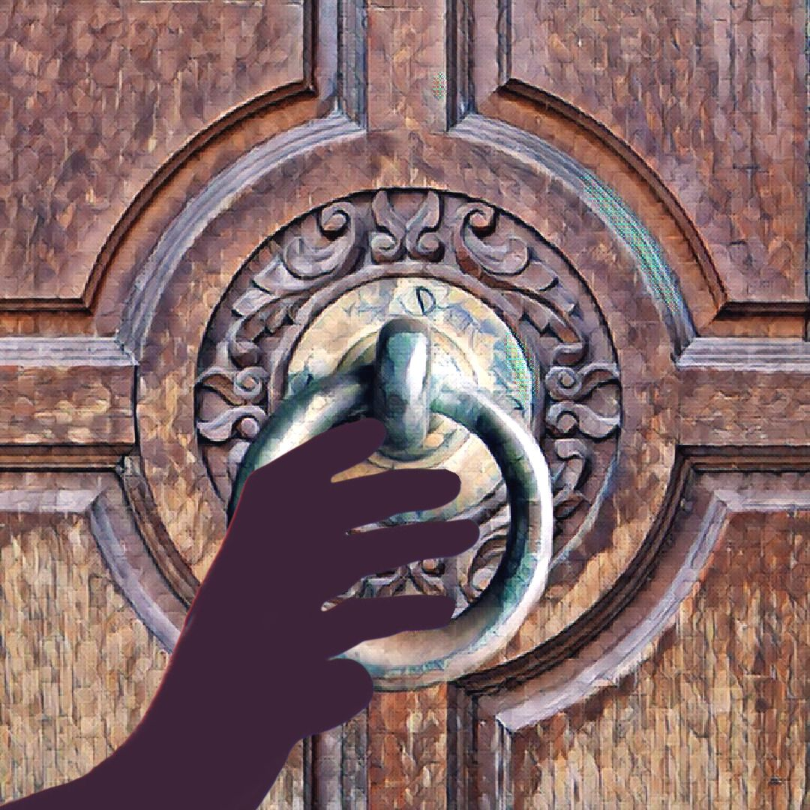
Step One: Trance State, Set a Goal
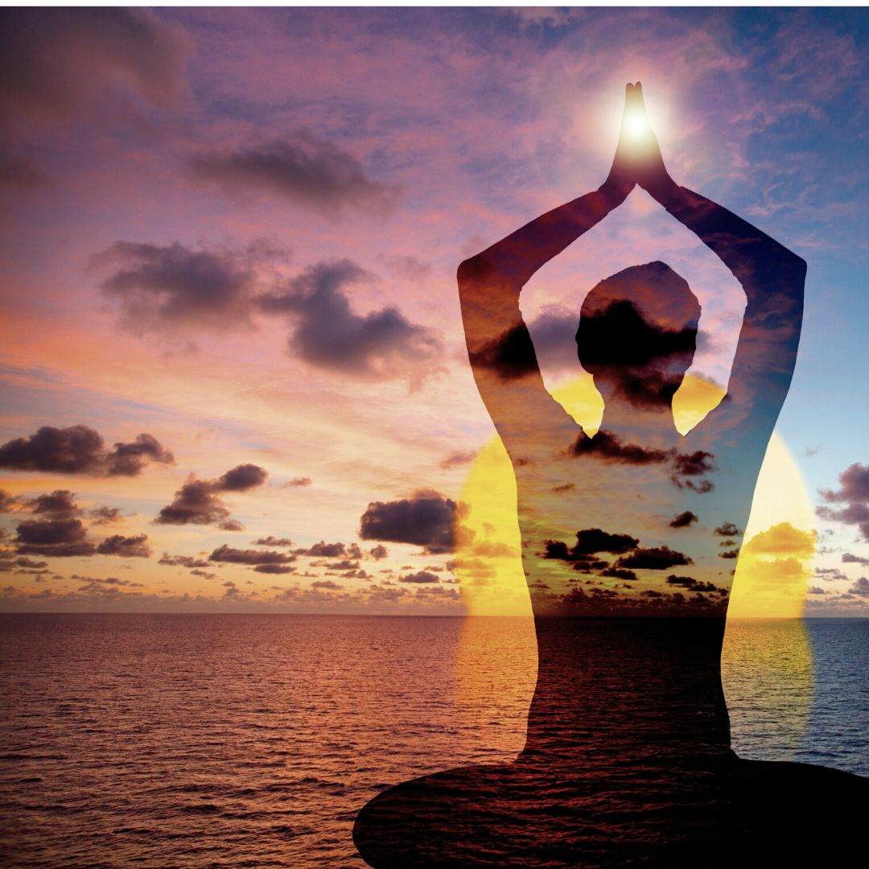
To begin your session, sit comfortably at a time when you feel balanced and will not be disturbed for 30 to 60 minutes. Take a few deep breaths and relax your body. Let any distracting thoughts drift away. Allow yourself to feel neutral in your body. Take three to ten breaths allowing tension to fall away. Follow the preparation steps above.
There are many ways to enter a hypnotic state with ease, and if you have learned a different method, feel free to use it. Some techniques visualize your body floating downward, and others have you walk down a short flight of stairs, relaxing more deeply on each step. I like to use the stairway method with counting: Feel your body sinking into calmness on slow breaths as you count backwards from ten, descending deeper on each breath. 10, 9, 8, 7, 6, 5, 4, 3, 2, 1, 0. You can even do this several times. The important thing is that your body is very relaxed, the mind is quiet, your breath is slow, and you are open to receiving information. As you breathe calmly, notice that your thoughts also become more tranquil. Allow them to come in and go out without focusing on anything except for relaxing deeper and deeper.
Humbly ask aloud (or silently) to contact your deepest self, to receive the truth, and to see what you need in order to heal. Ask to be whole, ask to trust. Feel your body soften and relax even more. Take long, relaxed breaths.
Setting a goal for your session.
This is central to your healing as it indicates one big objective, which drives your session. Say your goal clearly, out loud or silently like a deep wish. Be specific. For example, your goal might be to ask: Please help me heal the most important priority in my life now.
Or: Please show me the primary root of all my physical illnesses.
Or: If a specific issue is affecting your life now, ask to find and dissolve all past threads of it.
Or: Please show me why does XXX trigger me to feel insecure?
The question is your choice, and it is central to your session.
If necessary, repeat Step One breathing and counting backwards from ten until you feel quite relaxed and ready to begin asking questions. Don’t worry or overthink your technique too much. This is a simple skill and may require practice. Just do the steps over again until you feel comfortable. If you’re not ready, take a break and come back to try again at another time.

Step Two: Body Dowse for Answers
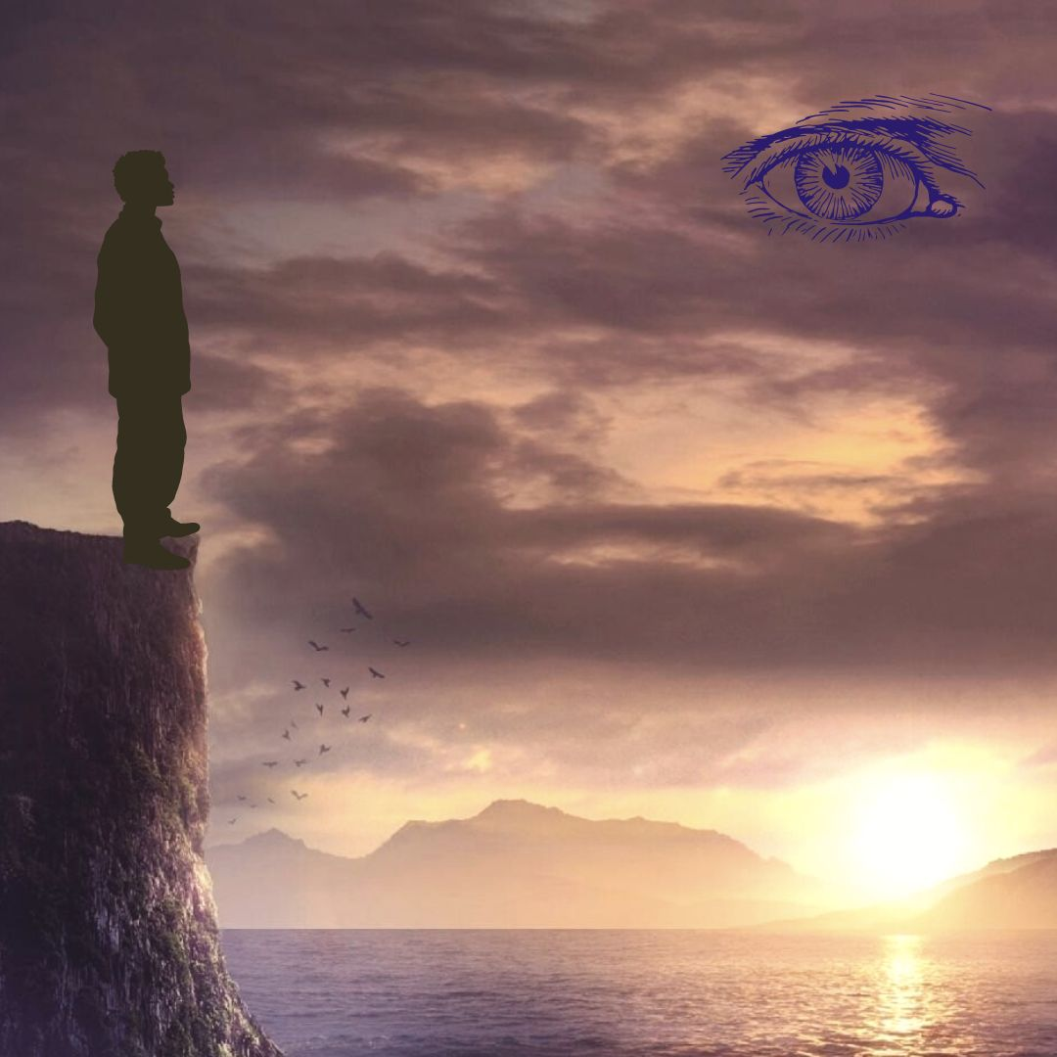
Your body is wiser than you can imagine. You are connected to all of universal knowledge, simply because you are part of it. Intuition is just an immersion of the conscious mind into your deep multi-dimensional subconscious awareness. In a deep state of calm, you can ask Yes/No questions and then use body-dowsing to find answers. Body dowsing is a simple and effective tool that allows us to answer Yes/No questions immediately from the body’s wisdom.
This skill has two essential parts, so we will take them one at a time. A) You must learn to use your body as a pendulum, or use a pendulum, or any kind of kinesiology tool. And B) You must learn how to ask clear Yes/No questions. This may seem impenetrable and confusing at first, but I assure you it is not. Just take the next step forward and you’ll get there.
Body dowsing does not require a physical tool, such as a pendulum. (Although you can also use a pendulum.) I use body dowsing not only in healings, but also to ask practical everyday questions about what is needed to be happy and healthy. Just like we have a spiritual intuition, we also have a physical body intuition. That is why body dowsing is a skill that can benefit your life in many areas. Even though the body is always hearing and relaying messages, we may not always be aware that it is doing that. Sometimes we have to get very quiet. We must learn to LISTEN for those messages to actually HEAR them.
To do body dowsing, the mind needs to be free of distracted chatter, excessive stress, and noise. Find a quiet moment when you feel relatively balanced. Your breathing should be very even and deep. You need to be in a neutral frame of mind and body.
Before you start body dowsing, you need to first determine how your body answers questions. Stand on the ground or sit in a chair with your feet firmly planted about twelve inches apart. In this state, you can ask any question in a Yes/No format.
Notice which way your body leans: forward or backward. Normally when your body answers in the affirmative, as in Yes, it will tip forward a bit. Likewise, when the answer is negative, the body tips backwards a bit. This direction may vary from person to person, so you need to test it out for yourself. To do that, ask a question for which you already know the answer. For example, ask: Is my name George Washington? If your body tips backwards, that would likely be a negative answer, as in No. You can ask the same question with your real name, and if the body tips forward, that would be a Yes or positive answer. There’s a chance your body dowsing direction is the reverse – Forward is No, Backwards is Yes. Test it again. Once you have determined your tipping direction, you’re ready to begin practicing body dowsing.
You can ask your questions standing up or sitting in a chair or couch. It helps to be well grounded with your feet on the floor. Or you can use a pendulum. You can use any kinesiology technique, such as muscle testing with the arm or wrist. It can be done remotely or in person. The basic technique of applied kinesiology is rooted in one of Sir Isaac Newton’s “Laws of Motion” which states: “For every action in nature there is an equal and opposite reaction”. This just means to me that universe is a network of consciousness. We can listen to it, because we are part of it.
Begin asking with the simplest Yes/No questions, such as: Is my name George Washington? What do you feel? What does your body do?
Do I have any trauma or blockages ready to heal?
Can this be dissolved today?
Does the trauma relate to a different lifetime?
Or does it relate to an event in my current lifetime?
Was I a human being?
Man or woman?
Does the lifetime contain any roots of discomfort that affect my current life?
Is the lifetime period in the past? Future? Is it before the year 1,000 CE?
On what continent does the lifetime take place? North America, South America, Africa, Europe, Asia, Australia, Antarctica?
Your body has many things to tell you for your benefit. You can use body dowsing to ask all sorts of questions, not just about past lives. It is extremely important to listen to the answers from your body. When we follow the messages of the body, we truly strengthen the connection between ourselves, our inner voice, the wisdom of the body, and universal wisdom, which is always there. The good news is that with practice you will become familiar with the quality of your body’s messages. How does a ‘Yes’ feel? How does a ‘No’ feel? Soon you will have enough experience and won’t need to wait for the tip forward or back. You just ask a question with your rooted body mind, and you will feel the body’s answer, you will KNOW it Yes or No.
During your session, after you have the first few answers to your questions using body dowsing, your deep awareness may connect into the actual lifetime or event, and you might receive a flood of memories from that life as if you were almost physically there. If this happens, just be a detached observer. Do not be distracted or emotionally pulled in. Stay on target. Get the answers to your questions and leave the scene with your prize. Your prize is to find the ROOT of the TRAUMA that took place, the specific emotional distortion, which you can then dissolve. Nothing more. We are here for one specific purpose. Do not allow yourself to be sidetracked with curiosity, entertainment, or anything extraneous to your goal.

Step Three: Ask Questions, Describe the Lifetime
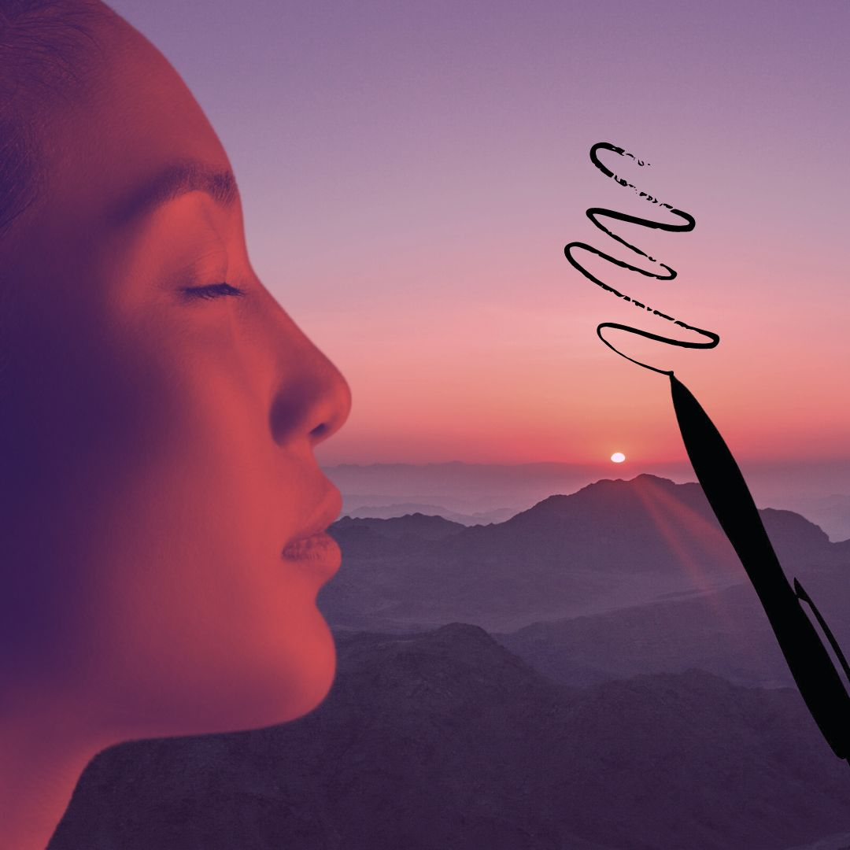
Do you know how to ask a clear question? Most people have no idea how to ask a Yes/No question precisely, and this is critical to your success. Poorly defined, vague questions will always give you wrong answers. The most important factor here is to stay simple and ask one question at a time without jumping to conclusions. When you receive an answer, you can check it by asking the same question a different way or in the opposite way. Example: Was I a man? Was I a woman? Was I not a man? Was I a hermaphrodite? Are you sure? Is this answer complete? Is there more to ask? Since we are just learning to ask questions, be patient and systematic in your inquiry.
The most common pitfall is that many questions contain hidden assumptions, which could be untrue, and this will make your answer ambiguous. When you ask a Yes/No question, it is important to try to be relatively free of assumptions. If your question contains unconscious presumptions in it, then your answer will likely be incorrect and unreliable. For example, if you were to ask the question “Did I have red hair like my sister’s?”, that is a Yes/No question, but it contains many assumptions. You may be incorrectly assuming you had any hair at all. You may be incorrectly assuming that you were a human being, or that another person was a human being, and that they were your sister. They could have been your aunt, your brother, or a Raggedy Ann doll. That is why it is important to keep your questions simple and one-dimensional. Otherwise your whole inquiry could lead to a dead end.
To answer the question “Did I have red hair like my sister’s?”, you need to first set it up with a series of simple one-dimensional questions. Who knows? It may turn out your whole family had blue hair, and they were all boys!
Asking precise Yes/No questions is a skill you can develop. Try to stay on target like Sherlock Holmes. What is your objective? Your one goal is to find the true core of any trauma in the past and to dissolve it with regard to its effect on your life now. You’re not wandering around aimlessly; you’re not time traveling. You’re not curious about extraneous, unrelated things. You have integrity, which means you never ask personal questions about someone else or invade another person’s space without their specific permission. You have nothing to prove. Your single goal is to learn the truth regarding your own experience, in order to heal your life now. This is an easy technique, but as you can see there are many pitfalls that could lead you down an empty path, and give you zero healing.
I start with basic questions: Is there a past life trauma that’s ready to heal? Y/N Is there not a past life trauma ready to heal? How many lifetimes ago? More than 10? Less than 10? Less than 5? 1, 2, or 3 lifetimes ago? Was I a man, a woman? Where did I live? North America, Mexico? Michigan? Was I a child? Married? Single? What century was it? Did I have children? What was my life’s work? What did I love? Gardening? What was my lifestyle? Was I a kind person? Or a cruel person? Was I rich or poor? What did I desire more than anything? Without disrupting your state of deep calm, take a few simple notes with pen and paper, so you can recall them later.
For further study on how to dowse and ask clear questions, I recommend this book: “How to Use a Pendulum: 50 Practical Rituals and Spiritual Activities for Clarity and Guidance”, by Richard Webster.

Step Four: Determine the Specific Emotion to Heal
When an emotion is so intense that it cannot be fully processed, it may become “stuck” in the body very tightly. Any emotion that is not digested remains stored in our body-mind and may later manifest as physical disease. We’re sometimes encouraged to hide our pain and continue staunchly under difficult conditions. However, over time, to stuff or deny intense emotion can cause a backlog of repressed, unconscious, irrational reactions, and emotional baggage that we carry over many lifetimes.
The intimate relationship between the mind and body ensures that every mental - emotional experience impacts your health in some way. Trauma that is not resolved or digested, may linger long past the actual event. A classic example of this is fear. If you lived in a previous incarnation under extreme fear or terror every day for many years, it could create a frequency memory pattern that endures after death. In your current life if you find yourself in a slightly similar situation, your body may produce an exaggerated physical-chemical reaction of the emotion, activating a fight-flight-freeze response. That is how a seemingly “harmless” event can produce a severe panic attack.
Past habits largely determine how we respond to stress, our relationships with others, our physical health, and our overall perceptions. Emotions usually represent negative distortions in our consciousness, like a deformed lens through which we see everything. For example, if someone grew up in an angry household, they may view daily life through the lens of anger, like a filter that colors their every thought, impression, and action. This acts like a block to diminish and obscure their true power. Although this block may be seen by others around you, it can be so deeply ingrained as part of your inborn nature that you are totally unaware of it. These techniques can help clear all past wounds.
What are emotions? We can think of emotions as chemical messages in the blood, flesh, and liquids of the body. They originate as biochemical signals in the brain amygdala centers and endocrine glands that surge through the body like tides.
Emotions are your powerful inner resource. Observe yourself, clear the distortions, and harness your feelings as fuel for your destiny.
Emotions are STRONG ENERGY. Emotions integrate the power of the heart and the nervous system into intention, thought, and action. When an emotional wound is not processed, it represents a drain on your energy and your health. You are like a leaky bucket and your energy is weaker because a part of your consciousness is still locked up in PTSD of fear or anger. You are like an injured shadow of your whole self. However, emotions are a double-edged sword. When we can discipline our thoughts, detach, and clearly observe to face our emotions, we can begin to know ourselves. Imagine the power you can summon in your life when your emotions are calm, your nervous system is undistorted, in harmony with your true purpose. You are free to step into your life destiny. Do not underestimate the power of your emotions for good. You can harness them as an unstoppable energy force.

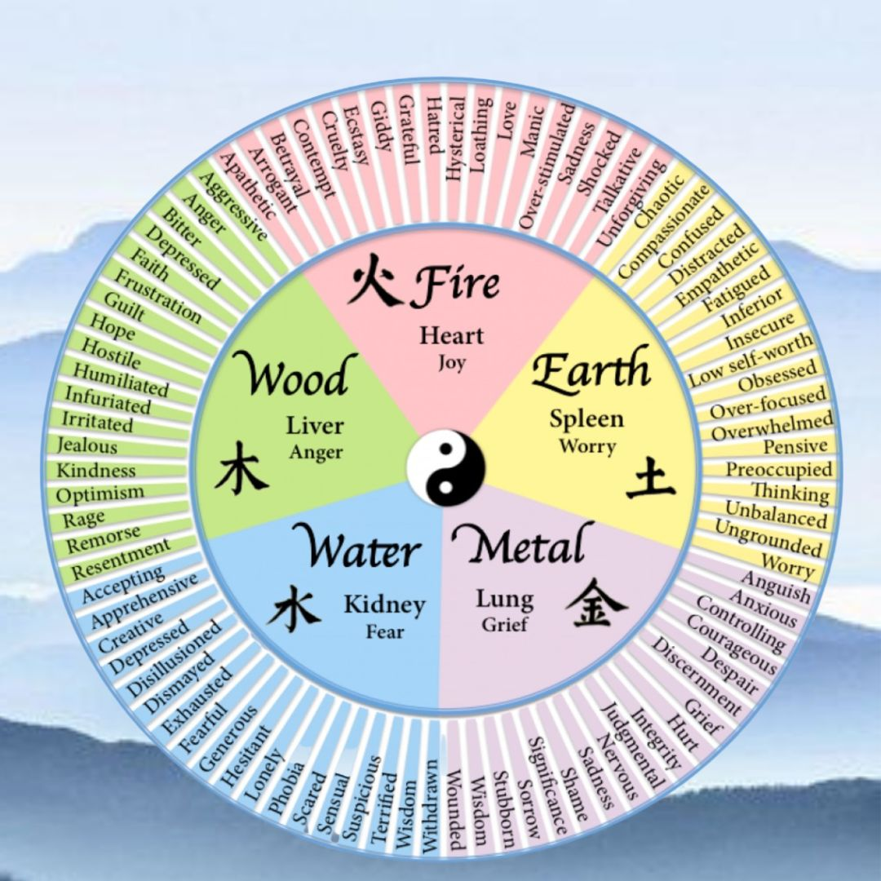
The five primary emotions of Anger, Joy, Worry, Grief, and Fear can be broken down into myriad specific sub-emotions, which may more clearly define the nature and intensity of the issue you are healing (see image).
Emotions are often held in the heart or lungs, such as that feeling of tightness in your chest during an anxious situation. However, there is no predictable rule for where emotions are stored physically. Traditional Chinese medicine sees the emotions as five basic states. Each emotion is linked to a corresponding element, body organ, and associated with common ailments. Longstanding emotional trauma in a past life can repeat the same frequencies over many lifetimes until it is dissolved. Traumatic emotions often follow these general patterns in the body, however every case is unique. Here’s a general example of a few possible associations:

- Anger relates to the Liver – Frustration, Headaches, Hot temper, Red eyes, Blood and Liver congestion, Repression, Tyranny, Obstructed creativity.
- Joy (or its opposite) is found the Heart – Insomnia, Depression, Restlessness, Betrayal, Loss of memory, Violent war, Spiritually blocked, Pride, Disharmony or cruelty in society.
- Worry relates to the Stomach and Spleen – Poor digestion, Overthinking, Low Self-esteem, Exhaustion, Longstanding mental torture, Decades of stress.
- Grief and Sadness dwell in the Lung – Colds & flu, Dry Skin, Stubbornness, Anxiety, Constipation, Loss of homeland or family clan.
- Fear is found in the Kidney – Weak willpower, Dry Mouth, Lymphoma, Osteoporosis, Poor teeth, Sexual insecurity, Prolonged terror.

When you are healing, use the wheel above to find your specific emotions. Try to narrow your trauma down to pinpoint an emotion or combination of emotions. Start with the big five, as these are the most basic: Anger, Joy, Worry, Grief, Fear, and then refine it down to more specific emotions if necessary.
Ask: Which of the five basic emotions best describes the trauma? If it was fear, then break it down to find any specific emotions within Fear that apply, such as Phobia or Withdrawn. Ask: Did I die as a direct result? How many years was this emotion a constant pattern in that life?
To do intuitive work, you must be a detached observer. Whether you are healing yourself or another person, your ability to see clearly depends on unbiased observation. If you have an emotional desire for a particular outcome, you will never find the truth. If you WANT a specific answer to your questions, you will fail. Relax. Take a breath. Balance yourself, and try again later when you’re in a neutral state of mind.
Is it truly a Trauma? Or is it a Shadow? An Entity? When you are doing intuitive work, you must learn to trust what you feel. However, in this line of work, what YOU see may be different from what another intuitive sees. For example, one person may see a blue shadow of fear. That is fine. However another person may see the same thing as a dark spot of gray smoke. Another person might call it an “entity”. And everybody may be correct. Whatever color or shape you perceive, just dissolve it. If you try to use your two-dimensional linear thinking to pinpoint the exact nature of something non-physical, you will always be confused.
No matter what you see, no matter what questions you ask, your single objective is to pinpoint the trauma. You must go beyond all those details and remember your goal of true healing. Ask: What emotion was the essence or core of my trauma? Did I die as a result of this trauma? How did I die? What was my age when I died? Was it a political issue? A war? A family dispute? What was my role? Was I a victim? A perpetrator? What was behind my emotion of fear/anger/grief/etc.? How many years did this constant trauma affect my life? How many people were involved? Keep asking simple questions backwards and forwards until you have a clear and complete picture of the situation. With practice, this will become easier. When you become proficient, after a few specific questions, the scenes from your past life may become crystal clear, and you can observe the situation as if you were present.

Ask: Do I have enough information to dissolve the trauma? Or do I need more details? Keep asking questions until you have enough of a picture to move to the next step of clearing. Remember your goal is to dissolve old emotional baggage to heal your life right now. Keep it simple. Maintain your deeply relaxed state. Write a few notes as you receive answers. Look for a specific trauma you need to heal. If you receive a flood of memories, that is good. However, remember, the story is not important. Just find the block. Stay on target with your objective, and do not be distracted by extraneous information.

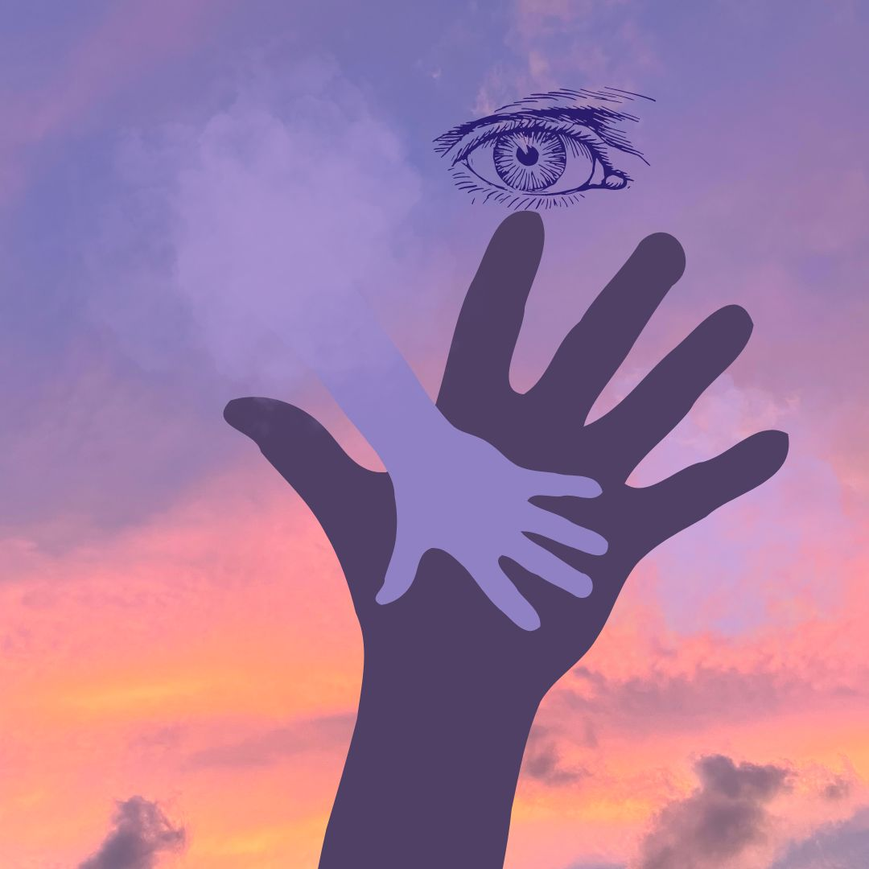
Step Five: Dissolve the Trauma with Specific Tapping

When you are confident you have a sufficiently clear picture of the trauma, the next step is to dissolve it. Ask with all your heart to heal and dissolve any traumatic memory that is affecting your life now. Hold one hand somewhere on your body to represent the past life trauma you are dissolving. Best areas to touch: Heart for Relationships and Self-love, Solar Plexus for Identity, Navel for Energy Center, Sacral chakra for sexual trauma, or any other body part if there was a specific wound. While you hold the area representing the past trauma, use your free hand to tap gently on the three points we learned in Brain Balancing. Tap lightly, approximately 6 – 9 times on each of these three points, and then repeat several times: Top of the Head, then Heart, and then Lower belly. Keep your tapping fingers separated so that you tap on both sides of the top of your head.
As you tap, breathe and ask to release all blocks. Let it go. Allow the central knot of the trauma to dissolve. Breathe comfortably and continue to ask to dissolve any distress that was lingering in your current life. Repeat the tapping sequence several times until you are satisfied that the desired shift has taken place. You may feel a sense of lightness or a change in your heart, like you are carrying less weight, as if a burden has been lifted. That’s very good. If you don’t feel anything, do not worry, it is working. Trust that your deep wish has a very positive effect.
What happens when you dissolve a past trauma? You are not making the event disappear. You are not changing the event in the past. You are just removing the “charge” that ties up your energy and affects you in the present, so you can be free of this energy drain.
Releasing old emotional baggage is a life-long, life-changing practice. It’s a path of self-reflection, to observe yourself. Notice your deep emotions. Emotions are your powerful resource to be harnessed and directed into conscious action, if you are calm. Stillness can be nourishing to our minds and bodies. Quiet time allows space to bring old emotions up into full consciousness, to be dissolved. When you feel something coming to the surface, there’s no need to react to it like a trigger. Just observe it rising into your awareness.
Over time, these healing techniques will help you cumulatively dissolve more and more old emotions with compassion and self-love. Remember you are part of the collective carrying the entire history of human traumatic memories. We are all connected. As you release your own enormous negative weight, you will not only utterly change your own perspective on life. Over time it will lighten the load for all of humanity, to bring about a new shared reality.

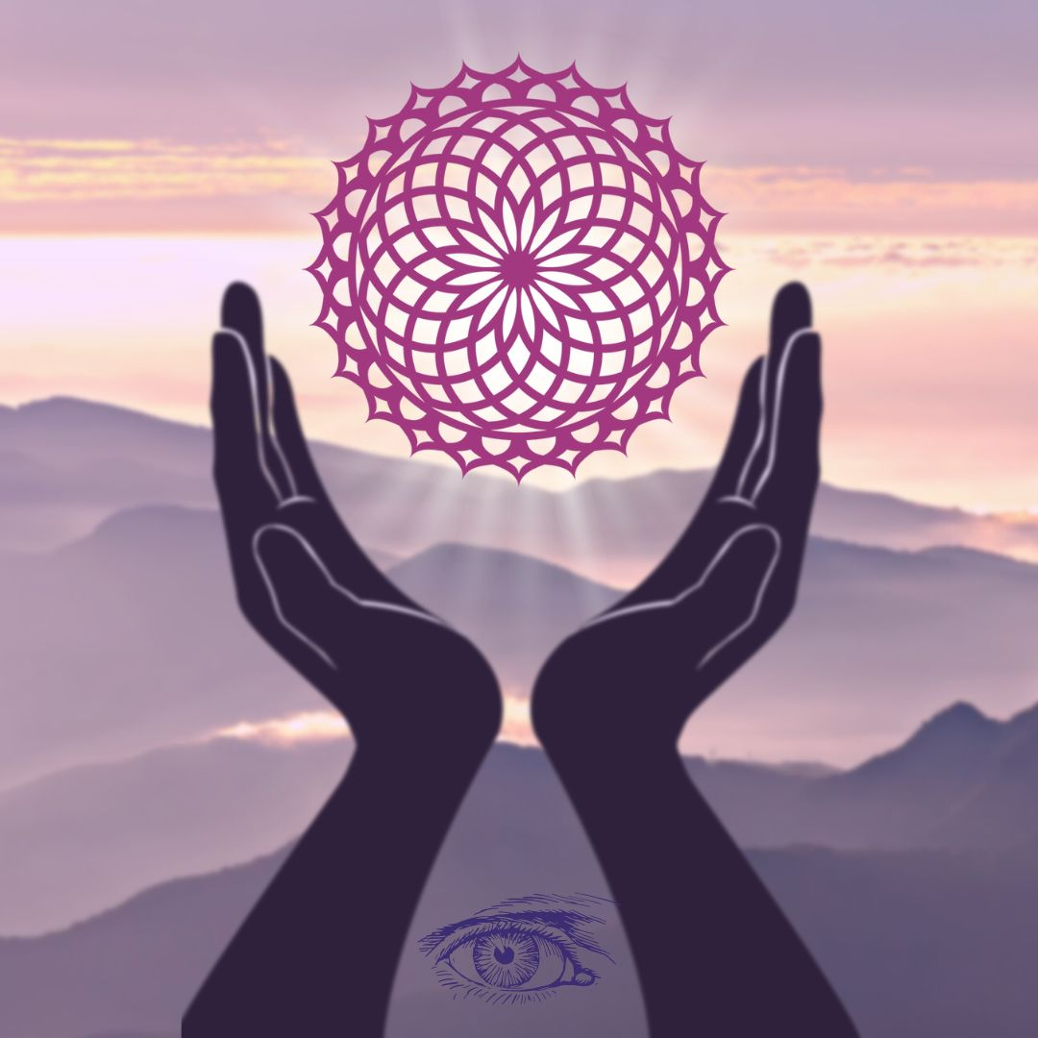
Step Six: Gratitude and Conscious Closing
Take a few moments to be grateful for your session. Jot down a few notes if you like. Visualize a protective bubble of white light around you and invite any negative energies to leave. See them moving out and away. Ask to be protected from any un-serving or harmful energies, so they will be deflected out of the bubble, and you will be surrounded in safety.
Close your session mindfully with a simple affirmation of thanks. Use your own words, such as: “Thank you for lifting a burden of XXX fear, anger, hatred, grief.” Or “Thank you for showing me this scene to help me understand who I am, and to love myself.” Offer gratitude to the universal oneness for your life now. Be thankful for your ability to heal, to change, and to evolve. Take a few deep, easy breaths, and close your session.
After your healing, give yourself a break for 10 to 20 minutes before you jump back into daily responsibilities. You have been transformed, and you must respect this. Have a cup of tea. Take a brief walk in Nature. Notice any subtle changes in yourself. You might feel lighter and happier. After removing trauma, big changes can often be felt immediately. However, in me, the most positive changes happened gradually over a period of weeks and months. Be patient and always keep going.
After your session, I suggest you wait at least a week before you do another. Do not underestimate the power of your healing. Do not try to do another trauma clearing immediately. This time-out allows your body-mind-spirit to adjust to subtle changes, so that your next healing can be even deeper and more successful. View each session as a practice, that goes deeper.
Sometimes working on past life trauma can raise uncomfortable feelings. You may feel a bit disoriented living in a totally new perspective. You may feel unnerved and want to question what’s happening. Perhaps it was distressing to see “yourself” in another life suffering painful injury or death. This is a normal response to surprising events. Just let it go. Have patience with yourself. Don’t dwell on the discomfort. Just relax, release, be grateful, and move on. Isn’t that the whole point of the healing anyway?
While it is important to know generally what happened and to clear the specific emotion, it is not necessary for you fully comprehend it with your linear, logical mind. It is not helpful to be overly drawn emotionally into the scene. View it with compassion. Be like a Buddhist - understand that impermanence is the nature of life. Release it. Take a few deep breaths, have a cup of tea, and let it go. Leave it behind. After all it’s not part of your life now. If you find you need more support to complete your healing and release the past, feel free to contact me by email to request an online session.

Note to Professional Healers
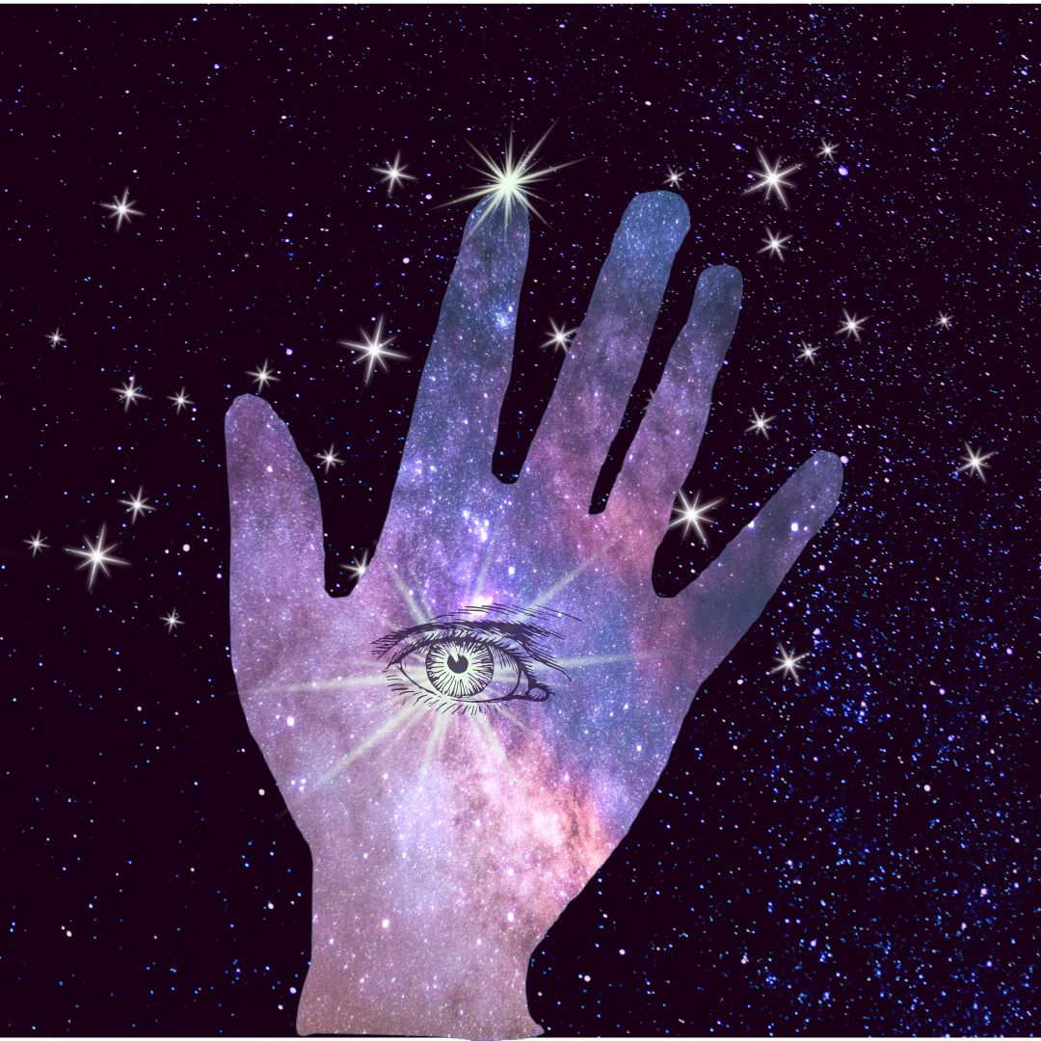
If you are an experienced healer and have been trained in other energy modalities, you can merge your skills seamlessly into this technique. If you practice a therapy such as Craniosacral, EFT, BodyTalk, Body Code, Emotion Code, Chiropractic, NAET, Polarity Therapy, Hypnotherapy, Somatic Bodywork, Accunect, or Spiritual healing, you already have a foundation of practical knowledge and experience to help you heal past lives.
There are many other fine techniques you can use to ask questions and receive answers through kinesiology, such as hand or arm muscle testing, finger pulling, pendulum, rods, etc. I chose body dowsing because it is the simplest applied kinesiology tool to explain in a book.
Likewise, there are also many ways to access the deep meridians to invite a lasting shift. I used tapping on the three “brains” at the top of head, heart, and belly, points from Chinese medicine, because it is the easiest way I knew to explain in a book.
Some healers have difficulty doing self-healing, because they are so used to working on others. If this is your case, to heal yourself, just visualize yourself as a hologram. Imagine your hologram person in the air or lying on your healing table. Then work on the hologram person. The effect is the same. For deeper refinement and details in any of these techniques, feel free to contact me about advanced healing workshops. As always, I invite your suggestions and observations. Thank you.
Final Suggestions:
- You can do this! Have courage. Take the first step.
If you think you can’t do this, you’re wrong. Imagine my fear on the first session. Take your time with patience and self-compassion.
- Trust that you have ALL the tools you need. Keep going!
If your life is hanging by a thread, maybe you WILL find the courage to look deeply into your own past and find your highest destiny. Trust your life process.
- Use whatever tools you already know to do your healing now.
If you know Reiki, use that. If you know anatomy, use it. If you’ve studied computers, use it. If you trust your religion, use it! We are all 100% ready to jump into self-healing.
- INTEGRITY. Your #1 intention is to heal your trauma. NOT to explore the past.
Your pure, sacred intention to HEAL will protect and guide you. Stay in highest integrity.
This is a warning: Do NOT use these tools for any other purpose. Do NOT do a session on another person without their conscious awareness and full permission. Not only will you ultimately fail, but you will suffer greatly. The universe has rules we must follow.
- Ask to dissolve the worst traumas first. Start with the top priority to heal.
What will heal your life most? If you don’t know – just ASK. Our most traumatic lives are the ones begging to be healed first, because they had long-term suffering or violent deaths. In my healings I ask to remove or dissolve the highest priority trauma for well-being. The most effective way is to focus on the deepest trauma first. Ask to dissolve the trauma that left the most negative subconscious memories affecting your life now.
- Do not compare yourself to any other person.
Your unique blueprint IS your highest integrity. Do NOT hope for a certain answer. Remove all other wants or wishes except to know the truth and heal yourself completely.
- Look for patterns that give you hints to understand yourself now.
After you finish several healings, notice what those lifetimes have in common. What overarching patterns do you see reflected in your current life? For example, my past lives showed frequent themes of betrayal in groups, persecution by authorities, superhuman perseverance, religious disputes, and digestive weakness. It is not surprising that these themes also show up in my present lifetime. This technique helps you remove the “Achilles Heel”, the weakest points within your very being, to reduce your burden of emotional “stress” that you carry every day. Healing these tendencies is humbling and beneficial work, definitely worth the effort.
Remember, if you need assistance or support, I’m as close as your email, or phone. Best wishes for global healing for us all! Sri Jana

Resources for Further Study:

Past Life Clearings with Sri Jana
Sri Jana offers individual past life clearings in person and remotely. This is also an excellent way to observe first-hand how the technique is done and to develop your own self-healing skills.
To schedule a session, contact Sri Jana on her website FiveSeasonsMedicine.com.

Advanced Trainings with Sri Jana
How to Heal Your Own Past Life Trauma, 3 Continuing Web Seminars,
- Level One – Step by Step Instructions, How to go into trance, Formulate accurate questions, Focus the healer’s mind, Identify emotions, Vitalize meridians to clear trauma.
- Level Two – Psychic safety, Practice on subjects, Overcoming common pitfalls.
- Level Three – Review, Emotional anatomy, Sexual clearings, Courage to change.

For Professional Healers, How to Heal Past Life Trauma FiveSeasonsMedicine.com
An intensive advanced 7-day workshop for practitioners with Sri Jana in Bali, Indonesia. Contents includes all materials in above courses, plus a detailed journal of clearing links, hands-on practice, and personal Q&A with Sri Jana. Daily classes allow time to relax, go out, and enjoy the beauty of Bali and beaches. You’ll leave physically and mentally refreshed with a deeper grasp of past life concepts and a new arsenal of techniques.

IBA International BodyTalk Association - bodytalksystem.com,
The BodyTalk System provides a complete training system to heal. It gives insights to the areas of the body that need attention, and in what order best to unravel any issue. BodyTalk respects the body's own needs and determines your body's priorities for healing. Using non-invasive techniques and tapping, it refocuses your body's natural healing response to establish better communication within the body. BodyTalk looks at the whole-person, emotional, physical and environmental influences to reveal the true underlying causes of dis-ease. Start with Modules 1 and 2, called BodyTalk Fundamentals.

The Body Code, the Emotion Code, Dr. Bradley Nelson, https://www.drbradleynelson.com, In Renowned holistic physician Dr. Nelson skillfully trains practitioners how to use muscle testing and meridians activation to remove the charge from past emotional events that inhabit your body in the form of “trapped emotions”.

Accunect, https://drkaimi.com, https://accunect.com, A brilliant healing system developed by Dr. Don Ka’imi Pilipovich, to release emotions, beliefs, and physical symptoms using principles of Traditional Chinese Medicine practiced energetically.

Biodynamic Craniosacral Therapy (BCST), https://www.craniosacraltherapy.org
BCST is a healing art that works with the energies that create and maintain health in the human system. Not a manipulative therapy, it has its roots in osteopathy and has evolved to include influences from human development, pre and perinatal psychology, trauma resolution, and recent advances in neuroscience. BCST supports nervous system regulation and allows the resolution of conditions resulting from stress and trauma. Practitioners use an educated, gentle, non-invasive touch to engage with the expressions of craniosacral fluid expressing total health.
