Manuscript

See Your Past Lives
Six Steps to Dissolve Old Trauma for Lasting Happiness
By Sri Jana
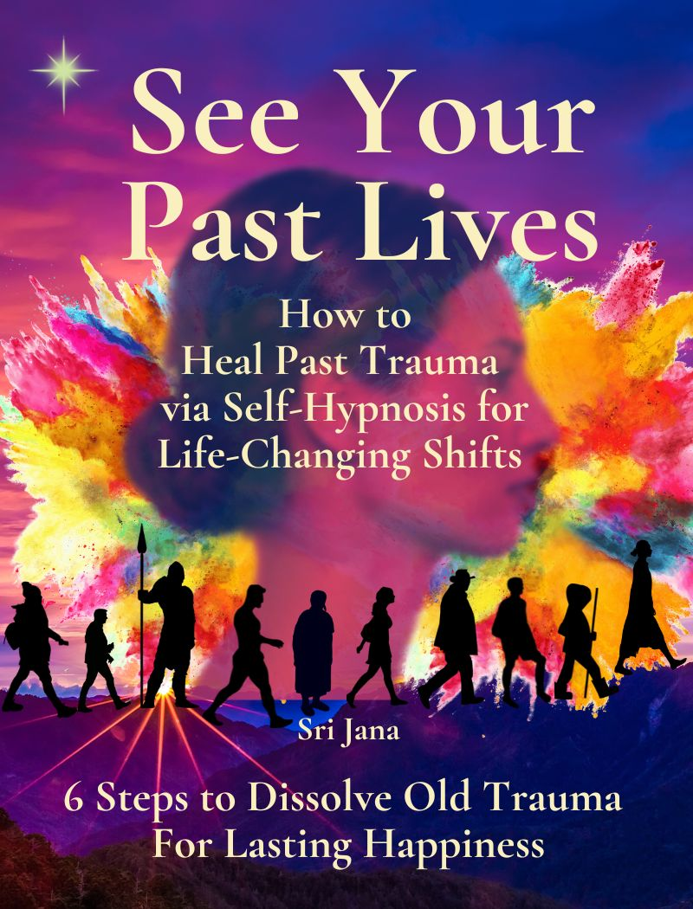

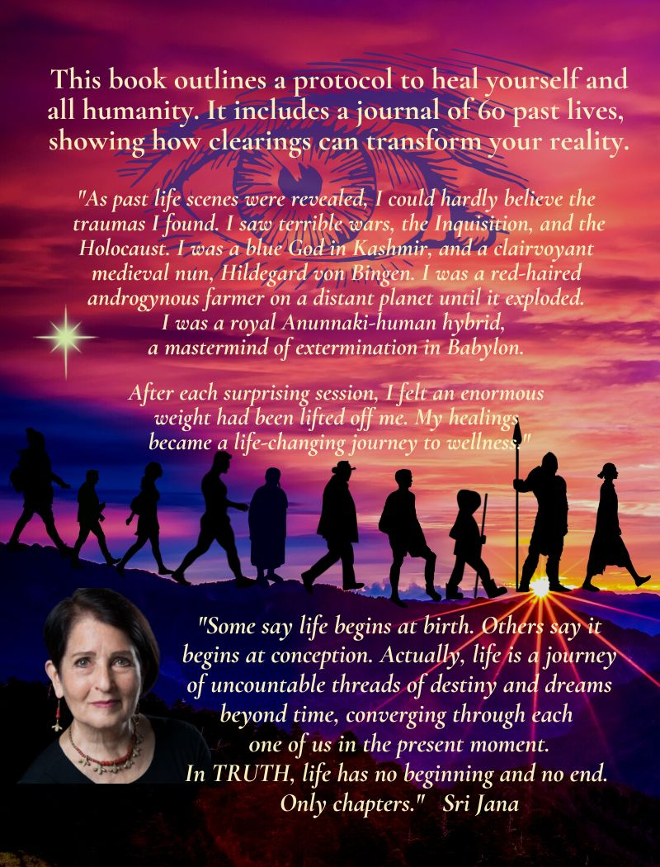

Book Contents

Part I. Introduction: My Story Page

- A Story Within a Story 4
- How Past Life Clearings Changed My Life 10
- Past Trauma Conditions Your Life 12

Part II. Foundational Concepts of Self-Inquiry
- What’s Self-Hypnosis? 15
- Brain Wave Frequencies are States of Consciousness 15
- Can You Track Your Brain States on a Single Day? 16
- You are More Powerful Than You Know 17
- Direct Your Intention, Expand Your Destiny 18
- Find Health and Wellness Through Self-Hypnosis 18
- Preparation for Work: Balance, Root, Calm 19

Part III. The Technique: Six Steps to Heal Your Past Lives 20

- Step One: Trance State, Set a Goal 20
- Step Two: Ask Questions. Body Dowse for Answers 21
- Step Three: Specific Questions. Describe the Lifetime 23
- Step Four: Determine the Specific Emotion to Heal 24
- Step Five: Dissolve the Trauma with Specific Tapping 26
- Step Six: Gratitude and Conscious Closing 26
- Note to Professional Healers 27

Part IV. Journal of My Past Life Healings 29
Chronological Timeline, Journal of Past Lives 21

A. Dissolving Layers of Sadness and Grief

- Viral Plague, a Lifetime of Despair 33
- Reptilians Mine Gold in Peru 36
- Barbarians Murder Gods in Kashmir 39
- Phaeem the Hermaphrodite, Planet Destroyed 42
- Humanoid Telepathy in Africa 44
- Tibetan Sound Healer Discovers Her Path 45
- French Opera Singer, Opioid Addiction 47
- Sexual Secrets in the Ashram 48
- A French Spy in the Jewish Resistance 49
- A Low Caste Life in the Ashram 48
- Starvation, Dakota Indian Woman and Tribe 51
- Suppression of Taoists in China 53
- Tibetan Bon Buddhism Threatened 55
- Monastery Takeover by Buddhists 56
- Genghis Khan’s General Left for Dead 58
- Buddhists Challenge Taoists in China 60
- Banished and Starving in Tibet 61
- Lover’s Quarrel and Death by Hot Oil 62

B. Improved Health, Food Intolerances Gone, I Begin to Feel Joy 64
- Betrayal in Tibetan Monastery 64
- Chinese Emperor’s Advisor Burned at the Stake 65
- Stigma of an Indian Bastard Child 67
- A Suffocating Life in Darjeeling 68
- Bandit Attack Leaves 110 Monks Dead 69
- Rejection as a Second Wife in Tibet 70
- Memory of Sexual Abuse at Two Years Old 72
- A Child’s View of the Holocaust 73
- Nicaraguan Woman with Brain Growth 74
- Paralysis and Tremor in France 76
- Three Bullets to the Head in Bordeaux 77
- Bone Marrow Cancer in China 78
- Zapotec Priest Killed in Aztec War 79
- French Army Officer, Musket Shot to Brain 81
- Dental Torture in Tibet 81
- Mary is Gone and I Miss Her 83

C. I Fall in Love, Move to Bhutan, and My Teaching Expands. 85
- Assault in Hong Kong 85
- Tibetan Oracle Murdered 86
- Sufi Priest Beaten to Death 88
- Death in the Arabian Dunes 89
- British Violence in India 90
- Cantonese Warrior Battles Mongols 92
- Mercury Poisoning in Medieval Belgium 94
- Chaos in Cantonese Imperial Court 96
- Balinese Child Bride Sold in Marriage 97
- Clan Leader Meets Thieves in Caucuses 98
- Buried Alive in the Inquisition 100
- Native American Acute Dissociative Stress 101
- Fear of Mother’s Insanity 102
- Self-hatred and Arrogance in China 104
- Phobia After Earthquake in Turkey 105
- Babylonian Strategist Conquers Aramaeans 106
- Stigma of a Bastard Half-God 110
- Monk Uprising in Burmese British War 110
- Jewel Thieves from Palermo 113
- Hildegard Von Bingen, Persecution, Perseverance, Poison 114

Conclusion 118
Appendix: Resources for Further Study 120

Part I. Introduction:
“Some say life begins at birth. Others say it begins at conception.
I say life is the journey of uncountable threads of destiny and dreams
beyond time, converging through each one of us in the present moment.
In truth, life has no beginning and no end, only chapters.”
Sri Jana
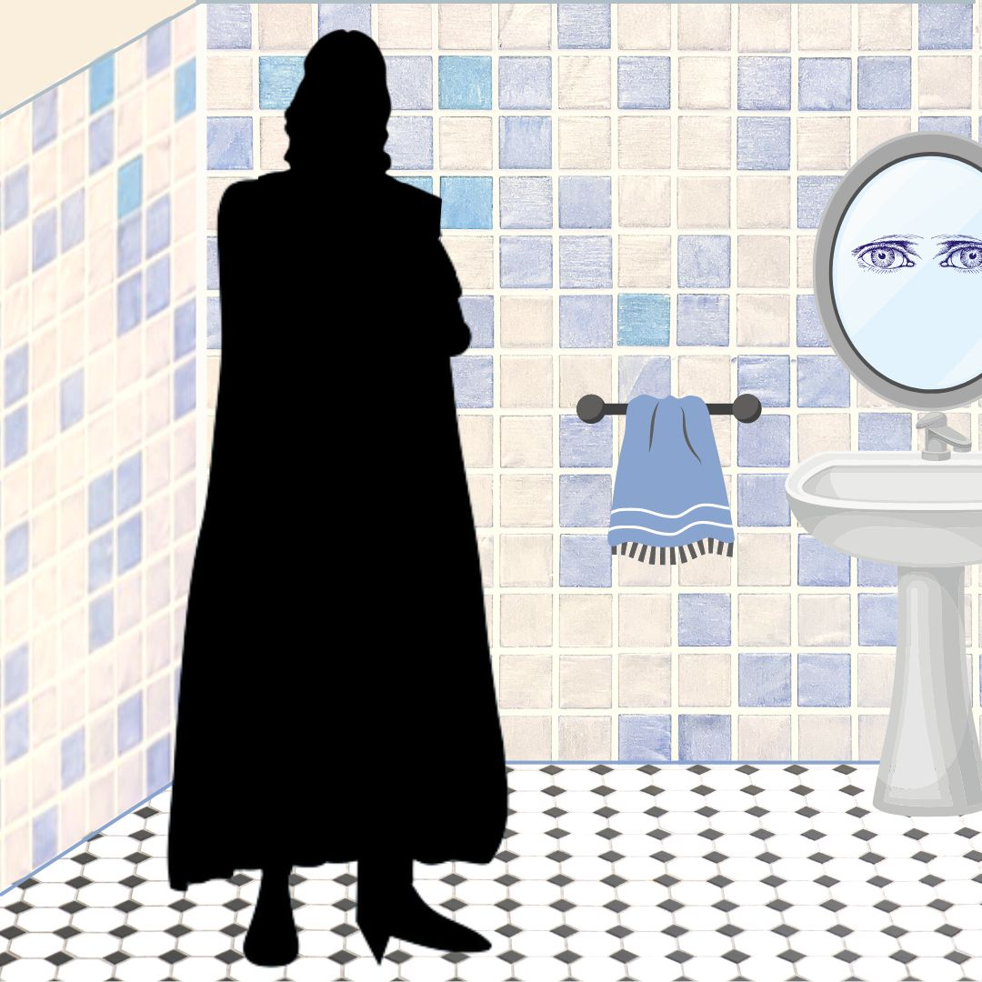
- A Story Within a Story

Storytelling is a time-honored way to show how things work together. Because, as you know, life is many-layered. A story might have exotic characters and colorful events that stimulate the imagination. A story can teach you what is good, and what is not good. Sometimes a story will ask a pointed question and leave you hanging without any answer at all. Today I will tell you a story within a story, a dual reality of how this journey came to be.
I could make up a story for you. I could weave a tale of adventure, love, sex, obstacles, victory, and all that. But that would be too easy. I’m not going to insult your intelligence or undervalue the significance of this moment we have together. I’d rather venture into my own unknown to embolden you to step into your true self. So, instead I will tell you a story that is 100% true. This is my way, because then the universe has my back. The power of a true story can never fail to reach its mark. If it is meant for you, a true story is guaranteed to touch that mystery spot of wisdom inside you that recognizes it. And somehow, I don’t know how, it touches anyone who is meant to hear it. A true story is something so astonishing and unpredictable, it can ignite your next brilliant idea. Or light the spark to fire your true destiny.
If you are reading this page, then the story unfolding right now is meant for you. Although it is the true story of my life and my many lives, the story isn’t about me at all. These experiences are shared by everyone. We all feel the heartache, the pain, the excitement, the futility, the joy, and the power of the world we live in. We’re all in this together. This story is about healing the world.
I know many people are wondering - Can I really do this? I assure you that you can. Almost anyone can do this. There are just a few prerequisites:
- You must believe in a universal consciousness greater than yourself – call it by any name.
- You must be willing to clear your mind of emotions, limiting thoughts, and assumptions.
- You must be physically and mentally stable, balanced enough to focus and follow a technique with mental clarity.
- You must be willing to love and accept yourself completely, the good, the bad, and even those parts of yourself beyond your comprehension.
- You must have a deep wish to heal yourself and bring benefit to all sentient beings.
- You must have a soul.
This technique is not like channeling, in which you receive messages from another being. A better description for it is self-hypnosis along with kinesiology or body-dowsing. You first relax yourself completely, to enter into a deeper state of openness and clarity. Then you ask clear, specific questions, and listen. If you understand the principles of kinesiology or a pendulum, then you’ll get that this technique is about asking a series of yes-no questions. The answers come together to create a complete picture. Self-applied kinesiology may take a bit of practice, but don’t worry, over time you get better at it.
A real-life story is far more interesting than fiction. My story began several years ago when I was working as a medical intuitive in a clinic in Santa Fe, New Mexico. I was beset by déjà vu experiences and bizarre dreams. I suffered depression, panic attacks, food-chemical intolerances, and maladies that could best be described as “unexplainable”. A series of life-threatening diagnoses came through my life like shadows, including cancer, adrenal failure, chronic fatigue, shingles, and total digestive collapse. Every moment of the day felt like a series of agonizing tests. I continued my daily work as best I could. However I never imagined in my wildest dreams that all this hardship was a perfect storm leading me to a groundbreaking discovery.
I began doing regular self-healings and found that I have over 200 previous lifetimes, many of them traumatic. I discovered how to identify and dissolve old emotional impressions at the root of bad dreams, self-defeating habits, and emotional over-reactions. I persisted in weekly healings on myself, scribbling messy notes through my astonishment. As past scenes revealed themselves clearly under self-hypnosis, I could hardly believe the events that I found. I did not find many kings or queens, but instead far more surprising: real people.
My journey included many wars on earth and other planets. At my loftiest I was a Buddhist Lama in Tibet and the clairvoyant medieval nun, Hildegard von Bingen. At my worst, I was a Babylonian royal hybrid God-man, a cruel mastermind of war and extermination. With each healing session, trauma vanished, slowly health returned, and my intuition expanded. I found it easier to forgive everyone especially myself. Over time, my healings became a life-changing journey to wellness.
This book is for experienced healers and everybody else. My single goal is to help you heal your life right now. We don’t need to time travel, wander around in the past, or re-live painful experiences. We may not need to spend thousands on professional therapists. I don’t care one iota if I was once a King, a Queen, or a beggar. The technique that I will show you to heal trauma is simple and uncomplicated. Like Sherlock Holmes, we will pinpoint the emotional patterns from the past that are negatively affecting you now. All other issues are extraneous, unimportant, and can only distract or confuse. Our single goal is to discover and clear past emotional patterns that are affecting your present life, in order for you to move forward in health.
My mission in writing this book is not to entertain or seek notoriety, but to show that it is possible for almost anyone to heal themselves in body-mind-spirit within this lifetime. I’d like to demystify time-healing, to help others recall their own past lives in order to clear and empower their lives right now. Perhaps these stories can help us all come together, to unravel our shared mysteries, to find lasting solutions to our personal and global challenges.
How the Book Began
One evening I was in the bathroom when my primary guide appeared in front of me. He seems to show up when my mind is relatively quiet, like when I’m taking a pee or half-asleep. I recognized him, tall, imposing, stern, and loving. He told me in thoughts that he had a warning for me. There were no words exchanged. He instructed me in no uncertain terms to begin to do healings on myself. I understood immediately, and I shivered. I had been doing intuitive healings on clients for a long time, but I had never considered doing this work on myself. He instructed me to start immediately and to do one healing a week. Then he vanished. I heard his warning deeply and resolved to begin right away.
My first few sessions were effortless and revealing. I noticed I could relax and go into self-hypnosis quite easily. I would sit on the couch in my treatment room to calm my breath and body as I do before every session. I sank into a deeply relaxed state of self-hypnosis that remained clear and fully aware. I began with a fervent prayer and a wish for total healing of whatever was the highest priority to address on that day. I followed my standard treatment steps and kept a scribbly paper of notes. Surprisingly, in nearly every session, some kind of past life trauma came up as a top priority to heal. I was aware that past trauma can affect our current lives. I knew that we often attract situations similar to those from our distant past. My wish as a healer was only to find and dissolve any traumatic emotional memory that negatively affected my present life. But to encounter a series of gruesome events in every session was a shocking revelation.
The scenes that came in were beyond surprising. Although I was stunned, I did my best to simply observe without reacting. I began asking the simplest yes/no questions. At first a scene would come to me in very hazy images or concepts. As I asked more specific questions, soon the patterns became clearer, and I would receive a flood of memories. The lives that came in to heal were not so much royalty, but a wide variety of people living in different times and distant geographic areas, each one struggling with issues of destiny, family, fears, and upheaval. They showed up as male, female, sometimes children. I simply focused on identifying the emotional trauma and asking for it to be dissolved. In many lives I was an innocent victim. In several others I was a ruthless killer. I just kept going, determined to clear trauma whatever it was, including anger, grief, self-hatred and shame. When a particular life scene was clear enough to heal, I did the meridian tapping of three points you’ll find in the next pages, just as I do for any client, in order to invite a healing shift. While this process required some inner focus and concentration, I found it comforting to embrace all sides of the issues. I was able to forgive everyone involved, especially myself. At the end of each session I always felt a sense of wonder, accompanied by a sense of grateful relief and completion.
After each successive session, I felt lighter, freer, stronger, and more fully myself. Within three months I had completed twelve sessions. I knew beyond a shadow of doubt, I had found an important secret that I must share with others.
We are the Reflection of Human Destiny and Evolution
Like all living beings, humans are constantly changing in response to the environment. Viruses mutate, caterpillars pupate, and humans transform. We are each encoded with memories from other dimensions and other timelines. While this is difficult to comprehend, let alone express in words, I’ve come to understand that we each hold a record of the entire universe. Lifetime after lifetime we are born into a specific biological DNA blueprint, representing circumstances and possibilities we may make use of. We sometimes use the word FATE to describe a kind of almost fixed path, and DESTINY to have a larger meaning that includes transformation beyond your blueprint.
Life endures and evolves in response to the environment. Humanity’s fast-track healing now involves tuning into universal cycles deep within our subconscious memory to harmonize and balance ourselves to a new reality. We can ask: Is our chain of lifetimes strung together into an overarching existence for specific purposes, a particular destiny? Is it possible that we are meant to discover our destiny now? I don’t have the answers, but I’m pretty good at asking questions.
What is trauma? Trauma represents highly concentrated toxic energy, like a knot at the root of stress. Trauma represents a chemical-biological pattern that holds you back from achieving your highest destiny. Every trauma you carry divides and fragments your consciousness, as if a piece of your awareness is tied up in that memory. When you deal with the trauma and dissolve it your consciousness opens up. Your intuition awakens.
Trauma is a burden. Trauma creates holes in your auric field, that protective energy vortex around you called Wei Qi in Chinese medicine. Old traumatic memories may appear as wounds or knots in your light body. Each trauma is tethered to specific memories and often to a body part. This may manifest as a pain in your body. When you release the root of trauma, you dissolve that memory, and the physical knot disappears. You expand your inner awareness. And the pain is gone.
For example, a person who suffers panic attacks for no apparent reason, may carry an old pattern of fear, or activation of the autonomic nervous system (ANS), increasing the likelihood of a fight-flight-freeze reaction. Likewise a pattern of migraine headaches could even be linked to a past wound to the head in a medieval battle. It’s as if PTSD from the distant past seeps into our subsequent lives, bringing along physical and emotional distress.
When I first began doing self-healings, I never imagined that this process would change my entire reality. Looking back, it’s as if I managed to “upgrade” my physical health and open my awareness of each life experience. Past traumas dissolved, and my health challenges vanished. Soon I began - with effort - to reframe any difficulty as an opportunity, or a useful lesson, or a clearing of the slate. Old self-defeating habits began to fall away, and I could more easily accept my new inner reality. I began to trust the intrinsic wisdom of my chain of existences. It was as if a timeline that was once my indelible, unavoidable FATE, merged into a happier, fulfilling DESTINY that I could NEVER have dreamed, and defies explanation. I often wondered: “How can I possibly describe this to others?” I decided to try to document my sessions and my changing awareness, to empower readers to step into their own multi-dimensional game of evolution. It’s so much fun! And we have nothing to lose, everything to gain.
As you work on this technique, my most important advice for you is to LET IT GO. When you find yourself in a position to RELEASE the past, DO IT. By releasing your own traumatic experience, you are also releasing other parties to the event. If you can open to this precious opportunity in the moment to DROP THE WEIGHT, you will move faster and faster to claim your freedom. You will soon find you are no longer a powerless victim, but a human dynamo of light and intention capable of manifesting a new reality.
As you embark on this technique, it is very important for you to ground yourself in your deepest reality, the beautiful, positive multi-verse of light. You may find it helpful to shelter your daily life to be less affected by day-to-day disturbances and challenges. These can include worry about money, family dissonance, electro-magnetic frequencies, disagreements, opinions of others, poisons in food, water, and air. As your root system in this new reality grows stronger, you will become more resilient, even tolerant to static distractions. Just like the pot of gold at the end of the rainbow is guarded by a tricky leprechaun, you may need to overcome some very tantalizing distractions to claim your treasure.
What is your reward? Your greatest treasure is freedom, health, and peace of mind. Visualize what you want every day. See it, describe it and ask for it clearly. Let this practice fill your days, as we recreate the world together in the image of truth and goodness.

- How Past Life Clearings Changed My Life
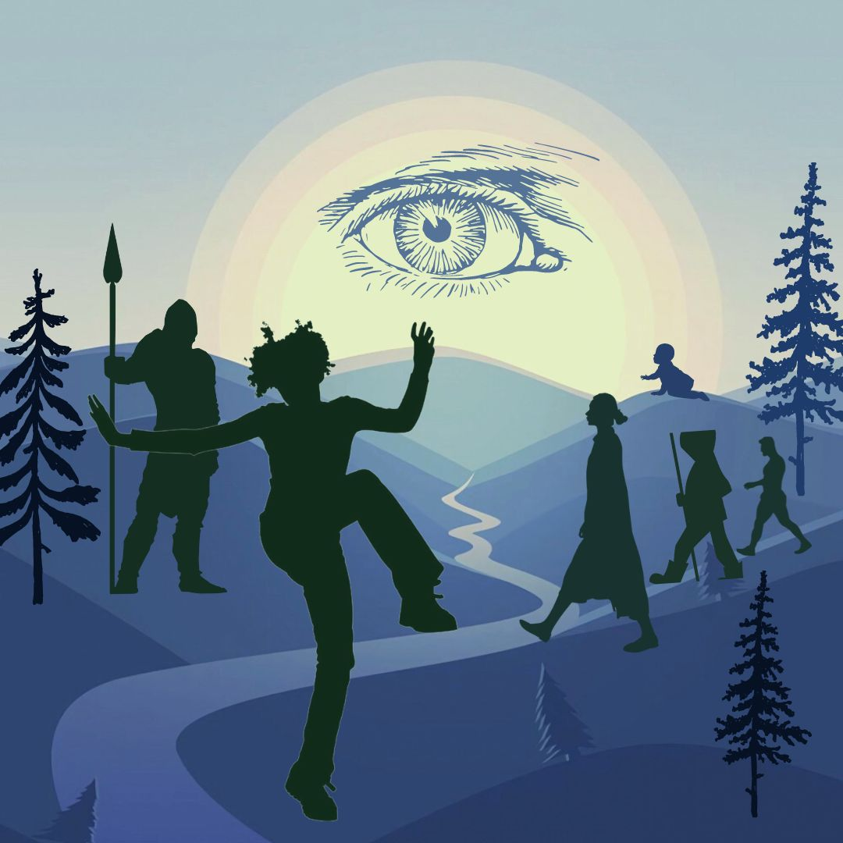
During a three-year period of weekly past life healings, the resulting outward changes in my life were nothing short of astonishing. My physical strength returned; my medical healing practice got busier. I felt less fear and more acceptance of the world around me. My usual negative reactions to people melted into patience and compassion. I began to savor each moment, able to view surprise as a pleasant gift, instead of an inconvenient discomfort. My mental clarity improved, and resilience to stress increased exponentially. My food intolerances vanished. My daily experience of life transformed and self-corrected in ways I could never have imagined.
The most significant emotional change was to eliminate fear. While fear can be based on rational self-protection in situations of danger, I was filled with utter terror most hours of every day, for no reason at all. Although I was smart enough to compensate and conceal my fear from everybody including myself, I felt panic at the simplest things. Getting on the London underground petrified me - it literally took me two weeks to gather the courage to go. Making a phone call to the utility company or going to the bank required extraordinary self-reassurance and mental determination. After having suffered severe food reactions for decades, just sitting down to a meal cooked by a friend was a cause for alarm. Walking through city air with exhaust fumes and cigarette smoke made me sick for days. This underlying emotional state of fear and wariness took a huge energy drain on my body and nervous system, so that I was exhausted by midday. As I performed these healings, slowly over time my fears melted. Soon I could look forward to the London underground, walk calmly down the street, and enjoy eating in a restaurant.
The second most important shift I experienced was more trust in my environment. I noticed that when I had a clear intention before an event, when I could visualize things as I might want them to happen, yet be willing to accept whatever took place, events would usually unfold in a very positive way around me. It was a feeling that the universe was hearing me, looking out for me, that I wasn’t isolated and alone. Someone had my back. Soon my days became filled with joyful serendipities. This was a huge change in my world outlook. Of course there were surprises, but even they didn’t shock me into terror like before.
This book represents the culmination of much research into my past and the clearing of many burdens. The themes of my different lives seemed to be connected somehow in a progression, as if I was destined to learn something in each life. This journey of healing many other lifetimes has utterly changed my present life. Now I feel more at ease, and less stress. My fear of death is reduced, and more seasoned with the understanding that life never ends, always gives you a second chance, an opportunity to grow and refine your best qualities. Now I can better enjoy each new moment without carrying a heavy weight or expecting the worst based on past fear experiences. This is a tremendous relief!
Positive change always starts on the inside. We may not see the benefit right away. Eventually it comes to the surface to manifest in physical reality. In a relatively brief time period, my life has utterly transformed from the inside out. You probably know the rest of the story. I overcame a mountain of fears, set an intention for a transformational journey, took a world healing tour to the Himalayas, met my future husband, Lama D, and moved to Bhutan. We later relocated to Bali, where we work in a beautiful, natural environment with balance and good health. Now I can offer healings and workshops online anywhere in the world. We hold health discussion group meetings in the community. This is a totally unexpected switch of destiny, which given my state of mind few years ago, would have been utterly impossible.
Transformation is a birthright for all of us. Imagine your destiny. Ask for what you truly want. Raise your frequency to claim your highest legacy, your unique contribution. By practicing this technique, you can achieve a total shift of your perspective in a short period of time.
The past life healing journal in this book is arranged by date, in the order the sessions took place. This allowed me to observe changes and health improvements over time. If you wish to see them in estimated date order, please refer to the Chronological Timeline.

- Past Trauma Conditions Your Life
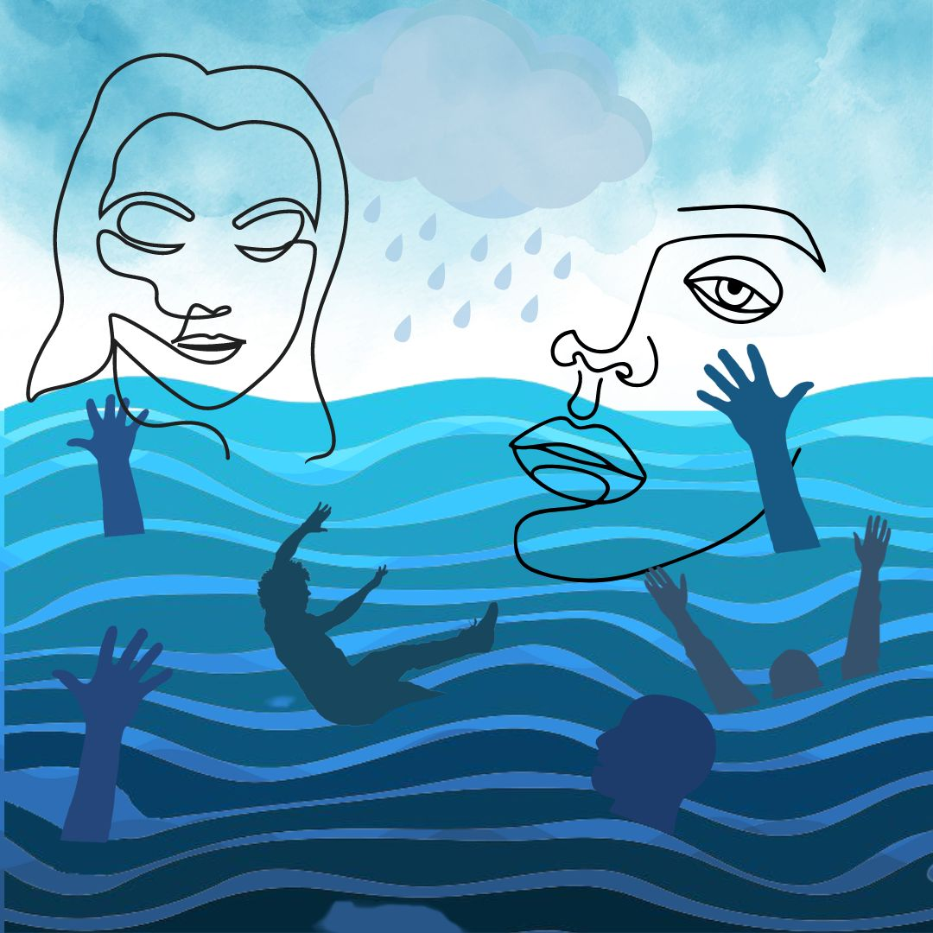
Do Past Lives Really Exist?
My journey began with a series of déjà vu experiences, dreams, and distinct feelings that I had lived through a similar moment long before. Meeting a person for the first time where I somehow remembered them - sometimes felt like a warning, sometimes infused me with an intimacy like falling in love. These are signals. I do not even know what actually gets passed from one life to the next. Some kind of essence of a person remains after death. Buddhists say it is the mind and the soul that continue infinitely after the body dies. Fortunately, I don’t have to answer these questions. I simply want to dissolve old trauma, and to be free and happy now.
Past Impressions and Memories Create Your Reality
Your body holds impressions, memories, and emotions from life experiences. These impressions influence your everyday reactions, emotions, and actions. One could even say that ALL of your responses to daily experiences are rooted somewhere in your past habits. Some of these memories are from your current life, and some may be from your more distant past. Your experiences are unique to you, so your reactions and your path to healing will be personal and individual.
We are conditioned by what we’ve been taught to believe in this society. Our conditioning and learning may help us, and it can also obstruct us. We are both guided and limited by our past, by what we expect to experience. By how we perceive and interpret our five senses of sight, sound, smell, taste, and touch. But life is far bigger than our five senses and our conditioning. We are deeply influenced by invisible forces within us and outside us. Most people go through life focusing on simply finding physical enjoyment and avoiding painful experiences. However, this approach of love vs. hate, desire vs. avoidance slowly isolates you in fear and steals your energy. It takes a toll year after year, until many people end up living a self-created illusion.
The Pope Made Past Lives Illegal in 545 CE
“You only live once”, we say in the West. But it wasn’t always true. Early Bible manuscripts and the Gnostic texts expressed a firm belief in rebirth. However, during the 6th century many church leaders were excommunicated by the Catholic Church for their belief in reincarnation. Roman theologian, Origen of Alexandria, in 250 CE wrote extensively about the pre-existence of the soul and reincarnation. He taught that the soul’s very source was God and that the soul traveled back to oneness with God after death, to be guided into a next incarnation. However, in 545 CE, Roman Emperor cemented the supreme power of the church at the Second Council of Constantinople, declaring that after death the soul ceases to exist. He demanded all church leaders sign the decree that anyone who asserts the “preexistence of souls” would be punished by death.
Emperor’s Justinian’s only obstacle was the powerful Pope Vigilius, who believed in rebirth and refused to sign the papal decree. The plot thickens here…it seems Justinian had Pope Vigilius arrested. He convinced the other ecumenical leaders in the Pope’s absence that the papal decree was authentic, so they all signed it, effectively forcing the Pope to swallow it against his will when he was miraculously released from jail. Shortly after the Council meetings ended, Pope Vigilius was killed, under suspicious circumstances.
Emperor Justinian knew that if common people understood they were forever children of God and part of God, and that the soul lives forever, they might no longer need an Emperor, pay taxes, fear death, or obey the Holy Roman Church. Soon people were required to be baptized in the church, or they could be forever “cut off from God and doomed to Hell.” It seems these changes did the trick, and now our modern belief that “You only live once” is fundamental to Western thought. I wonder – how does this belief impact our attitudes toward God and human destiny?
Many people experience constant stress and anxiety in their daily lives. Where do these difficulties spring from? Do they come from outside us? Or inside us? Or is it both? The worries that we carry from the distant past are often a repeating pattern, an unnecessary burden, a drain on our energy. All these concerns, hardships, and stress make a heavy burden to carry.
How can a memory from the distant past condition your experience right now? For example, some people fear rejection in groups, as a result of persecution or past punishment. Many people carry anger from one life to another, as if continually trying to fight their way out of an old emotional pattern. Some people have a fear of sex due to past shadows of fear and shame, that can negatively affect happy sexual relations in this life. Disease in this life can be influenced by having suffered it in the past, as if it gives a predisposition, or a tendency to suffer the same disease again. I discovered food intolerances, back pain, dental issues, indigestion, neck trauma, and shingles that all had roots in a previous life. A pattern of self-doubt or self-hatred may be related to an experience of failure many lifetimes ago. However once the negative charge of the trauma is dissolved, it can no longer imprison you.
Your life is always trying to heal you. An illness is often a message from your body’s wisdom. To get well, you need to listen. What is this issue trying to tell you? When you can face your difficulty straight-on with an open mind, then you are ready to heal. If you have the courage to live, if you can be brave enough to die, then you can summon the fearlessness to look at your past and clear it while you can. When you master this technique to dissolve past trauma, you will be able to enjoy life right now without the stress of carrying heavy burdens every moment. To dissolve old patterns of pain and fear will re-orient your life toward joy. It’s that simple.
Free Yourself from Past Life Trauma
To reclaim your happiness and gain control of your reactions, it all starts with your mind. Using this technique, you don’t have to travel back in time or re-live painful experiences. Instead, you can observe them from a safe distance and dissolve the pent-up emotional content that affects you now. The only requirement is that you must be willing to see and accept all of your emotions, even the difficult, uncomfortable ones.
A sixth sense is the birthright of every human being. Anyone can develop their intuitive abilities if they are willing to be quiet and see things simply as they are. Learning to trust intuition is like perfecting any other ability, it requires practice. It helps to be relatively free of distractions, mind chatter, and stress. Stress comes in different forms, such as physical toxins in food, air, water, or medicines. It can be from people, situations, or electrical fields. It can be our own internal stress such as mental confusion, addictions, habits, opinions, or emotions. Clear intuition will help you to discern what is important for you to know vs. what is not.
Now you can strip away the old barriers to your happiness. You can simply remove the heavy obstructions from your past lives one layer at a time, to be free in body, mind, and spirit.

- What’s Self-Hypnosis?
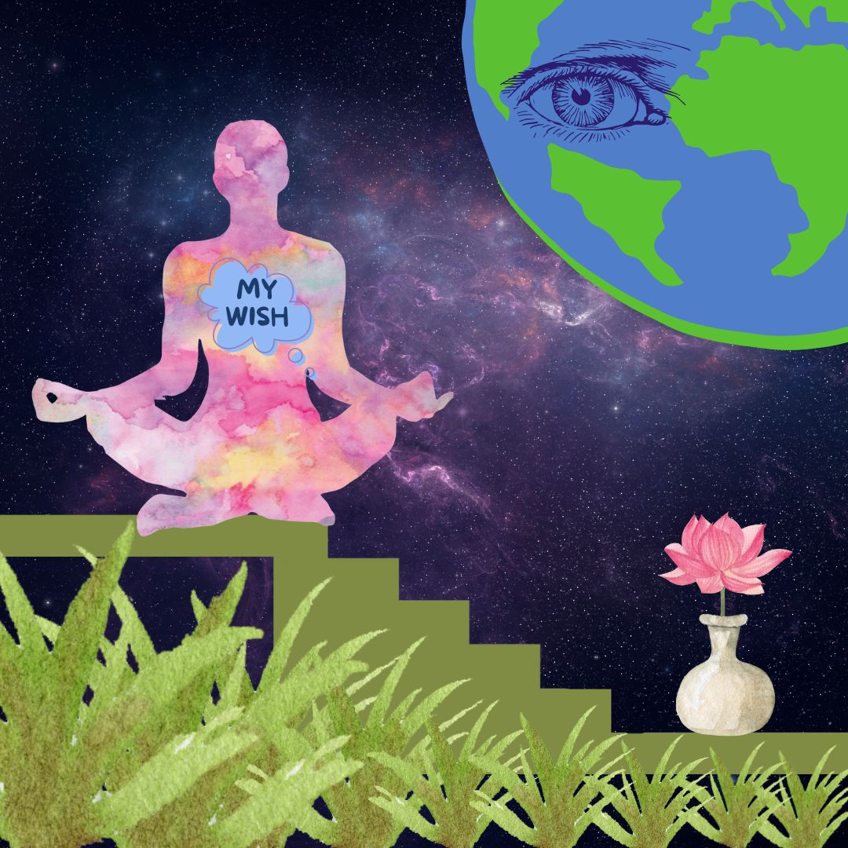
Back in 1774 a German Doctor Franz Mesmer proposed that health was a result of balanced frequencies in the body fluids, while illness was caused by a blockage in the “tides”. He theorized a magnetic energy that could be exchanged through the air between people, objects, and even planets with the capacity to heal. Does that sound familiar? His “mesmerism” sessions were held in incense-filled rooms, where patients sat in a trance circle, hands linked, receiving healing frequencies accompanied by a glass harmonica. Mesmer was blacklisted by the medical establishment as a charlatan for exploiting women with nothing more than the “art of suggestion”. But eventually his theories became widely accepted as “hypnotism”. Nowadays hypnosis is used to induce a relaxed state of mind or trance to heal negative habits like smoking. Likewise, meditation was once viewed as a mysterious Asian practice of Sanskrit mantras by an exotic guru. Now meditation is an accepted tool to calm the mind and reduce stress.
Self-hypnosis means you do it yourself. You are the practitioner. You consciously relax your own mind to access deeper parts of yourself in order to heal. We all naturally experience varying emotions, attitudes, and mental states every day. Simple self-observation will confirm that you constantly jump from one level of consciousness to another. We can learn to observe these states with calm clarity and control them to live in a state of joy. Then we can use this clarity to quiet the mind through gentle breathing to harness profoundly powerful parts of ourselves.
Many people go through their lives with no concept of how to relax. As a result their experience becomes a tangled mess of undigested events that build up like silt in the body, mind, spirit. Just like a river can be dredged of silt to allow the water to flow easily, we all need to release our mindset and let go of body patterns occasionally. This means we drop anything we don’t need and allow ourselves to be redirected. What is YOUR favorite way to empty your mind and recharge yourself?
In the following section on self-hypnosis, you will learn step-by-step techniques to relax yourself into a state of trust and openness, yet with precise clarity at the same time. You are a multi-dimensional being, with capacity for a vast expanse of awareness. And simultaneously you can drill down to a single point of utter precision. The key is to use your breath to relax into a deeper and deeper state of quiet. I suggest you study this technique and master it, because it will serve you in every phase of your life. Take your time to refine and develop this skill. The deeper you relax, the more expansive your field of vision to know the truth.
Once you are in a state of deep relaxed self-hypnosis, then you can ask questions through body kinesiology. And somehow, you will know the answers. I call this body dowsing, which is using your body like a pendulum to answer yes-no questions. But I’m getting ahead of myself. First I want to talk with you about brain waves and levels of awareness.

- Brain Waves are States of Consciousness.
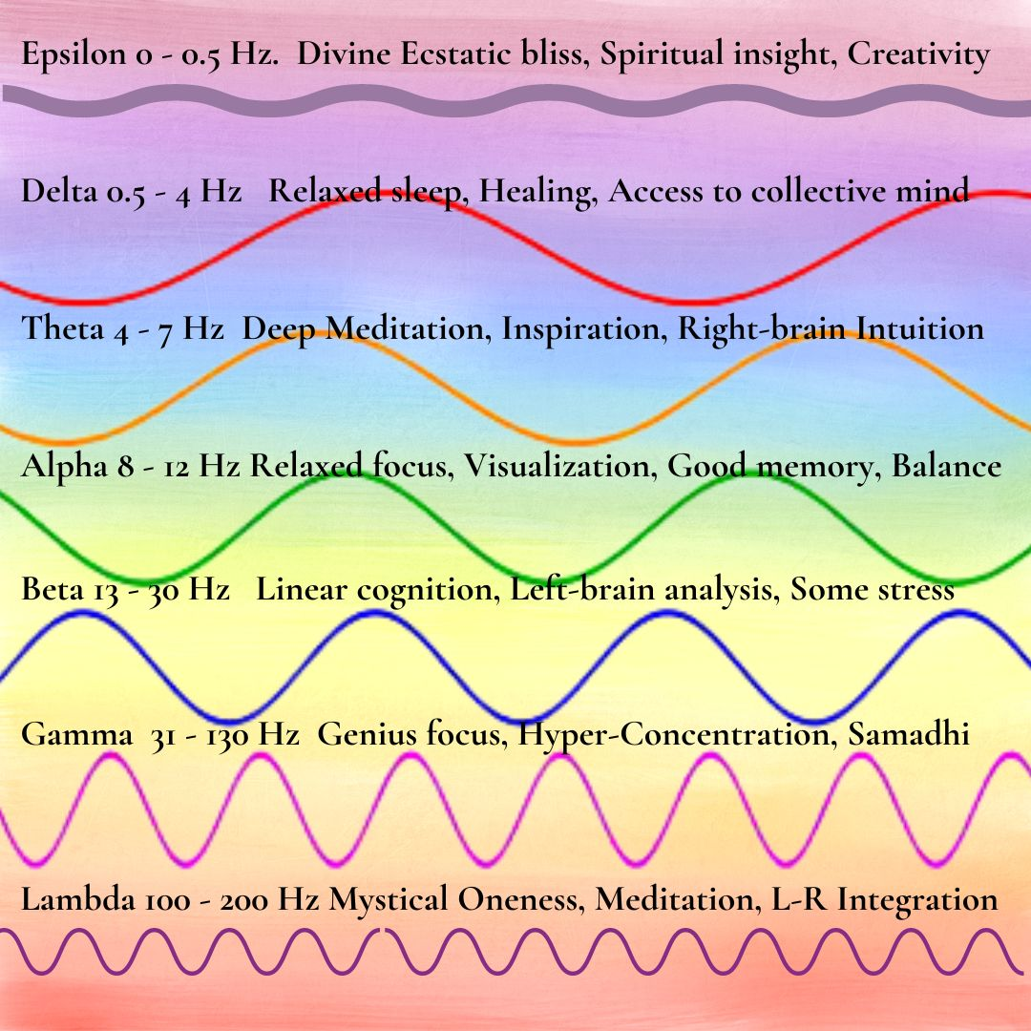
Brain waves are one indication of your level of awareness, health, and happiness. Brainwaves can be tracked by EEG, which measures electrical activity in the brain using small, metal discs (electrodes) attached to the scalp. Brainwaves can also be remotely detected via satellite or computer networks. It’s one thing to get an electroencephalogram EEG test to observe brainwaves. However, very few scientists have any idea how to interpret them correctly. Even AI computers have difficulty trying to accurately categorize our erratic electrical brain patterns into recognizable thoughts or levels of awareness.
Brain frequencies are associated with different states of consciousness, so they are very relevant in accessing higher states of awareness in self-hypnosis. However, your brainwaves are so unpredictable and diverse, they would defy the most skilled scientists to identify your thoughtforms or level of realization. Perhaps these categories are real and mutually distinguishable. Or maybe they exist as a continuum of frequencies. Personally, I’m not ready just yet to call this real “science”, as more analysis is needed. I discuss it only to invite you to consider brainwave frequencies as a bare starting point for you to observe and track your own mental-emotional gyrations.
What Are Common Brainwaves?
Gamma Waves (38 To 42 Hz) are fast, subtle, high-frequency brain waves. In experienced meditators, Gamma waves are said to be often present all the time, indicating a relaxed state of expanded awareness. They indicate complex integration of both hemispheres and various brain centers when you are very quiet. Gamma waves are defined as short duration, like a burst of genius, such as when you find a brilliant solution to a problem but don’t know quite where it came from. Even higher brainwave frequencies exist above 40 Hz, which are sometimes called “Hyper-Gamma” states.
Beta Waves (12 To 38 Hz) occur in a normal waking state of faster brain activity such as when your attention is focused on everyday talking and linear cognitive tasks. You might be listening to a lecture on body anatomy or designing a website. The Beta state gives you focused mental activity, problem-solving ability, judgment, and decision-making.
Alpha Waves (9 To 14 Hz) are associated with quietly flowing thoughts, when we are fully present in the moment and the brain is calm. You could be relaxing on a beach drinking a cup of Kombucha, listening to gentle music. Alpha waves are characterized by relaxed focus, ease, good memory, alertness, mind-body balance, and some types of meditation.
Theta Waves (4 To 8 Hz) happen during sleep, deep meditation, and hypnosis. In this state the senses are somewhat withdrawn from the external world, and you are more focused on inner signals. Theta is said to be our doorway to learning, memory, and intuition. Theta is the twilight intermediate state that you might feel when drifting off to sleep, waking up, or in hypnosis.
Delta waves (.5 to 3 Hz) are very slow and deeply penetrating, found in deepest meditation and profound dreamless sleep. Delta waves are essential for healing, cell regeneration, and access to the collective awareness.
Two Extraordinary Brain Frequencies! Lambda and Epsilon have recently been discovered: Scientists identified two more exceptional brainwave frequencies at the extremes of the spectrum: Extremely high frequency brainwaves of 200 Hz are called Lambda, associated with wholeness, integration, and mystical out-of-body experiences. These super-high frequency brainwaves seem to ride on a very low frequency wave of less than 0.5 Hz called Epsilon. Scientists observe that the high frequency Lambda waves occur simultaneously with very low Epsilon waves.

Significantly, researchers also notice that whenever extraordinary meditation states are present, electrical activity between right and left hemispheres of the brain tends to synchronize and balance. Balanced hemispheres usually indicate special heightened awareness, inspiration, and total-body wellness.
It seems highly relevant that different groups of EEG researchers, independently found the same two states of consciousness of widely divergent parallel brainwave activity. They also observed a reciprocal link between these two extreme frequencies and states of consciousness of the highest levels of meditation, deepest insight, original creative problem-solving, balanced brain hemispheres, and high degrees of self-awareness.
Lambda waves are triangular, sharp waves occurring over the forehead with eyes open. Lambda waves occur with abrupt, jerky eye scans, but disappear when eyes are closed and in sleep. Lambda is best elicited when we scan a complex picture visually in bright light. You might think Lambda waves would make you feel wired and hyper, but in fact, the effects of Lambda feel more like slow, deep healing Epsilon waves. More study is needed.
- Can You Track Your Brain Waves on a Single Day?
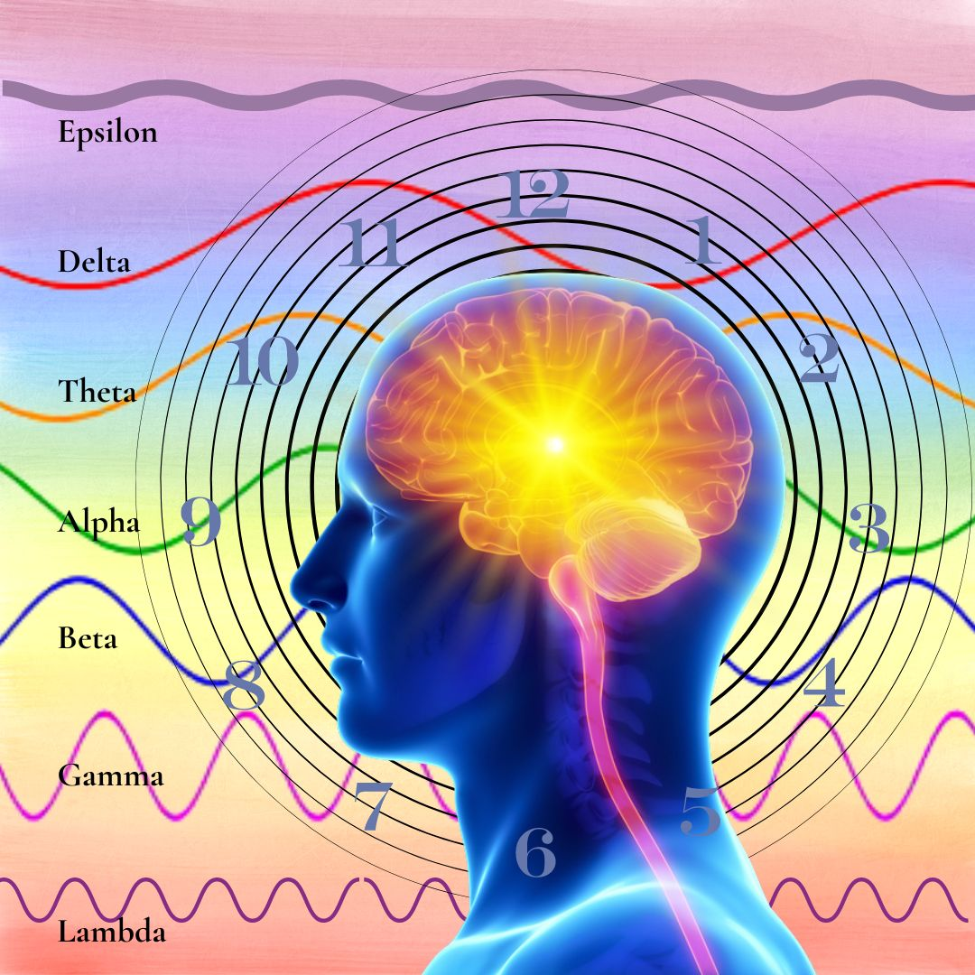
Brainwaves are a fascinating journey. However, it doesn’t end there. We are so much more. As a multidimensional being, we also ride a roller-coaster of emotional highs and lows. We remember past traumas, triggered by seemingly innocuous events. We are aware of other times and realities that somehow penetrate this realm. On a given day, how many times do you drift up, down, and around through uncharted dimensions and states? Just for fun, shall we track a hypothetical day?
In the early morning hours, you’re sleeping soundly in the Delta state. As you awaken slowly, you drift up through Theta, in which you feel subtle intuitions about the day. Your morning meditation is filled with light, bringing you a few precious minutes of heightened awareness in the Lambda-Epsilon state. As you drive to work, you descend peacefully into a relaxed Alpha state, listening to music, as you breathe deeply and contemplate a few raindrops on the windshield. Soon the day is upon you, and you rush to your office computer, where you strategize, fully awake in the conscious Beta state. Suddenly, a brilliant insight in the highest Gamma state, a surprising genius discovery, completely changes the trajectory of your project. Immediately, you reorganize your staff schedule for the project, working carefully in a problem-solving Beta state.
At 10:30 am you walk out for a cup of tea and a snack, drifting briefly into relaxed Alpha. A female colleague says something that echoes your mother’s constant criticism of your creative thinking style compared to your obedient older brother. Irrational anger and frustration spring up from nowhere, and suddenly you’re in an agitated high Beta state with no way to cool down. You’d like to punch this woman in the face, but you use your best meditative skills and deep breathing to restrain a violent response and calm down to a strained Alpha. In this somewhat instable tranquility, you happen to watch a brief video about Bengal tigers snuggling with their owners, which finally puts you into a state of Theta harmony and oneness.
At lunch with a friend you hardly notice your soup and salad as you discuss your upcoming projects in full Beta awareness. A brief off-the-charts ecstatic moment of joy invades your senses as you inhale a piece of chocolate cherry cheesecake. Well, maybe this could be defined as a “High Gamma Spike” of bliss. I don’t know.
On the way home, you see a forlorn woman with a flat tire and three children at the side of the freeway. You successfully replace the tire, and she is so grateful to you, her adoring gaze shocks you into a déjà vu memory of your younger sister in a past life in Sicily, where you loved her beyond measure and would do anything in the world to help her. Never mind the frustrated motorists all around you, you’re deep in a daze of newfound love, feeling profoundly nourished by the meeting. You follow your usual route home in a semi-hypnotic trance, arriving without the foggiest idea of how you got there. Dinner prep and discussion is a busy Beta cognitive time with family talking about the day. After dinner you watch a movie in a quiet, Alpha state, still pensive about your surprising encounter. But a funny and skillfully hypnotic TV ad for cookies, tempts you to open a bag of chocolate Oreos and eat them all without noticing. Gradually you get sleepier, drifting down from Alpha, through relaxed Theta, and finally into deepest restful Delta sleep. How many altered states did you experience in a single day?

- You are More Powerful Than You Know
We can observe our brain waves and states of consciousness constantly shifting up, down, and around the cosmos every day. We are almost totally unaware of these changes, because we may be tuning in to outside stimuli, and reacting to them. But what if you could use your mind to observe and direct your states of consciousness in the moment? You would possess the key to untangle every obstacle in your life! By using your mind to relax deeply, you could observe things without emotional attachment, find the secrets to your health, and dissolve all the old trauma held in the body-mind. You could remove the negative effects of stress, handle traumatic events, prevent overwhelm, to feel safe and secure every moment. With this self-hypnosis technique, old traumatic memories are stripped of their emotional intensity and dissolved, leaving you healthy, free of the past, and able to gain self-mastery right now. This is the essence and power of self-hypnosis.
As a unique, multi-dimensional being, you're constantly tuning in to multiple frequencies. You naturally sense different dimensions as you eat, sleep, learn, digest, process, and express yourself into the collective. Some say there are 12 levels of density in the known cosmos. Others say there are 15 or more densities, plus infinite parallel realities. Some densities are said to be physical, some non-physical, some just light and sound. Perhaps your density is your layer of reality in this particular life, and a shift happens if we move from one density to the next. As we navigate the various levels and permutations of spirit, we can only ask: Are the dimensions really numbered? Or is this also a continuum that invites us to find our highest integrity each moment in synchronicity with universal Oneness and our personal evolution?
You are powerful. So, what do you want? Just ask for it. Use your heart and mind to manifest a new world. Your heartfelt passion is like the “juice”, a kind of fuel to manifest your thoughts in the physical realm. Creative children do this every day in their imaginations. All successful people share this manifestation skill. However, very few people ever get beyond selfish goals of money and power. The ability to manifest with the mind gives you even more power. And it is even more potent to merge the power of the mind with the heart. Here we are learning the skill to manifest from the heart for all sentient beings in the universe.
In healing past trauma, we often deal with transmuting fear. Fear is a misunderstanding of a person’s own worth and security. Fear, blame, and resentment are a terrible waste of our valuable energy. Fear drains our lives both spiritually and materially. Fear destroys everything in its path; it can never create anything.
As a healer, your role is to recognize fear and transmute it with loving intent. You will need to have a clear conscious process of generating that intent. For example, we might create a completely new concept called “dissolving fear to heal past trauma in the multi-verse”. Once it is defined, this idea has power, because it is full of intention. As a learned skill, this concept has the power to invoke and to literally bring another reality into existence. I hope this nugget of an idea can help you to refine your own power, to know yourself, and transform the quality of all life.
- Direct Your Intention, Expand Your Destiny
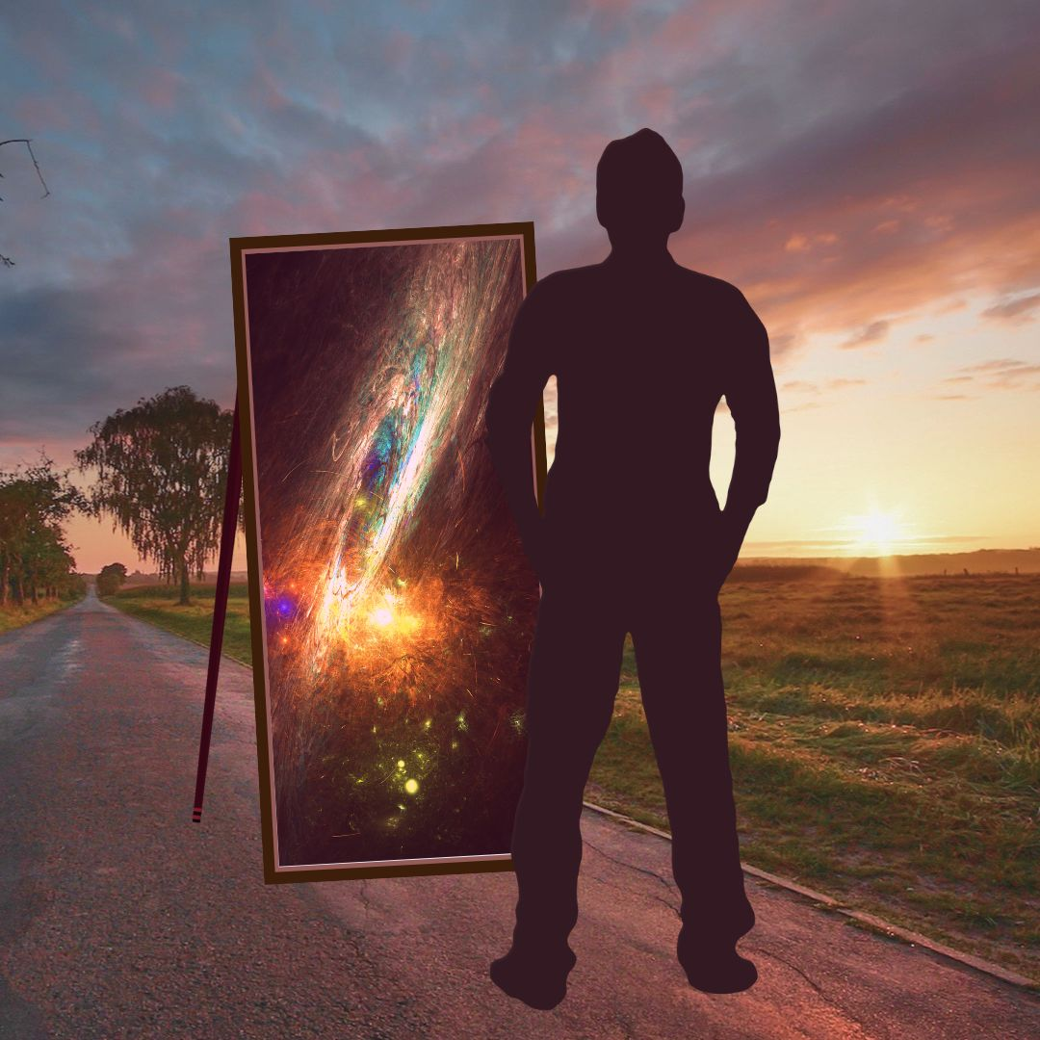
Intention is the primal force of creation. We are taught that the universe is made of spinning electrons, protons, and neutrons, which somehow manifest into molecules and matter. But excuse me, how can matter can manifest matter? Did science forget somewhere along the line to include the intention of the Supreme Almighty Spirit? Maybe it is the Will of God that creates all physical matter and all dimensions. And perhaps this is what makes it possible for you to explore your own personal path to complete your destiny.
When you look in the mirror what do you see? Maybe your body electrons, atoms, and molecules are just the spinning intentions of God creating a miracle of cells and flesh. That makes you, me, and everyone a timeless spinning network of intentions or desires.
We go through life asking for a miracle, when in fact we ARE exactly that. From beginning to end, physical matter is an intelligent grid of intentions. The Supreme Spirit then adds a touch of consciousness into molecular matter, and the result is LIFE. Yet what we see and feel is just a tiny fraction of our whole being. What we see in the mirror is the outer expression of an inner event. Our form is created from Spirit, and the body is a collection of intentions, coming together to build and sustain our human life.
Imagine the power you will have when you are able to balance your mental states and direct your own intentions in harmony with that power of the universe. Consider this as a way to navigate the myriad experiences of daily life. When you learn to observe and control your thoughts, your experiences will unfold in harmony. Instead of reacting to internal or external events, you will be your own driver, better able to maintain a constant, balanced state of health and well-being.
One of the big secrets to integrating ALL your power is to learn to RELAX. Study your reactions. Use your power of intent. Take responsibility for your conscious intentions. When you encounter something you’re not happy with, make an intention to change that situation. This creates a sphere of conscious positive energy which is already spinning all over the world. Ask for what you need. Then the tools, people, opportunities, and knowledge will come to you and to all of us. Trust that.

- Find Health and Wellness Through Self-Hypnosis
In self-hypnosis, like meditation, you set aside a quiet time to invite yourself to deeply relax, where you will not be distracted by the usual stimuli. The step-by-step instructions in the next chapter will show you how to practice self-hypnosis. I like to begin with slow breathing to move gradually from wakeful Beta alertness into a more tranquil Alpha state. Then I relax into Theta in which I begin to feel tranquil yet totally aware and not sleepy. It’s not important to identify the states, just keep relaxing deeper and deeper with each breath.
If you’re an experienced meditator, then self-hypnosis will very likely be much easier for you. But there are so many meditation techniques and misconceptions, I prefer to avoid the term altogether. Some techniques use deep stillness, others use specific thought forms, while others are visualizations, chants, or mantras. If you’re new to meditation, maybe you’re lucky, as you won’t have to battle old preconceptions. Just observe yourself mindfully to find moments in which you become truly tranquil, open, and joyful in your body and mind. Then gently extend the length of their duration to several minutes or even hours as you go through your day.
Many of our most challenging experiences are directly connected to traumatic memories somehow held in the body tissues. Without the ability to consciously relax, your body remains stuck in tension and hypervigilance, so that safety, calm, and intimacy are never available. Factual knowledge and medical training are of limited value in healing you fully, until you first develop the skill of embodied relaxation. When you can relax yourself deeply, without depending on external events like music, food, alcohol, or your mother, you will feel grounded and safe. You can trust the present moment. You can feel connection and joy. This is the benefit of self-hypnosis. You can have full access to your inner power.
As you practice self-hypnosis, notice your mind will become more tranquil. Observe the brain moving to a deeper state in which you can more easily access information about the distant past. Your body-mind is more suggestible. This receptive state will allow you to ask questions and accept changes, so that old patterns can come up and be dissolved. Get ready to take simple notes with paper and pen, because when you come out of this state you may not remember every detail.

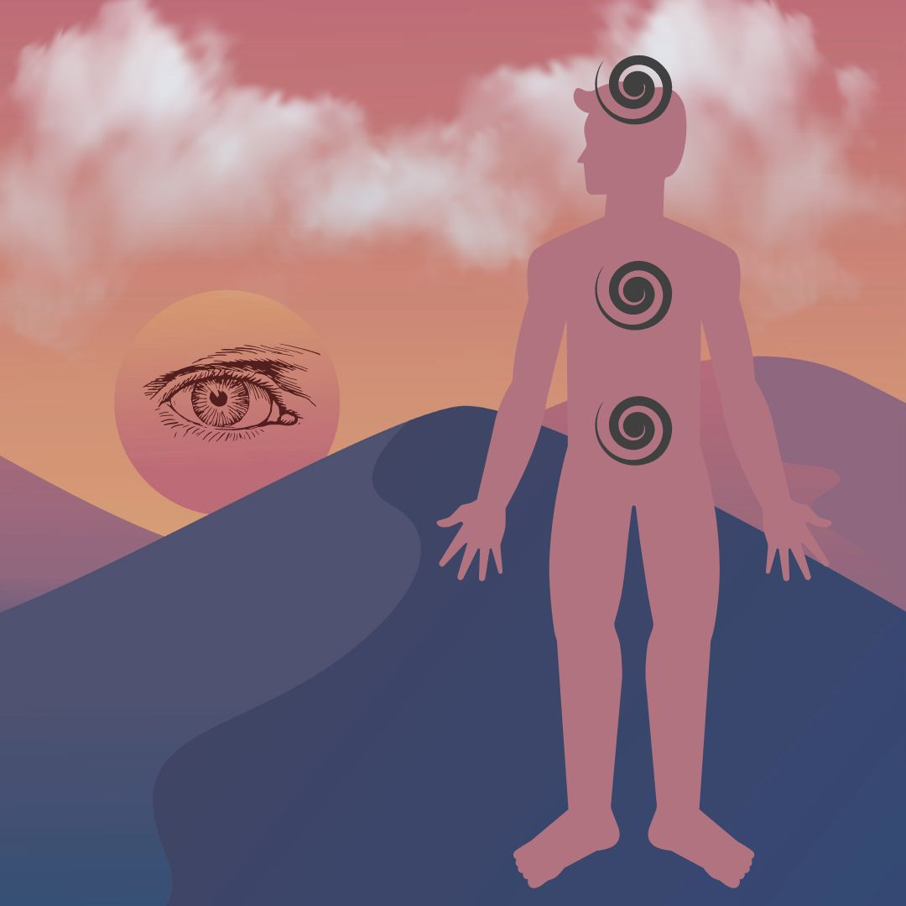
- Preparation for Work: Balance, Root, Calm

Before you begin your healing session, prepare yourself with these simple steps. Preparation is especially important when you are working on yourself. You can begin to set the stage a few days ahead of time by balancing your lifestyle habits. Eat a simple diet of mostly unprocessed vegetables. Walk in nature to attune and balance your meridians. Try to get lots of deep sleep at night. Before your session do these steps:

1. Take a small drink of clean, filtered water, and keep it handy to stay hydrated.
2. Breathe comfortably three to six times until you feel calm.
3. Root your imaginary grounding column deep into the earth, and extend your column up
to the center of the galaxy overhead.
4. Empty your mind of thoughts, and let them sink down into your heart.
5. Be kind to yourself. Accept yourself completely just as you are right now.
6. Do the following brain-balancing sequence:

What is Brain Balancing?
Brain balancing is a huge key to optimizing awareness. As you probably know, our left and right brain hemispheres are mostly separate and perform distinct functions. Both sides are equally important and must be synchronized. By balancing left and right brain cortices, we are able to utilize our WHOLE BRAIN. We can merge big-picture awareness on the right with precise logic on the left. Don’t let anyone tell you one side of your brain is better than the other. It’s your brain! You can develop your left brain, your right brain. Or even better, develop both. Use this simple tapping exercise to gently reset the left and right brain hemispheres to work together to supercharge intelligence and harmony. Otherwise, old synapse habits largely determine all your brain and body processes. This tapping exercise helps to keep you flexible, clear away accumulated debris in the neural pathways, to open and calm the nervous system before we do important transformational work.
Brain-balancing resets your nervous system and optimizes all body functions, so you can stay relaxed and grounded. This immediately boosts brain clarity, calms emotions, and resets the nerve pathways. This gently synchronizes body functions in all organs. Do this every night before sleep, before a meeting, a performance, or healing session. You’ll feel cumulative benefits every time you do it.
The SWEET SPOT of the Pineal is your Root of Super-Intelligence. The Pineal Gland is located in the very center of the brain, between the two hemispheres. The Pineal Gland sits in the third ventricle, a protective cavity of brain fluid. It contains tiny crystals that respond to piezo­electric frequencies. Just like an antenna, the Pineal Gland receives frequency vibrations. It produces hormones that affect mood and biorhythms of day, night waking, and sleep.
Left and right brain hemispheres are like any polarity in nature, such as Yin-Yang, Male-Female, and Positive-Negative electricity. When these dual energies are in balance, there is maximum freedom and connection. Left-Right Brain Balancing is the root of the current trans-humanist battle in the world today. We are free to choose our own path.
Pineal gland micro-crystals are very sensitive to tapping, as we synchronize the two brain hemispheres. The purification and activation takes place in the background while you sleep. The pineal gland is damaged by electromagnetic energy, so it’s best to sleep with no WiFi. You can turn your router off at night. If you do this pineal activation and tapping before bed, the pineal gland will clear co that the energy center of higher intelligence called third eye will awaken while you sleep.
How to do Brain Balancing
Take a deep breath in – and out. Keep the tip of your tongue on the roof of your mouth behind your front teeth, to connect the meridians.
As you breathe normally, place one hand low on the back of your head by your neck, so it touches both sides. With the other hand, spread the fingers and tap three to six times gently on the head (both sides), the heart, and the belly. The three tapping points are the top of the head, heart, and belly from Chinese medicine.
Now move the hand on your head one hand-width up the back of your head, and with the other hand tap three to six times on the head, heart, and belly. Move your hand again one hand-width up the back of your head and tap on the head, heart, and belly. You’re creating a gentle wave around your brain from back to front.
Move your hand one more hand-width around your head and tap head, heart, and belly. When your brain hemispheres are balanced, left and right sides of the body can synchronize. Move another hand-width around your head and tap head, heart, and belly. When the brain cortices are integrated all your body systems line up in health.
Move one last hand-width around your head almost over your eyes and tap head, heart, and belly. This lowers stress, calms the mind, and reduces the effects of EMF’s electro-magnetic frequencies. Good. Last step – place both hands gently on the sides of the head. It should feel very calming. Tap with either hand on head, heart, belly. This helps line up all the meridians, so we can respond intelligently in any situation. Now replace that hand to the side of your head. Then tap with the other hand head, heart, belly. Finish with both hands on the sides of the head. Good job. Take a breath.
Body Relaxation Exercise
When you are in a state of deep relaxed self-hypnosis, then you can ask questions, and somehow, you will know the answers. You have an almost infinite capacity for right-brained big-picture awareness. And simultaneously you can drill down to a single point of left-brain utter precision. The key is to balance your brain hemispheres and then use your breath to relax into a deeper and deeper state of quiet.
Now we’re going to do a full body relaxation. I want you to learn to relax yourself into a state of trust and openness, yet with precise clarity at the same time. You can play with this technique and master it, because it will serve you in every phase of your life. The deeper you relax, the more expansive your ability to know the truth.
The purpose of a body scan is to relax and pay attention to how your body really feels. Bring your attention into the present moment, back from any distractions or worries, let go of thoughts, and even my words. Sit with your back comfortably straight with both feet on the floor and your hands comfortably in your lap. Or you can lie down.
Close your eyes and listen to your breath. Your goal is to relax every muscle and sinew of your body one body part at a time, using your breath, and allow every tension to release. Direct your awareness to your belly as it rises and falls naturally with each breath. Feel your body become a bit heavier as it sinks deeper into the mat or your chair on each exhale.
This is your relaxation technique, so you can do it in order you want. The secret is in your breath. I usually start with the little fingers, because if I’m afraid or revved up, there is tension in my hands. If I can release all tension in my little finger, then I have won the battle, and every part of my entire body will fall in line. I’m sure you already know this exercise. You can develop this as a skill, and get really efficient to relax your whole body in a few minutes. Everyone should do this once a day – it’s the best ant-aging secret in the world, and it’s free! Go through each flange of each finger, wrist, then tendons in your hands, the lower arms, elbow, upper arms, shoulder, using your breath and releasing ever more on each exhale. Use your intention to love yourself with each breath as you and relax your neck, throat, your scalp, your face and especially your mouth. Move down your spine to relax the shoulder blades, collar bone, shoulder joints, chest, belly, relaxing deeper on each breath. Next I usually go to my toes, relaxing each flange starting with the little toe, just like we did on the hands. Move up the feet, tendons, heel bones, ankles, lower legs, upper legs hamstrings and quads. Then the hip joints, belly, lower lumbar, and especially the diaphragm. Any area you feel tightness, focus your breath intentionally with love to release it.
Now expanding your awareness, feel your breath move easily through your entire body as you rest here. Notice the movement of the breath through the entire body from your head to toes. Notice how the breath moves freely and easily from your feet to the top of your head. Be fully aware of your body – whole, complete, strong and at ease. Open your eyes, and notice if your awareness has changed in any way.
In conclusion, when we use our mind to relax deeply, we can observe things without emotional attachment. Then the secrets of the universe make themselves available to us. We can dissolve old trauma held in the body-mind, and even eradicate pain. With this ability, you can dissolve stress, handle traumatic events with ease, eliminate overwhelm, to feel safe and secure every moment. With this self-hypnosis technique, old traumatic memories are stripped of their emotional “charge” of intensity, and dissolved forever, leaving you healthy, free of the past, and able to gain self-mastery right now. This is the essence and power of self-hypnosis.

Part II. The Technique: Six Steps to Heal Your Past Lives
Step One: Trance State, Set a Goal
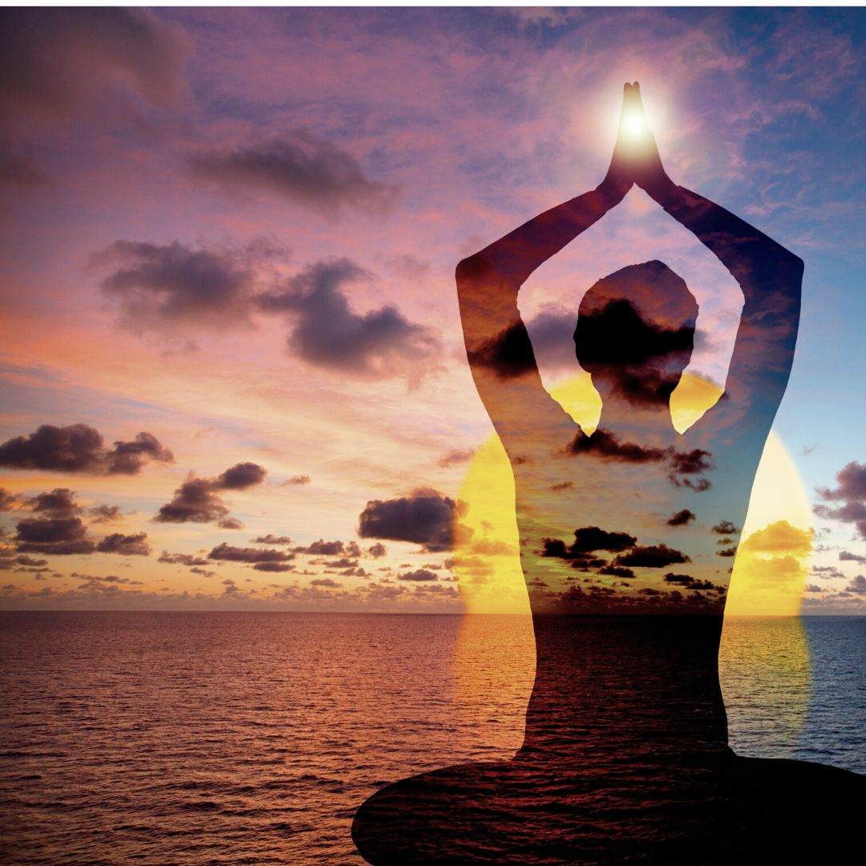
To begin your session, sit comfortably at a time when you feel balanced and will not be disturbed for 30 to 60 minutes. Take a few deep breaths and relax your body. Let any distracting thoughts drift away. Allow yourself to feel neutral in your body. Take three to ten breaths allowing tension to fall away.
There are many ways to enter a hypnotic state with ease, and if you have learned a different method, feel free to use it. Some techniques visualize your body floating downward, and others have you walk down a short flight of stairs, relaxing more deeply on each step. I like to use the stairway method with counting: Feel your body sinking into calmness on slow breaths as you count backwards from ten, descending deeper on each breath. 10, 9, 8, 7, 6, 5, 4, 3, 2, 1, 0. You can even do this several times. The important thing is that your body is very relaxed, the mind is quiet, your breath is slow, and you are open to receiving information. As you breathe calmly, notice that your thoughts also become more tranquil. Allow them to come in and go out without focusing on anything except for relaxing deeper and deeper.
Humbly ask aloud (or silently) to contact your deepest self, to receive the truth, and to see what you need in order to heal. Ask to be whole, ask to trust. Feel your body soften and relax even more. Take long, relaxed breaths.
Setting a goal for your session.
This is central to your healing as it indicates one big objective, which drives your session. Say your goal clearly, out loud or silently like a deep wish. Be specific. For example, your goal might be to ask: Please help me heal the most important priority in my life now.
Or: Please show me the primary root of all my physical illnesses.
Or: If a specific issue is affecting your life now, ask to find and dissolve all past threads of it.
Or: Please show me why does XXX trigger me to feel insecure?
The question is your choice, and it is central to your session.

If necessary, repeat Step One breathing and counting backwards from ten until you feel quite relaxed and ready to begin asking questions. Don’t worry or overthink your technique too much. This is a simple skill and may require practice. Just do the steps over again until you feel comfortable. If you’re not ready, take a break and come back to try again at another time.
Step Two: Ask Questions. Body Dowse for Answers
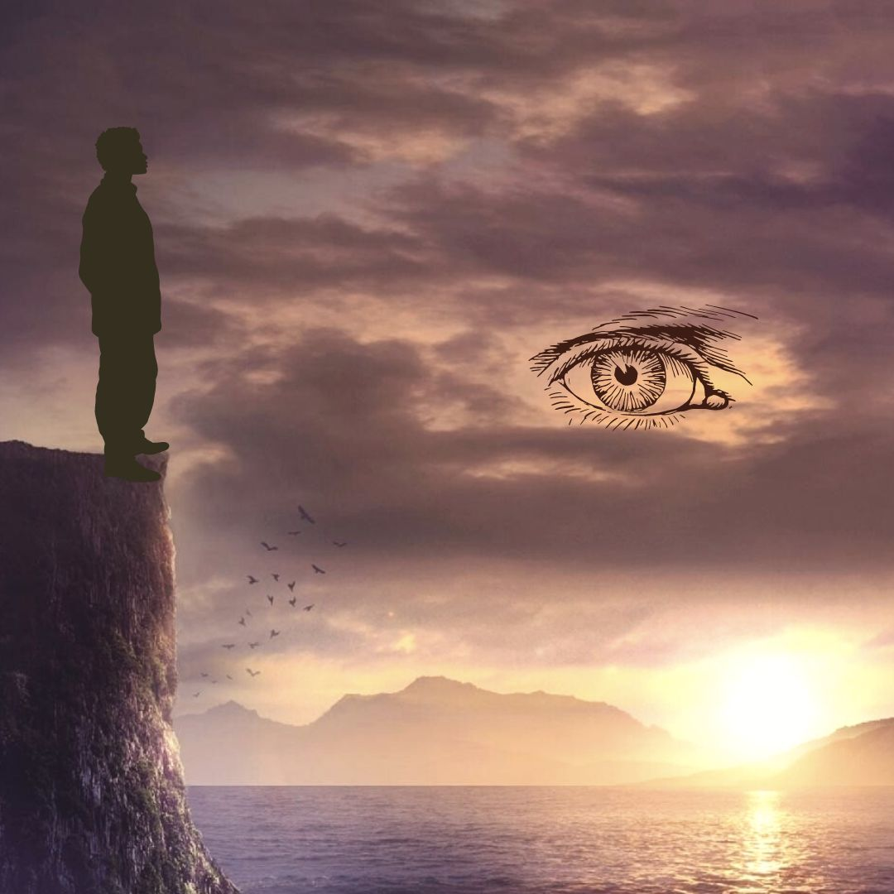
Your body is wiser than you can imagine. You are connected to all of universal knowledge, simply because you are part of it. In a deep state of calm, you can ask Yes/No questions and then use body-dowsing to find answers. Body dowsing is a simple and effective tool that allows us to answer Yes/No questions immediately from the body’s wisdom.
Body dowsing does not require a physical tool, such as a pendulum. (Although you can also use a pendulum.) I use body dowsing not only in healings, but also to ask practical everyday questions about what is needed to be happy and healthy. Just like we have a spiritual intuition, we also have a physical body intuition. That is why body dowsing is a skill that can benefit your life in many areas. Even though the body is always hearing and relaying messages, we may not always be aware that it is doing that. Sometimes we have to get very quiet. We must learn to LISTEN for those messages to actually HEAR them.
To do body dowsing, the mind needs to be free of distracted chatter, excessive stress, and noise. Find a quiet moment when you feel relatively balanced. Your breathing should be very even and deep. You need to be in a neutral frame of mind and body.
Before you start body dowsing, you need to first determine how your body answers questions. Stand on the ground with your feet firmly planted about twelve inches apart. In this state, you can ask any question in a Yes/No format.
Notice which way your body leans: forward or backward. Normally when your body answers in the affirmative, as in Yes, it will tip forward a bit. Likewise, when the answer is negative, the body tips backwards a bit. This direction may vary from person to person, so you need to test it out for yourself. To do that, ask a question for which you already know the answer. For example, ask: Is my name George Washington? If your body tips backwards, that would likely be a negative answer, as in No. You can ask the same question with your real name, and if the body tips forward, that would be a Yes or positive answer. There’s a chance your body dowsing direction is the reverse – Forward is No, Backwards is Yes. Test it again. Once you have determined your tipping direction, you’re ready to begin practicing body dowsing.
You can ask your questions standing up or sitting in a chair or couch. It helps to be well grounded with your feet on the floor. Or you can use a pendulum. You can use any kinesiology technique, such as muscle testing with the arm or wrist. It can be done remotely or in person. The basic technique of applied kinesiology is rooted in one of Sir Isaac Newton’s “Laws of Motion” which states: “For every action in nature there is an equal and opposite reaction”.
Begin asking with the simplest Yes/No questions, such as: Is my name George Washington?
Do I have any trauma or blockages ready to heal?
Can this be dissolved today?
Does the trauma relate to a different lifetime?
Or does it relate to an event in my current lifetime?
Was I a human being?
Man or woman?
Does the lifetime contain any roots of discomfort that affect my current life?
Is the lifetime period in the past? Future? Is it before the year 1,000 CE?
On what continent does the lifetime take place? North America, South America, Africa, Europe, Asia, Australia, Antarctica?
Your body has many things to tell you for your benefit. You can use body dowsing to ask all sorts of questions, not just about past lives. It is extremely important to listen to the answers from your body. When we follow the messages of the body, we truly strengthen the connection between ourselves, our inner voice, the wisdom of the body, and universal wisdom, which is always there. The good news is that with practice you will become familiar with the quality of your body’s messages. How does a ‘Yes’ feel? How does a ‘No’ feel? Soon you will have enough experience and won’t need to wait for the tip forward or back. You just ask a question with your rooted bodymind, and you will feel the body’s answer Yes or No.
During your session, after you have the first few answers to your questions using body dowsing, your deep awareness may connect into the actual lifetime or event, and you might receive a flood of memories from that life as if you were almost physically there. If this happens, just be a detached observer. Do not be distracted or emotionally pulled in. Stay on target. Get the answers to your questions and leave the scene with your prize. Your prize is to find the ROOT of the TRAUMA that took place, the specific emotional distortion, which you can then dissolve. Nothing more. We are here for one specific purpose. Do not allow yourself to be sidetracked with curiosity, entertainment, or anything extraneous to your goal.

Step Three: Specific Questions. Describe the Lifetime
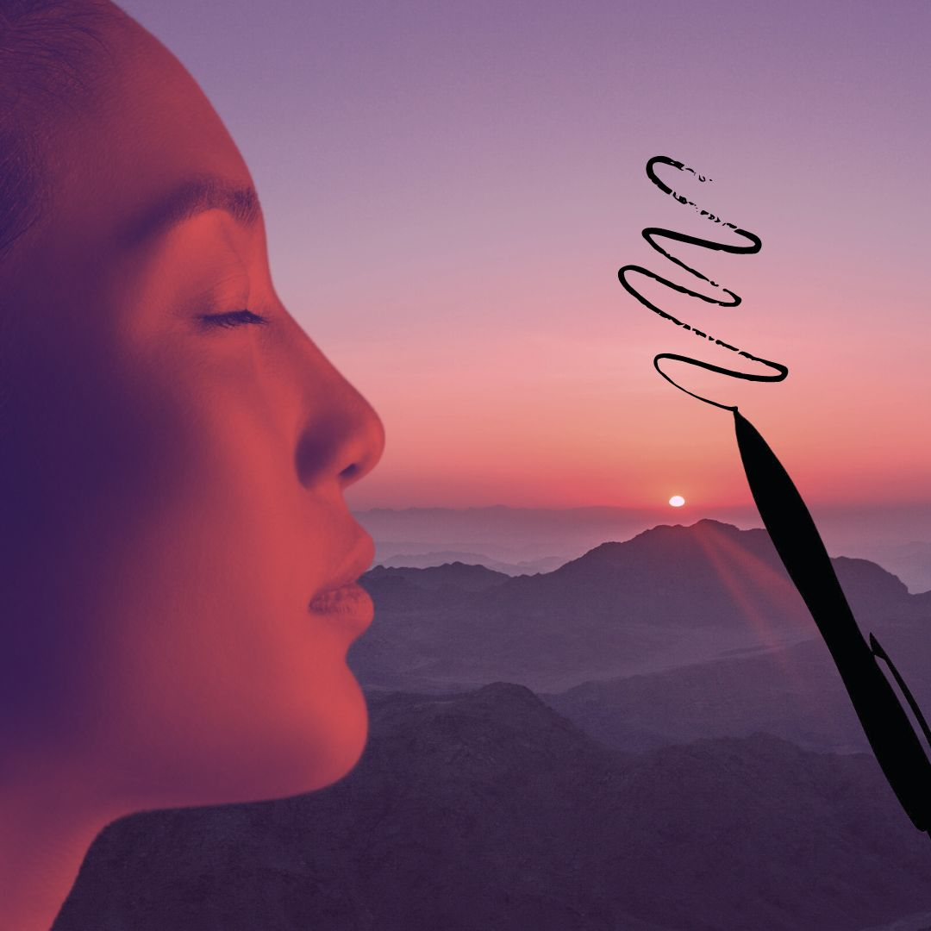
Do you know how to ask a clear question? Most people have no idea how to ask a Yes/No question precisely, and this is critical to your success. Poorly defined, vague questions will always give you wrong answers. The most important factor here is to stay simple and ask one question at a time without jumping to conclusions. When you receive an answer, you can check it by asking the same question a different way or in the opposite way. Example: Was I a man? Was I a woman? Was I not a man? Was I a hermaphrodite? Are you sure? Is this answer complete? Is there more to ask? Since we are just learning to ask questions, be patient and systematic in your inquiry.
The most common pitfall is that many questions contain hidden assumptions, which could be untrue, and this will make your answer ambiguous. When you ask a Yes/No question, it is important to try to be relatively free of assumptions. If your question contains unconscious presumptions in it, then your answer will likely be incorrect and unreliable. For example, if you were to ask the question “Did I have red hair like my sister’s?”, that is a Yes/No question, but it contains many assumptions. You may be incorrectly assuming you had any hair at all. You may be incorrectly assuming that you were a human being, or that another person was a human being, and that they were your sister. They could have been your aunt, your brother, or a Raggedy Ann doll. That is why it is important to keep your questions simple and one-dimensional. Otherwise your whole inquiry could lead to a dead end.
To answer the question “Did I have red hair like my sister’s?”, you need to first set it up with a series of simple one-dimensional questions. Who knows? It may turn out your whole family had blue hair, and they were all boys!
Asking precise Yes/No questions is a skill you can develop. Try to stay on target like Sherlock Holmes. What is your objective? Your one goal is to find the true core of any trauma in the past and to dissolve it with regard to its effect on your life now. You’re not wandering around aimlessly; you’re not time traveling. You’re not curious about extraneous, unrelated things. You have integrity, which means you never ask personal questions about someone else or invade another person’s space without their specific permission. You have nothing to prove. Your single goal is to learn the truth regarding your own experience, in order to heal your life now. This is an easy technique, but as you can see there are many pitfalls that could lead you down an empty path, and give you zero healing.
I start with basic questions: Is there a past life trauma that’s ready to heal? Y/N Is there not a past life trauma ready to heal? How many lifetimes ago? More than 10? Less than 10? Less than 5? 1, 2, or 3 lifetimes ago? Was I a man, a woman? Where did I live? North America, Mexico? Michigan? Was I a child? Married? Single? What century was it? Did I have children? What was my life’s work? What did I love? Gardening? What was my lifestyle? Was I a kind person? Or a cruel person? Was I rich or poor? What did I desire more than anything? Without disrupting your state of deep calm, take a few simple notes with pen and paper, so you can recall them later.
For further study on how to dowse and ask clear questions, I recommend this book: “How to Use a Pendulum: 50 Practical Rituals and Spiritual Activities for Clarity and Guidance”, by Richard Webster.
Step Four: Determine the Specific Emotion to Heal
When an emotion is so intense that it cannot be fully processed, it may become “stuck” in the body very tightly. Any emotion that is not digested remains stored in our body-mind and may later manifest as physical disease. We’re sometimes encouraged to hide our pain and continue staunchly under difficult conditions. However, over time, to stuff or deny intense emotion can cause a backlog of repressed, unconscious, irrational reactions, and emotional baggage that we carry over many lifetimes.
The intimate relationship between the mind and body ensures that every mental - emotional experience impacts your health in some way. Trauma that is not resolved or digested, may linger long past the actual event. A classic example of this is fear. If you lived in a previous incarnation under extreme fear or terror every day for many years, it could create a frequency memory pattern that endures after death. In your current life if you find yourself in a slightly similar situation, your body may produce an exaggerated physical-chemical reaction of the emotion, activating a fight-flight-freeze response. That is how a seemingly “harmless” event can produce a severe panic attack.
Past habits largely determine how we respond to stress, our relationships with others, our physical health, and our overall perceptions. Emotions usually represent negative distortions in our consciousness, like a deformed lens through which we see everything. For example, if someone grew up in an angry household, they may view daily life through the lens of anger, like a filter that colors their every thought, impression, and action. This acts like a block to diminish and obscure their true power. Although this block may be seen by others around you, it can be so deeply ingrained as part of your inborn nature that you are totally unaware of it. These techniques can help clear all past wounds.
What are emotions? We can think of emotions as chemical messages in the blood, flesh, and liquids of the body. They originate as biochemical signals in the brain amygdala centers and endocrine glands that surge through the body like tides.
Emotions are your powerful inner resource. Observe yourself, clear the distortions, and harness your feelings as fuel for your destiny.
Emotions are STRONG ENERGY. Emotions integrate the power of the heart and the nervous system into intention, thought, and action. When an emotional wound is not processed, it represents a drain on your energy and your health. You are like a leaky bucket and your energy is weaker because a part of your consciousness is still locked up in PTSD of fear or anger. You are like an injured shadow of your whole self. However, emotions are a double-edged sword. When we can discipline our thoughts, detach and clearly observe to face our emotions, we can begin to know ourselves. Imagine the power you can summon in your life when your emotions are calm, your nervous system is undistorted, in harmony with your true purpose. You are free to step into your life destiny. Do not underestimate the power of your emotions for good. You can harness them as an unstoppable energy force.

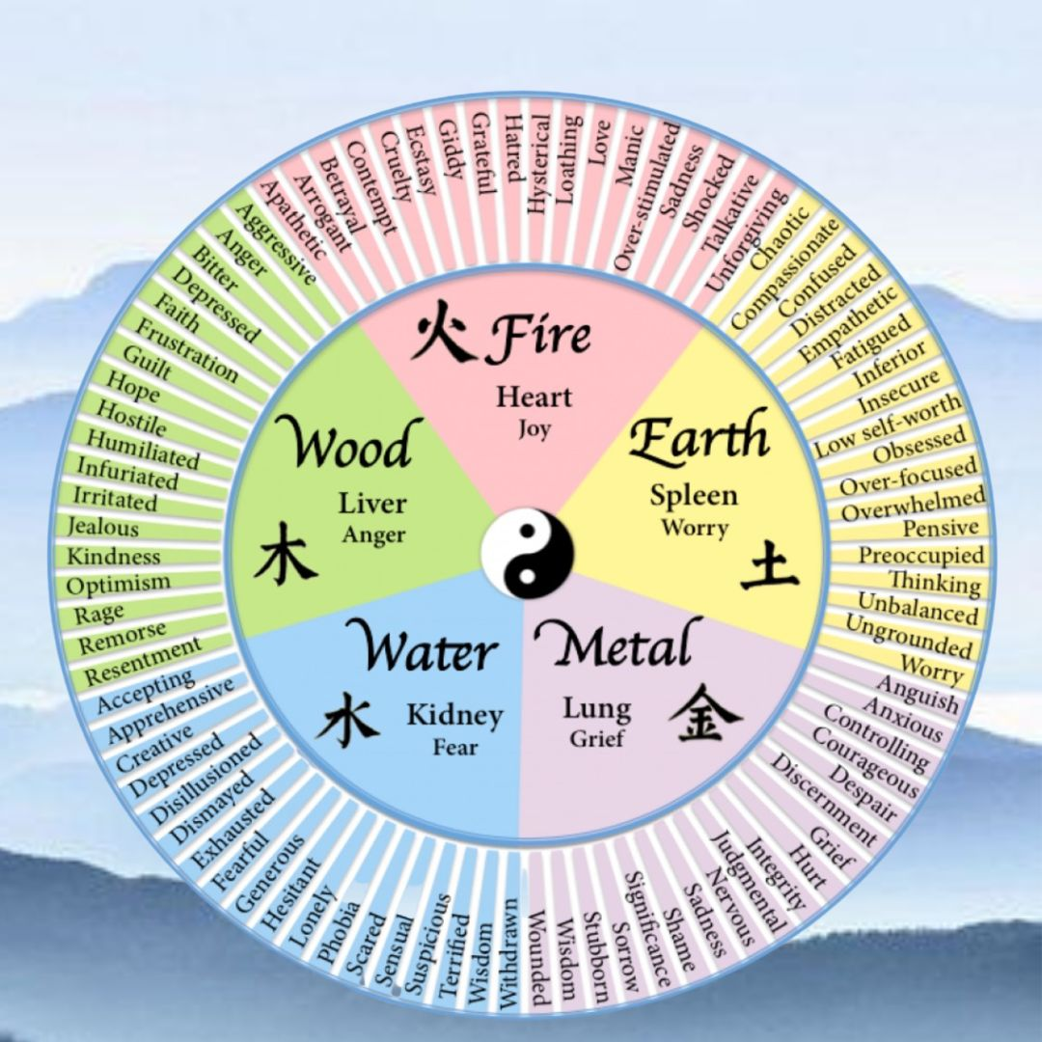
The five primary emotions of Anger, Joy, Worry, Grief, and Fear can be broken down into myriad specific sub-emotions, which may more clearly define the nature and intensity of the issue you are healing (see image).
Emotions are often held in the heart or lungs, such as that feeling of tightness in your chest during an anxious situation. However, there is no predictable rule for where emotions are stored physically. Traditional Chinese medicine sees the emotions as five basic states. Each emotion is linked to a corresponding element, body organ, and associated with common ailments. Longstanding emotional trauma in a past life can repeat the same frequencies over many lifetimes until it is dissolved. Traumatic emotions often follow these general patterns in the body, however every case is unique. Here’s a general example of a few possible associations:

- Anger relates to the Liver – Frustration, Headaches, Hot temper, Red eyes, Blood and Liver congestion, Repression, Tyranny, Obstructed creativity.
- Joy (or its opposite) is found the Heart – Insomnia, Depression, Restlessness, Betrayal, Loss of memory, Violent war, Spiritually blocked, Pride, Disharmony or cruelty in society.
- Worry relates to the Stomach and Spleen – Poor digestion, Overthinking, Low Self-esteem, Exhaustion, Longstanding mental torture, Decades of stress.
- Grief and Sadness dwells in the Lung – Colds & flu, Dry Skin, Stubbornness, Anxiety, Constipation, Loss of homeland or family clan.
- Fear is found in the Kidney – Weak willpower, Dry Mouth, Lymphoma, Osteoporosis, Poor teeth, Sexual insecurity, Prolonged terror.

When you are healing, use the wheel above to find your specific emotions. Try to narrow your trauma down to pinpoint an emotion or combination of emotions. Start with the big five, as these are the most basic: Anger, Joy, Worry, Grief, Fear, and then refine it down to more specific emotions if necessary.
Ask: Which of the five basic emotions best describes the trauma? If it was fear, then break it down to find any specific emotions within Fear that apply, such as Phobia or Withdrawn. Ask: Did I die as a direct result? How many years was this emotion a constant pattern in that life?
To do intuitive work, you must be a detached observer. Whether you are healing yourself or another person, your ability to see clearly depends on unbiased observation. If you have an emotional desire for a particular outcome, you will never find the truth. If you WANT a specific answer to your questions, you will fail. Relax. Take a breath. Balance yourself, and try again later when you’re in a neutral state of mind.
Is it truly a Trauma? Or is it a Shadow? An Entity? When you are doing intuitive work, you must learn to trust what you feel. However, in this line of work, what YOU see may be different from what another intuitive sees. For example, one person may see a blue shadow of fear. That is fine. However another person may see the same thing as a dark spot of gray smoke. Another person might call it an “entity”. And everybody may be correct. Whatever color or shape you perceive, just dissolve it. If you try to use your two-dimensional linear thinking to pinpoint the exact nature of something non-physical, you will always be confused.
No matter what you see, no matter what questions you ask, your single objective is to pinpoint the trauma. You must go beyond all those details and remember your goal of true healing. Ask: What emotion was the essence or core of my trauma? Did I die as a result of this trauma? How did I die? What was my age when I died? Was it a political issue? A war? A family dispute? What was my role? Was I a victim? A perpetrator? What was behind my emotion of fear/anger/grief/etc.? How many years did this constant trauma affect my life? How many people were involved? Keep asking simple questions backwards and forwards until you have a clear and complete picture of the situation. With practice, this will become easier. When you become proficient, after a few specific questions, the scenes from your past life may become crystal clear, and you can observe the situation as if you were present.

Ask: Do I have enough information to dissolve the trauma? Or do I need more details? Keep asking questions until you have enough of a picture to move to the next step of clearing. Remember your goal is to dissolve old emotional baggage to heal your life right now. Keep it simple. Maintain your deeply relaxed state. Write a few notes as you receive answers. Look for a specific trauma you need to heal. If you receive a flood of memories, that is good. However, remember, the story is not important. Just find the block. Stay on target with your objective, and do not be distracted by extraneous information.
Step Five: Dissolve the Trauma with Specific Tapping
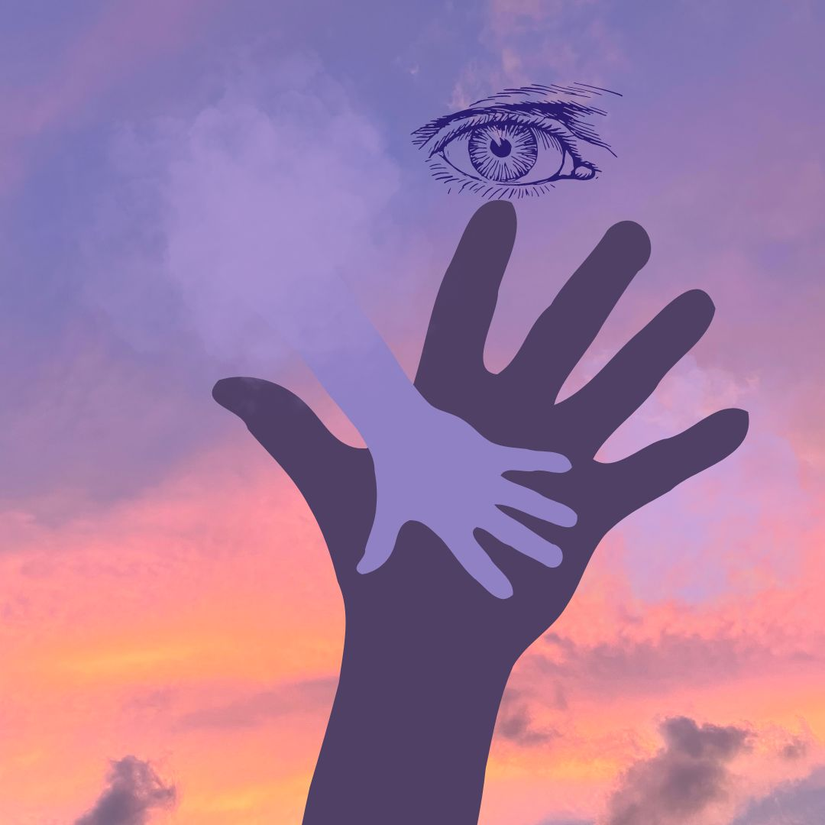

When you are confident you have a sufficiently clear picture of the trauma, the next step is to dissolve it. Ask with all your heart to heal and dissolve any traumatic memory that is affecting your life now. Hold one hand somewhere on your body to represent the past life trauma you are dissolving. Best areas to touch: Heart for Relationships and Self-love, Solar Plexus for Identity, Navel for Energy Center, Sacral chakra for sexual trauma, or any other body part if there was a specific wound. While you hold the area representing the past trauma, use your free hand to tap gently on the three points we learned in Brain Balancing. Tap lightly, approximately 6 – 9 times on each of these three points, and then repeat several times: Top of the Head, then Heart, and then Lower belly. Keep your tapping fingers separated so that you tap on both sides of the top of your head.
As you tap, breathe and ask to release all blocks. Let it go. Allow the central knot of the trauma to dissolve. Breathe comfortably and continue to ask to dissolve any distress that was lingering in your current life. Repeat the tapping sequence several times until you are satisfied that the desired shift has taken place. You may feel a sense of lightness or a change in your heart, like you are carrying less weight, as if a burden has been lifted. That’s very good. If you don’t feel anything, do not worry, it is working. Trust that your deep wish has a very positive effect.
What happens when you dissolve a past trauma? You are not making the event disappear. You are not changing the event in the past. You are just removing the “charge” that ties up your energy and affects you in the present, so you can be free of this energy drain.
Releasing old emotional baggage is a life-long, life-changing practice. It’s a path of self-reflection, to observe yourself. Notice your deep emotions. Emotions are your powerful resource to be harnessed and directed into conscious action, if you are calm. Stillness can be nourishing to our minds and bodies. Quiet time allows space to bring old emotions up into full consciousness, to be dissolved. When you feel something coming to the surface, there’s no need to react to it like a trigger. Just observe it rising into your awareness.
Over time, these healing techniques will help you cumulatively dissolve more and more old emotions with compassion and self-love. Remember you are part of the collective carrying the entire history of human traumatic memories. We are all connected. As you release your own enormous negative weight, you will not only utterly change your own perspective on life. Over time it will lighten the load for all of humanity, to bring about a new shared reality.

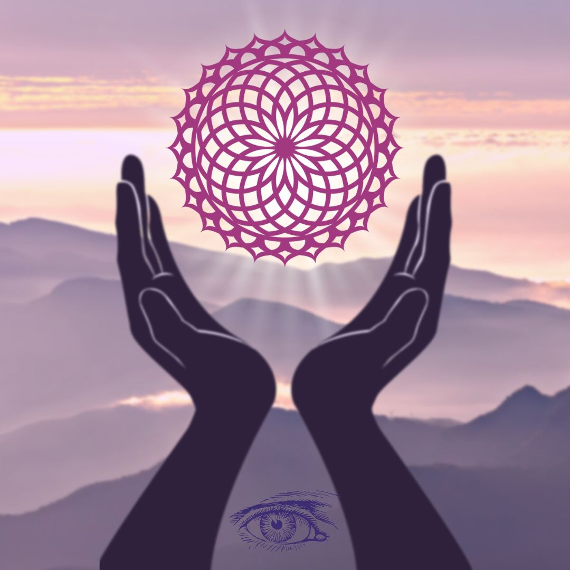
Step Six: Gratitude and Conscious Closing
Take a few moments to be grateful for your session. Jot down a few notes if you like. Visualize a protective bubble of white light around you and invite any negative energies to leave. See them moving out and away. Ask to be protected from any un-serving or harmful energies, so they will be deflected out of the bubble, and you will be surrounded in safety.
Close your session mindfully with a simple affirmation of thanks. Use your own words, such as: “Thank you for lifting a burden of XXX fear, anger, hatred, grief.” Or “Thank you for showing me this scene to help me understand who I am, and to love myself.” Offer gratitude to the universal oneness for your life now. Be thankful for your ability to heal. Take a few deep, easy breaths, and close your session.
After your healing, give yourself a break for 10 to 20 minutes before you jump back into daily responsibilities. Have a cup of tea. Take a brief walk in Nature. Notice any subtle changes in yourself. You might feel lighter and happier. After removing trauma, big changes can often be felt immediately. However, in me, the most positive changes happened gradually over a period of weeks and months. Be patient and keep going.
After your session, I suggest you wait at least a week before you do another. Do not underestimate the power of your healing. Do not try to do another trauma clearing immediately. This time-out allows your body-mind-spirit to adjust to subtle changes, so that your next healing can be even deeper and more successful.
Sometimes working on past life trauma can raise uncomfortable feelings. You may feel a bit disoriented living in a totally new perspective. You may feel unnerved and want to question what’s happening. Perhaps it was distressing to see “yourself” in another life suffering painful injury or death. This is a normal response to surprising events. Just let it go. Have patience with yourself. Don’t dwell on the discomfort. Just relax, release, be grateful, and move on. Isn’t that the whole point of the healing anyway?
While it is important to know generally what happened and to clear the specific emotion, it is not necessary for you fully comprehend it with your linear, logical mind. It is not helpful to be overly drawn emotionally into the scene. View it with compassion. Be like a Buddhist - understand that impermanence is the nature of life. Release it. Take a few deep breaths, have a cup of tea, and let it go. Leave it behind. After all it’s not part of your life now. If you find you need more support to complete your healing and release the past, feel free to contact me by email to request an online session.

Note to Professional Healers
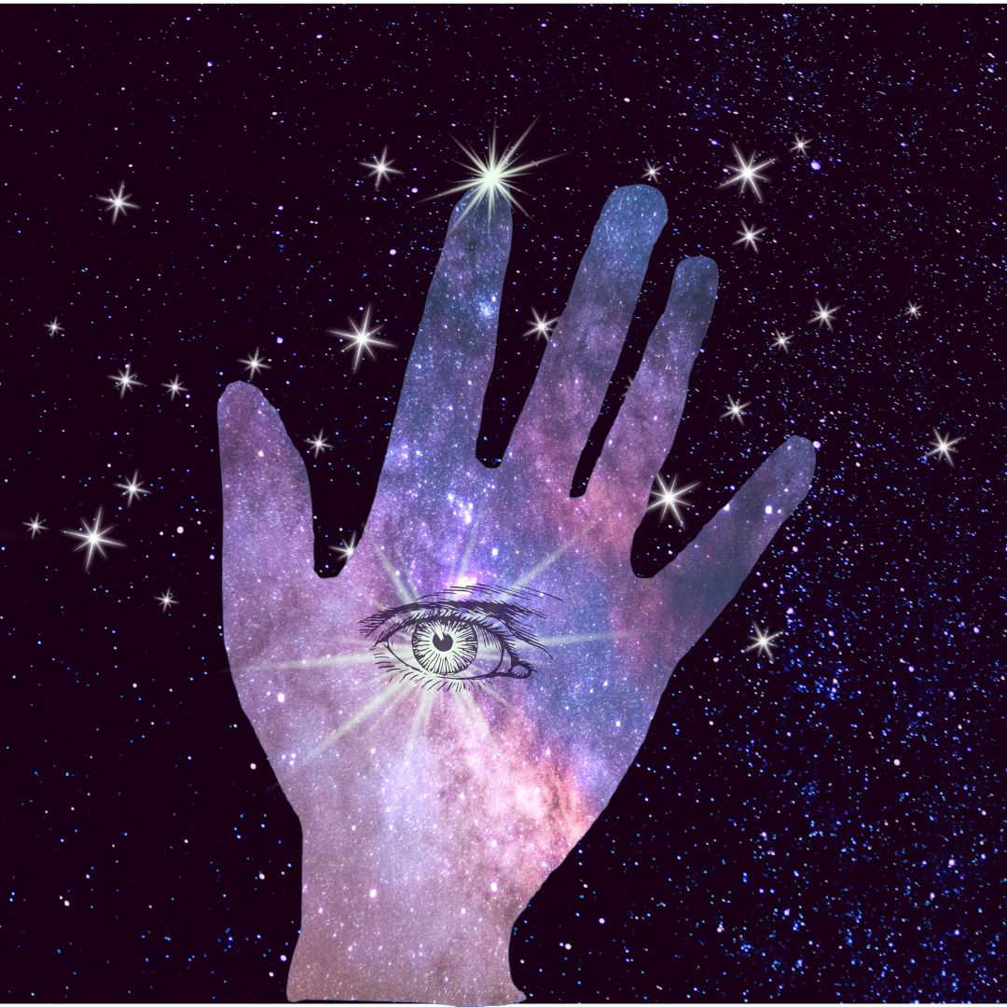
If you are an experienced healer and have been trained in other energy modalities, you can merge your skills seamlessly into this technique. If you practice a therapy such as Craniosacral, EFT, BodyTalk, Body Code, Emotion Code, Chiropractic, NAET, Polarity Therapy, Hypnotherapy, Somatic Bodywork, Accunect, or Spiritual healing, you already have a foundation of practical knowledge and experience to help you heal past lives.
There are many other fine techniques you can use to ask questions and receive answers through kinesiology, such as hand or arm muscle testing, finger pulling, pendulum, rods, etc. I chose body dowsing because it is the simplest applied kinesiology tool to explain in a book.
Likewise, there are also many ways to access the deep meridians to invite a lasting shift. I used tapping on the three “brains” at the top of head, heart, and belly, points from Chinese medicine, because it is the easiest way I knew to explain in a book.
Some healers have difficulty doing self-healing, because they are so used to working on others. If this is your case, to heal yourself, just visualize yourself as a hologram. Imagine your hologram person in the air or lying on your healing table. Then work on the hologram person. The effect is the same. For deeper refinement and details in any of these techniques, feel free to contact me about advanced healing workshops. As always, I invite your suggestions and observations. Thank you.

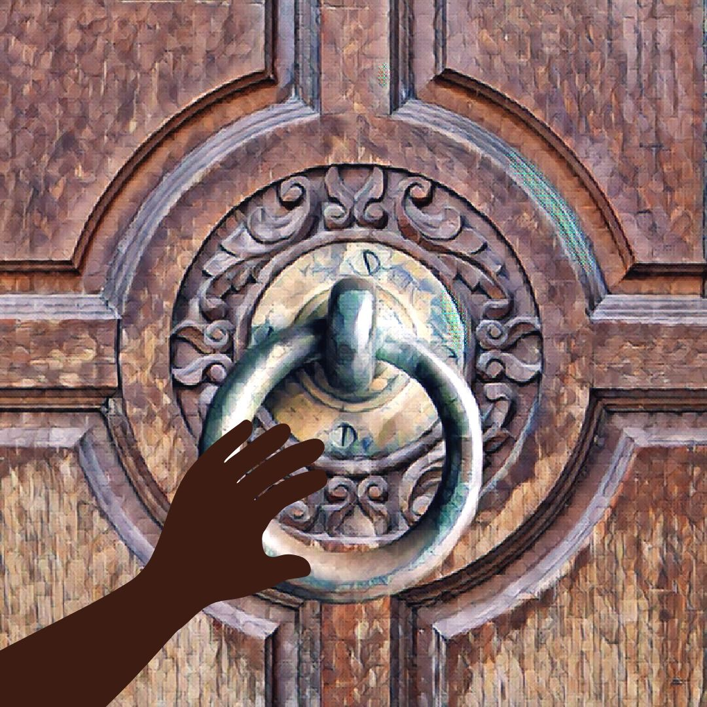Part III: Journal of My Past Life Clearings
I share this journal of my personal past life clearings in the hope that it may help illuminate the process for you, although your experience will be totally different. This journal of lifetimes is printed in the order in which I did the sessions. This helped me observe changes in my health and mental state, which improved enormously over time. The Chronological Timeline shows my healing sessions in historical sequence.
I need to warn you. Many of these past lives were filled with shocking acts of violence, like rape and murder, betrayal, disease, and misfortune. Even lives that took place in seemingly peaceful places like monasteries, temples, and palaces, were often quite violent. Of my 200 past lives on earth, many of them were relatively peaceful. However in these healings, I asked to focus on the most traumatic past lives, because these are the ones that affected my current life as deep negative subconscious memories. I was surprised to notice some lifetimes occur in the same time period. While I find this confusing, I understand we may have lives in different parallel dimensions, and perhaps carry on several lives simultaneously.
I have lived in countries far and wide, from China, Tibet, Mongolia and India to France, Spain, Peru, and North America. Sometimes I was a master, rich and powerful. Other times I was a poor servant, a beggar, or a child who died young. In some lives I was a victim of uncontrollable events. Other times I was a warrior and perpetrator of terrible violence. A few characters that I know now, for better or worse, showed up in several of my past lives.
Please remember that your journey and your experiences will be very different from mine. I suggest you keep an open mind so that you can discover what makes your destiny unique. Not everyone will have past lives around the globe. Some people “stay local”. Some people choose to be born in the same family group lifetime after lifetime. There’s very little rule about it. No particular pattern is better or superior. In my case there did seem to be a progression of lessons, exposing me to certain energies, perhaps an invitation to learn things that I actually need in my current life. Across the spectrum of my various lives there seemed to be a few recurrent themes, such as travel to distant lands, love for music and singing, a pattern of persecution, to tenaciously protect my clan, and to live in spiritual organizations. Sometimes when I see familiar things, it stirs a memory, a desire to return to a happy place, or occasionally the opposite feeling of emptiness and fear. You can notice this in yourself when you feel a certain resonance to things. Are you drawn to the colors, cuisine, language, and times of certain places? These feelings are guideposts in your healing journey. Just be an open-minded observer.
In my sessions I was able to integrate my knowledge of meditation, Chinese medicine, and other healing modalities I am familiar with, since I have studied these systems for decades and in previous lifetimes. I did not include all these details in this book as they might be confusing to many. However, I encourage each reader to bring forward any knowledge that seems beneficial to your own process. The most important key to healing is to find the specific emotion of trauma, and this requires no professional training. For experienced practitioners, you can make your healings even more beneficial by incorporating your particular knowledge of hypnotherapy, anatomy, massage, specific body points, mental awareness, microbiome, etc. More refinement and details of this technique are available. Contact me directly.

Chronological Timeline, Journal of My Past Lives
Chap # | Year | Chapter Title | Treatment or Balancing
4 | 230,000 BCE | Phaeem the Hermaphrodite, Planet Destroyed | Sadness, Grief, Hopelessness, Adrenal Fatigue
5 | 165,000 BCE | Humanoid Telepathy in Africa | Sadness, Insecurity, Fear
1 | 58,000 BCE | Viral Plague, a Lifetime of Despair | Anger, Shingles Predisposition, Immune deficiency
3 | 9,000 BCE | Barbarians Murder Gods in Kashmir | Fear, Terror, Autonomic Nervous System Fight-Flight
13 | 7,500 BCE | Tibetan Bon Buddhism Threatened | Worry, Endocrine imbalance, Overwhelm, Adrenal Fatigue
6 | 6,800 BCE | Tibetan Sound Healer Discovers Her Path | Kinship, Sense of belonging, Family ties
2 | 6,300 BCE | Reptilians Mine Gold in Peru | Anguish, Grief, Dismay, Adrenal exhaustion
50 | 3,700 BCE | Babylonian Strategist Conquers Aramaeans | Self-rejection, Self-poisoning, Neck Pain, Entitlement, Superiority
51 | 3,000 BCE | Stigma of a Bastard Half-God | Arrogance, Heartlessness, Fear, Loneliness, Hypersensitivity, Grief
44 | 200 BCE | Clan Leader Murdered in Caucuses | Anguish, Right chest trauma, Heart and Chest tension
49 | 450 BCE | Phobia After Earthquake in Turkey | Digestive Trauma, Self-hatred, Phobia of Impending Doom
30 | 25 | Bone Marrow Cancer in China | Grief in skeleton, Chronic Low Energy, Weak Kidneys, Tired Blood
27 | 190 | Nicaraguan Woman with Brain Growth | Poor lymph circulation in right Brain, Cranial bones imbalance
21 | 350 | Stigma of an Indian Bastard Child | Unworthiness, Self-hatred, Adrenal deficiency, Lymph stagnation
37 | 365 | Sufi Priest Beaten to Death | Skull Trauma, Dental-Periodontal Pain
12 | 575 | Suppression of Taoists in China | Loneliness, Disillusionment, Lymph stagnation, Self-rejection
18 | 650 | Lover’s Quarrel and Death by Hot Oil | Terror, Trigeminal neuralgia - Shingles, Right Brain trauma
41 | 785 | Mercury Poisoning in Medieval Belgium | Mercury toxins in liver and bone marrow, Phobia, Hysterical fear
43 | 810 | Balinese Child Bride Sold in Marriage | Anger, Mental anguish, Liver congestion
14 | 875 | Monastery Takeover by Buddhists | Trauma to right frontal lobe of brain, Terror
17 | 925 | Banished and Starving in Tibet | Rejection, Terror, Food Intolerances, Weak Kidneys, Low energy
20 | 950 | Chinese Emperor’s Advisor Burned at Stake | Phobia of betrayal in groups, Dry skin, Chronic dehydration
8 | 985 | Sexual Secrets in the Ashram | Sexual clearing, Lymph stagnation, Shame, Fear
23 | 995 | Bandit Attack Leaves 110 Monks Dead | Rage, Rigid connective tissue, Lymph stagnation, Skull trauma
38 | 1040 | Death in the Arabian Dunes | Fear, Terror, Food Intolerances, Hysteria, Heartache
19 | 1075 | Betrayal in Tibetan Monastery | Terror, Locked in Fight Flight, Distrust of Family, Rigid Fascia
33 | 1080 | Dental Torture in Tibet | Fear of dental work, Memory of pain in jaw and gums
42 | 1100 | Chaos in Cantonese Imperial Court | Anguish, Grief, Musculo-skeletal imbalance, Sexual fear
40 | 1125 | Cantonese Warrior Battles Mongols | Anger, Rage, Trauma to right cranium, Skeletal imbalance
54 | 1150 | Hildegard Von Bingen, Persecution, | Anger, Wariness, Fear of betrayal, Painful Heart and Throat
48 | 1190 | Self-hatred and Arrogance in China | Brain Congestion, Depression, Lymph stagnation, Self-hatred
31 | 1230 | Zapotec Priest Killed in Aztec War | Cranial pain, Dental Trauma, Fear, Skeletal Imbalance
15 | 1266 | Genghis Khan’s General Left for Dead | Acute Cranial trauma, Meridian imbalance, Skull Acupuncture
16 | 1325 | Buddhists Challenge Taoists in China | Insecurity, Worry, Lymph stagnation, Edema
36 | 1390 | Tibetan Oracle Murdered | Anxiety, Food and Chemical Intolerances, Weak digestion
46 | 1390 | Native American Acute Dissociative Stress | Phobia, Mental instability, Panic, Self-sabotage, Confusion
10 | 1430 | A Low Caste Life in the Ashram | Insecurity, Hypersensitivity, Anger, Lymph stagnation
53 | 1455 | Jewel Thieves from Palermo | Terror, Lymph congestion, Abdominal organ trauma
47 | 1495 | Fear of Mother’s Insanity | Fear, Adrenal deficiency, Low Energy, Phobia-Impending doom
28 | 1500 | Paralysis and Tremor in France | Hopelessness, Nerve stagnation on Right Side
45 | 1545 | Buried Alive in Inquisition | Anger, Rage in spine, Tailbone junction blocked
24 | 1550 | Rejection as a Tibetan 2nd Wife | Grief, Anger, Rejection, Self-Hatred
22 | 1575 | A Suffocating Life In Darjeeling | Grief, Heart congestion, Fear, Rage, Exhaustion
32 | 1657 | French Army Officer, Musket Shot to Brain | Trigeminal neuralgia-shingles, Right Cranium pain
29 | 1735 | Three Bullets to the Head in Bordeaux | Anger, Cranial nerves, Dental Trauma, Fear
35 | 1780 | Sexual Assault in Hong Kong | Sexual trauma, Root chakra blocked, Rigid Connective tissue
39 | 1795 | British Violence and Death in India | Fear, Guilt, Cranium bone trauma
11 | 1830 | Starvation, Dakota Indian Woman and Tribe | Depression, Anger, Food and Chemical Intolerances
52 | 1842 | Monk Uprising in Anglo-Burmese War | Phobia of impending doom, Rage, Anger, Nervous Anxiety
7 | 1892 | French Opera Singer, Opioid Addiction | Stomach fear, Worry, Fatigue, Edema, Dental trauma
9 | 1938 | French Spy in the Jewish Resistance | Fear, Wariness, Trauma to Right frontal lobe and eye
26 | 1944 | A Child’s View of the Holocaust | Hopelessness, Grief, Chemical Intolerance, Lymph toxins
25 | 1950 | Memory of Abuse at Two Years Old | TMJ, Anger, Fear of intimacy, Trauma to throat
34 | 1980 | Mary is Gone and I Miss Her | Removal of an unneeded entity, more like a friend

- Dissolving Layers of Sadness and Grief

- Viral Plague, a Lifetime of Despair
Anger, Shingles Predisposition, Immune deficiency

I was a young girl, a humanoid of royal birth in the foothills of the Western Himalayas about 60,000 years ago. I was not exactly human; I was something similar but smaller. I lived a very short life of despair and grief. My father the King, along with our whole family and all our people suffered greatly due to a terrible pestilence. It was a plague caused by a virus that weakened my entire family and the whole population. This was a communicable disease that affected over 30 million people in this area. The virus did not kill, but rather caused the person to become so weak that they would die from something else.

Do not expect to understand this advanced civilization. Ours was a highly evolved culture with great refinement, art, literature, wisdom, beautiful clothing, personal grace, and expression quite different from modern times. For example, we were smaller than modern humans. Common people were 3 feet tall. We royals were about 4.5 ft tall. The Gods were blue and 8 feet tall and lived several thousand years. The Gods did not intermingle with humans, however they ruled the area and oversaw the human affairs through the King, my father. Many of our people worked in service to the Gods. We loved and honored the Gods.
The Gods did not cause this virus. They told us they were immune to it, and that they wished to heal it in humans. So, we believed they did not have the power to heal us. In fact, they did have the method to eliminate the virus in themselves and in humans. But they wished to make a major change in the human population, to drastically reduce the our numbers and re-educate humans in a new and different way. So, they allowed the virus to do it. They helped to spread it with the goal of thinning our genome. We were a race of shorter human beings that no longer exist now. The rulers wanted to eliminate our line and focus on developing another line of humans. We were short, highly intelligent, wise, and intuitive, with a refined culture. The new humans were larger, stronger, and of medium intelligence.

The pestilence lasted for 400 years. Because of it, everyone's life span was short. I lived for only 8 years, a life of despair, sadness, and hopelessness. I had beautiful dark skin and long black hair. As a royal, I received the best medical care, but alas everyone was ill. Finally, I died, and it was over. After 400 years, the epidemic ended, their goal was complete, and our population was gone.

The virus was related to the modern herpes zoster (shingles) virus, but I believe this particular virus may not exist in modern times
Steps in This Healing:
My first self-healings came on the heels of a terrible case of shingles. I had contracted the herpes zoster virus on the trigeminal nerve of the face. It was a serious case that took me out of commission for several months and showed me that my immune system was very weak.
- Step One: Trance State, Set a Goal – I relaxed gently into a quiet state of self-hypnosis and asked to heal whatever was the highest priority for my body-mind-spirit.
- Step Two: Body Dowsing – I asked basic questions.
Is there a past life ready to heal? Yes
When did this happen? 60,000 years ago. I started to be surprised, but quietly continued.
- Step 3: Describe the Lifetime - Was I a man or woman? Neither. Was I a child? Yes.
Where did I live? Western Hemisphere? No. Asia? Yes. India? Yes. North, South, East or West? North. Mountains or lowlands? Himalayas.
Did I die of the trauma? Yes.
How old was I when I died? Over 50? No. Under 20? Yes. 8 years old.
Was I a human? Yes. Did I live in a community? Yes. How many people? 30 million. Was I rich or poor? Rich. Was I of royal birth? Yes, daughter of a King. Was I bed-ridden? Yes. Was I well cared-for? Yes, but it didn’t help. What was the cause of the plague? A virus. Was it curable? No.
At this point, the story began to flood my memory and fill in more details with a feeling of hopelessness, sadness, an unfulfilled life. This virus affected the entire civilization. I felt my father the King and his frustration. I was an only child. I felt my own helplessness that I could not be a stronger participant in the society. The whole civilization was in the death-grip of a virus. I was pretty surprised that this particular story came up on the heels of my shingles. I trusted that it was the most important trauma to clear at this time.
- Step Four: Determine the Specific Emotion to Heal – I read the emotions wheel and asked which emotion described the trauma. The three words that struck most strongly were grief, despair and anger. I asked what parts of my body are most strongly affected? I got that stomach and general digestive weakness was the primary area affected. I got that many other situations in my current life had contributed to this weakness. I asked: “Do I have enough information to clear the trauma? Or should I look for more details?” Yes, enough details.
- Step Five: Dissolve the Trauma with Specific Tapping – Holding and awareness of those emotions and body parts in my mind, I asked with all my heart to clear the trauma, to dissolve any predisposition to the shingles virus, to heal any weakness in the digestion, and any tendency to anger, grief, or despair. I tapped gently on my head, heart and lower belly for about a minute. I waited to feel a shift in my energy, any subtle change that would tell me it had been effective. I asked to trust what I was feeling. When I felt a gentle shift, like a wave of relief, I stopped tapping and took a deep breath.
- Step Six: Gratitude and Conscious Closing –I took some quick notes. Then I asked to forgive everyone and everything involved. I put a protective bubble around myself and felt a sense of gratitude. Then I just sat in wonder for a few minutes, surprised at what I had just experienced. I wondered: “Was it real? Could that have really happened? I slowly got up and made a cup of tea. Since I had a busy day ahead, I just trusted that the session was OK and gradually moved into my day. Over the following few days, I was amazed to notice that my shingles began to heal much more rapidly, as if a deep block of predisposition to the virus had been removed. I noticed my body was able to reclaim its strength again. I felt very happy.

- Reptilians Mine Gold in Peru
Anguish, Grief, Dismay, Adrenal exhaustion

I was a shamanic master and doctor in a South American civilization in approximately 6,300 BC. I was seen as a spiritual teacher whose responsibility it was to chant, pray, and cultivate harmony between the visible and invisible worlds above and below. We believed this practice was essential to a good life and a harmonious community. I suffered terrible anguish my entire life, from the day I was born until I died at 84 years old. My anguish was in a way self-imposed and entirely personal. I could not accept the terrible lack of integrity and goodness in the world. I simply could not bear the pain that such a terrible schism existed between good vs. evil. I was forced to live with this stark contrast between my beautiful people vs. the selfish powerful rulers. It was an utter conundrum for me. How was this necessary or even possible in a beautiful universe? It was a life of terrible suffering and anguish that never went away.

The pure Reptilian extraterrestrials were already here when I was born. They were very powerful both physically and mentally. Our people feared them, and they brought great harm to us. I tried to defend the people, but I was not able to help in any way. There were about 200 reptilians in my area, both males and females. They were about 8 feet tall and arrived to our village via spaceships from far away. They were experts in galactic travel. They had two arms, two legs and walked upright. The reptilians needed gold for their physical well-being. They hired our people as human slaves to work in the mines to collect gold, which they put in their spaceships to take away.

The reptilians used mind control to enslave the people, who were ruled totally by fear. All the common men worked in the mines, which consisted of large open holes in the mountain. The workers were treated very cruelly. Anyone who objected was killed quickly. The miners were well paid with food. Oh yes, the reptilians were generous with food, excellent quality nutritious food, which they took home to their wives, who bore many, many healthy children. This gave the reptilians hundreds of years of slaves to work in the mines.

I was immune to their mind control because I was born in another lineage to be a shaman. As a doctor, I could heal many things for the people, so I suppose our masters needed me. My spiritual practice harmonizes my nervous system to the cosmos, to nature and goodness. However, most people were not immune. They worked in the mines every day for their entire lives. And their lives were very very short. An average worker lasted between 5 and 10 years doing this heavy menial work. But there were enough young men coming up and well-fed women to bear children, so there was always a plentiful supply of slaves. And a steady supply of babies to eat. They preferred young ones under two years old. They first ate the organs, the heart and liver. Then they drained and drank the fresh blood. Killing and eating was just part of daily life.
They do not understand emotions, not even joy. I did not notice any experience of joy in any aspect of their life.

After about 400 years, when they had gathered enough gold, the group left Earth. I believe they are still around in modern times, perhaps in our Milky Way galaxy. They took a lot of gold with them and no other elements. Some say these reptilians had a role in human genetics and the creation of the human race. But I did not see that. I see they had a single purpose and that was to gather gold that they needed somehow for their physical health. These pure reptilian beings were highly intelligent and completely selfish. The nervous system and mind are not equipped to understand or feel emotions, compassion, or pain as humans do - these experiences are entirely foreign to them. The pure reptilians were not particularly evil, just totally self-oriented, and therefore capable of doing great harm. I believe there are many kinds of reptilians and extraterrestrials in our universe, many of whom have mixed heritage with humans. I would like to think that those who may have played a role in human design and genetics, were perhaps of very different and higher order of integrity and spiritual evolution.
Steps in This Healing:
- Step One: Trance State, Set a Goal – I meditated quietly, counted backwards from 10, and felt a sense of calm self-hypnosis come over me. I felt deeply tranquil yet perfectly clear. I asked to heal whatever was the highest priority for my body-mind-spirit.
- Step Two: Body Dowsing – I asked basic questions.
Is there a past life ready to heal? Yes
When did this happen? 100 years ago? No. More than 1000 years ago? Yes. More than 5,000 years ago? Yes. Approximately 8,400 years ago in 6,300 BCE. Where did I live? North America? No. South America? Yes. Argentina? No. Peru? Andes mountains? Yes.
- Step 3: Describe the Lifetime - Was I a man or woman? A man.
In the session I began to feel a sense of horror and hopelessness, in which struggle is impossible. But I did not react and tried to continue asking basic questions. Was I married? Yes. Did I have children? Yes. What was the source of the trauma? Family dispute? No. War? No. Invasion? Yes. Invasion by other people? No. Invasion by non-humans? Yes. Selfish motivation? Yes. Mind control? Yes. Were they tall? Yes. Gods? No. Reptilians? Yes. Why did they come? Need gold for something related to health. At this point, the story began to flood my memory and fill in more details.
Step Four: Determine the Specific Emotion to Heal – I read the emotions wheel and asked which emotion described the trauma. The three words on the chart that struck most strongly were grief, anguish, and dismay. I asked what parts of my body were most strongly affected, and I got that this emotion was primarily in the lungs, as I was having trouble breathing. I asked: “Do I have enough information to clear the trauma? Or should I look for more details?” Yes, enough details.
- Step Five: Dissolve the Trauma with Specific Tapping – Holding and awareness of grief, anguish, dismay, and hopelessness in my mind, I asked with all my heart to clear the trauma, to dissolve any trauma. I breathed and tapped gently for about a minute on the three points in succession, my head, heart and lower belly, waiting for a change in my inner state, any subtle release that would tell me it is working. I asked to trust what I felt. Soon I felt a gentle release, I stopped tapping and took a deep breath.
- Step Six: Gratitude and Conscious Closing –I wrote down some quick notes. I asked to forgive everyone and everything related to this trauma. I could see the reptilians with more neutrality and no judgment. I found compassion, no dismay, and acceptance of other living beings different from me. I put a protective bubble around myself and offered thanks. During the following weeks, I was surprised to find my emotions were much more balanced. My pattern of depression began to loosen, giving way to a perspective of acceptance and understanding toward everything.

- Barbarians Murder Gods in Kashmir
Fear, Terror, Autonomic Nervous System Fight-Flight
I was a young god living in Kashmir before the last flood, sometime around 12,000 BCE. Kashmir was a harmonious place in the mountains, a well-organized matriarchal society. I was one of the blue extraterrestrial gods who had introduced Sanskrit as a sacred language from our home planet. I was a full-blooded god, not mixed heritage, beautiful, 8 feet tall with long black hair. I was a teacher of wisdom and chanting, 42 years old. This was considered very young, as I was expected to live over 300 years. Hence, I was unmarried and had no children.

I suffered a traumatic death accompanied with fear and terror in an attack of my city by barbarians. The genetic mixing of various types of gods and humans for several centuries began to create serious tensions. Some of these tribes were rejected by other societies. Some were very warlike and violent. On this occasion we were threatened every day for a week and there was much fear in the city. There was no way to escape. Ultimately all the gods and humans in my city were killed, men, women, and children, murdered by half-breed barbarians from the south, the area you now call Pakistan. They were jealous of our superior abilities. They wanted control of all political and financial resources, as well as religious power.
In the end all of us in my city, the gods and humans alike were killed. Eighteen gods and 2,000 humans were killed, bodies lined up sliced through the throat with knives. I died instantly. Our half-breed attackers did not understand the deep and ancient refinement of our culture. They were envious of our high civilization, our grace and ease of living. After my city was destroyed, my group of gods made the decision to leave Earth. Much sacred knowledge was hidden in order to protect it for the future. This was a turning point in Earth history and a major setback for human evolution.
Steps in This Healing:
- Step One: Trance State, Set a Goal – I sat quietly and observed my breathing relax and slow down. I meditated until I felt a deep silence. I walked down three imaginary steps into a peaceful sense of calm repose, yet I was totally awake. My goal was to find and heal whatever was the highest priority for my body-mind-spirit.
- Step Two: Body Dowsing – I asked basic questions.
Is there a past life ready to heal? Yes
When did this happen? 100 years ago? No. More than 1000 years ago? Yes. More than 5,000 years ago? Yes. Approximately 11,000 years ago. Where did I live? North America? No. South America? No. Europe? No. Asia? Yes. China? No. India? Sort of. Himalayas? Yes. Kashmir? Yes.
- Step 3: Describe the Lifetime - Was I a man or woman? A woman. Was there a trauma? Yes. Was it a longstanding trauma? Yes. I began to feel a constant fear of impending doom in which I was helpless. Yet at the same time I felt strong, accepting and even fearless of death. I continued without reacting. Did I die from this trauma? Yes. Was I human? No. What!? Was I non-human? Yes. Was I an extraterrestrial? No. Was I born on Earth? Yes. Was I a god? Yes. Was I part of a community of gods living on earth? Yes. Was I married? No. Did I have children? No. What was the source of the trauma? Family dispute? No. War? No - a longstanding dispute. Invasion? Yes. Invasion by other people? Yes. By barbarians from the South? Yes. Jealousy? Yes. Ignorance? Yes. At this point, the story began to flood my memory and fill in details. I was tall and beautiful. I was a god, and there was a dispute with humans envious of our power and lifestyle.
- Step Four: Determine the Specific Emotion to Heal – I read the emotions wheel and asked which emotion described the trauma. The words on the chart that jumped out at me most were terror, fear, exhaustion, and fight-flight response which drains the adrenal glands. I asked what parts of my body were most strongly affected, and I got that this was part of my pattern of adrenal fatigue. I asked: “Do I have enough information to clear the trauma? Yes. Or should I look for more details?” No.
- Step Five: Dissolve the Trauma with Specific Tapping – Holding and awareness of terror, fear, and adrenal exhaustion in my mind, I asked with all my heart to clear the distress, to dissolve any trauma. I tapped gently for about a minute on the three points in succession, my head, heart and lower belly, patiently waiting to feel any shift in my awareness, a gentle letting go that would indicate I was finished. I asked to trust what I felt. Soon I felt a release and stopped tapping. I relaxed and took a deep breath.
- Step Six: Gratitude and Conscious Closing –I scribbled as best I could through my surprised state. I asked forgiveness for everyone and everything related to the event. I could see and accept the resentment of humans, the awareness of the gods, and their decision to leave an impossible situation. I created a bubble of protection bubble around me and said thank you. I had a cup of herbal tea in the garden, and then went about my day without thinking any more about the healing. During the weeks after this session, I found in myself more acceptance for jealousy and violence. I noticed I felt less terrified of violence and death. On the contrary, I felt almost a wise, detached equanimity about it.

- Phaeem the Hermaphrodite, Planet Destroyed
Sadness, Grief, Hopelessness, Adrenal Fatigue

In this session I asked to receive an answer to the question: Why I am always so sad? I also asked to remove the root of sadness from my life. As I relaxed deeper and deeper, slowly a surprising scene appeared before me that answered my question and gave me the release I needed.

Looking down at my feet, I was barefoot standing on the ground with some dirt and grass. My feet were fair skinned, wide, fleshy, and covered with delicate reddish hair. I looked up and saw a peaceful landscape of grass, trees and gentle hills in full daylight. The color of the plants and sky were soft and beautiful, but somehow the colors were different, so I suspected this was not Earth. Then I noticed three white moons in the daytime sky above.

My name is Phaeem. I am about 4 feet tall. I have clear light skin and wavy reddish-brown hair, shoulder length. I am dressed in a simple pants and a shirt open, revealing delicate red hair on my wide chest. I am happy. Always happy. I have broad full lips, a warm, engaging smile, and clear blue eyes. I am a mature man. And I am also a woman. I have a woman’s breasts, a penis, female labia, and a vagina.

Now I am sitting on the ground leaning against the wall of my house. It is a one-room house of four walls made of dirt, something like adobe, with a dirt floor. Around me is a field where we work the land to grow food like grains and vegetables. My mother, father, and sisters live nearby, but today I am alone. My thoughts are simple and childlike. My emotions are simple too. My mind is clear and calm. I am not educated as there is nothing like school here. We do not use formal language, as we are telepathic, and do not need words. We live a simple life, and we understand each other perfectly without speaking. I am naturally happy. So happy.

In the next scene, I am in a violent dark place on the same planet far away from my house, something like a city. There are fires and explosions. I see much death and destruction. I see dangerous energy and light flying around violently and evil forces organizing a battle for domination. Now it happens. My world is destroyed; the entire planet explodes in fire. I don't exactly know why. But I do know that powerful beings wished to destroy it for selfish interest and some kind of control in the galaxy. I die.

In the next scene I am suspended in space, and I have no body. I feel limp, void, empty, lost, and very sad. I have nowhere to go. I am not Phaeem anymore. I am a shadow of my lifeless body hanging here in space with my head leaning to the side, limp. Time doesn’t exist. I have no idea how long I stayed there, perhaps eons. My body is transparent, so it is not really a body at all. It is so sad.
Looking back from the present, I see that we were in a galactic war where a planet was destroyed by Dark forces, perhaps the very same group that would threaten Earth and our Milky Way galaxy in modern times. I understand that my existence over many lives is teaching me with each step and leading to a resolution of some kind. God is great. Could it be that I have returned to re-experience a similar showdown in the 21st century?

When the session was over, I was deeply moved by what I saw. However, I did not theorize or speculate. I just stayed on task to remove any trauma. The healing was simply to dissolve all sadness and grief. And when I finished, I felt very, very different. Over the following few days, the uplifting feeling continued. Now my life has changed completely. Over the subsequent weeks I had a sense that much sadness, hopelessness, and adrenal fatigue had been lifted off me. My former reservoir of grief was gone. The permanent melancholy has vanished. It’s amazing that I feel so much happier.
- Humanoid Telepathy in Africa
Sadness, Insecurity, Fear, Loss
I am a female humanoid in a tribe huddling together on the plains. There is no natural protection for us on this vast landscape, and we are filled with fear. Somehow, I know we are in West Africa about 165,000 years ago. There are about nine of us gathered together and we are hungry. We are also afraid, as one of our tribe members has been killed by a predator, and this is a terrible threat to the tribe.

We are nude with medium skin color and somewhat thick dark body hair. We do not use words or language. We communicate easily and constantly telepathically. Sometimes we use humming sounds, and we are always able to communicate perfectly. The male members of the tribe are 3-4 inches taller than the females. We partner for life, and we care for the children communally. Occasionally the strongest male will take more than one wife. We support each other. I have never felt anger or competition with anyone in the tribe, only love and care. This is our way.

I am not the center of my existence. In fact, I do not even consider myself a unique individual. The tribe is everything. I would gladly and unhesitatingly give my life if I knew it would benefit the tribe. It is not that I have a low opinion of myself. Not at all. Rather my awareness as an individual is not important. The tribe is my everything, my very being, and we must continue to survive no matter what. The life and continuance of the tribe in time is everything for me. I feel the tribe. I am the tribe.

We send one of our strongest members, a male, away on a hunting journey for food. He is going alone. We give him food, knives, spear, everything he will need. But we are afraid for him because it is a dangerous journey. We say goodbye with loving gestures and reassuring touch. He knows we will be with him, and that we will support him on his journey in every moment. The invisible threads of family support that telepathically connect us will always keep us in touch with each other. Because these threads of love connect us, I will always know how he is, if he is well, if he is happy, if he is in danger, or if he dies. Like threads that extend for hundreds of miles, no matter where he is on the plains, these bonds make us a beautiful and unified tribe. Our life is peaceful and loving. But right now, our world is dangerous. We huddle in fear and hunger. Soon we sense this brother will never return. He is lost to animals. We feel sad.

- Tibetan Sound Healer Discovers Her Path
Kinship, Sense of belonging, Family ties

I am a middle-aged woman in Tibet, dressed in my best clothes. The time is approximately 6,800 years ago. I have been invited as a guest into a big tent with many people and hundreds of monks. I look down to my boots - they are beautiful skin boots with traditional embroidery. I’m wearing a very ornate dress dark red with embroidery, jewelry, and ornaments in my hair. I am a respected sound healer. I am asked to perform sacred healing sounds, simple sounds that I channel from the heart. I am singing. Everyone listens. They do not chant with me. My voice fills the air.

In the next scene I am walking up around a large mountain on a narrow trail with a group of 5 to 7 monks, very clean and strong. We walk up and up for a very long time, several days. Finally, we come to a monastery built on the side of a mountain, very isolated. We walk up many steps. So many steps. My legs are tired. About halfway up we stop in an enclosed area and are served chai, or tea. It is warm and good. I feel refreshed. We continue walking up to the very top of the mountain where there is a monastery with a large room and a very old monk and many young monks sitting around him. The air is thin and clear. I have been invited to perform sacred utterances. They listen attentively, drinking in the healing sounds. The syllables I use are sacred. I was not taught by teachers to do this. The healing can vibrate in the cells and bring health and wellness. It can heal whatever a person needs in the body, mind, or spirit. The monk is very old. I feel I have always known him, like a warm and loving father. He and his boys listen silently with respect and attention.

In the next scene I am at the monastery again several years later. I am outside at a ceremony for the death of the old Monk. There is great enthusiasm and many older monks playing cymbals,
drums, blowing horns. There are also young boy monks there, running and playing in and around the cymbals and horns. I am an honored guest, but I do not remember performing. I felt already knew the old man even before I met him the first time. He was thin, jovial, and had a wonderful sense of humor that put everyone at ease. This ceremony was to help him depart free from this world.

In the next scene I am lying on my deathbed, surrounded by my family in a tent home. My sister is there, my two brothers and their children. I am very happy. My lungs feel tired. I'm not exactly sick. I am dying as my body shuts down from old age. I had no children. I was the Healer. Especially my brothers are filled with love. The tent is large and comfortable. I decide to go up to the monastery as soon as I die so I can “live” there. There is no stress or tension. I die very happy and float up the mountain.

I understand the utterances were something that came through me, perhaps an old type of Tibetan chanting. Syllables were simple with one vowel and one or two consonants. The sacred sounds were not words in our spoken language. I feel kinship with this lineage, and joy that I have something or somewhere to belong.

- French Opera Singer, Opioid Addiction
Stomach fear, Worry, Fatigue, Edema, Dental trauma

I was a French opera singer three lifetimes ago. I lived in Genova and sang in several theaters in Italy. I remember traveling frequently on the train from Paris to Genova and Milan with my suitcases. I spoke perfect Italian. I had a beautiful figure and a full soprano voice. I used cocaine drops prescribed by my doctor to help me handle the emotional stress of performing, rehearsals, travel, and exhaustion. While the drops helped me at first, soon they became an addiction that lasted my entire life.

When I was 24 years old, I suffered an embarrassment because of my health. I was fatigued, preoccupied, and worried. I had to cancel and forfeit an important performance of Madame Butterfly at La Scala. I managed to sing the First Act, but I could not continue. There was no cover that night, no one else to take my place. The Italian tenor was lividly angry with me. The theater management was very displeased, and my career suffered greatly from this.

Later in life the pattern of stress in my lifestyle as a performer got worse. I developed serious edema, periodontal disease and lost most of my teeth. It was a combination of lifestyle factors
including late night eating after performing, exhaustion, partying, sweets, heavy drinking, and of course my drops. This was the accepted norm for performers of the day; however I did not expect it to take such a heavy and painful toll on my health. I passed away from heart failure at the age of 42 in Genova.

- Sexual Secrets in the Ashram
Sexual clearing, Lymph stagnation, Shame, Fear

I was an upper-class Brahmin woman in a boarding school in Northern India near Nepal in about 985 CE. At the age of 18 my instructor 10 years older made sexual advances to me. There was no penetration however intense sexual play took place between us for several years. it was highly secretive because we were both celibate according to our traditions.

I was in love with him for 3 years. But I could not tolerate the double standard and terrible secrecy. I suffered disillusionment, fear, dismay, and sexual guilt. I was deeply worried. Finally I confessed to the authorities in the school, and it caused a lot of trouble. He was angry with me and very embarrassed. He was demoted and shamed as a result. I went on to teach in this school and was celibate for the rest of my life.

Interestingly I know this man in my current life as a teacher of yoga, philosophy, and meditation. All indications are that he is a fine teacher and good family man.

- French Spy in the Jewish Resistance
Fear, Wariness, Trauma to Right frontal lobe and eye

I was a Frenchman working as a spy in the Jewish resistance in Brussels around 1938. I was of slight build, intelligent, creative, resourceful. I became an expert at getting into closed homes and offices to find hidden information needed by our group. The information was usually written by hand in journals and address books on desks and bedside tables. I could memorize the contents of the pages, or sometimes photograph address books and documents. I was quite skilled at hiding in small spaces, behind doors, in closets, and cleverly slipping away unnoticed. I never harmed anyone, and these papers were very useful for our resistance. I had a female partner, but we were not officially married.

On one occasion I was seen leaving an apartment and going down the stairs. I knew I was in danger. A few days later I was in a restaurant and went to the men's room. There I was immediately attacked by a German man with a hammer and hit three times on the head. The man fled when someone else came into the bathroom and fortunately I survived. But I was badly wounded by the blow, which smashed the right eyebrow, the frontal bone, and injured my eye. It was bloody and painful. The supraorbital frontal bone was broken, the zygomatic foramen was smashed, and the eyeball damaged. However all the nerves were intact. A very kind woman in the Jewish resistance movement nursed me for several months. My wound healed and my sight returned, but I had a bad scar.

After that I felt danger and feared I would be chased for the rest of my life. I understood these were politically motivated moves by financial organizations to protect and consolidate Nazi power. Eventually three years later I was killed by a gang of three German thugs on the street who held me and hit me solidly several times in the back of the head with a metal pipe. I died immediately at 44 years old.

- A Low Caste Life in the Ashram
Insecurity, Hypersensitivity, Anger, Lymph stagnation

I was a young woman living in Southwest China near Tibet around 1430 CE. I was born into the lowest caste. At that time there were five castes in this area, and I was in the lowest. I suffered from years of feeling insecure, inferior, low self-worth, unstable, and worried. I joined the ashram spiritual community at the age of 24 because I was inspired to study spirituality. But I was blocked from participating in the physical practices, reading books, and the teaching, because of my caste. For about 20 years I was held down and experienced discrimination, like many women.

I was allowed to do the most menial tasks, such as kitchen prep, cleaning, laundry, and carrying water. I was celibate. I never married, and never had sex. However the other people in the ashram were not celibate. The men in particular enjoyed sex with women, some of whom were experts in the sexual practices. Some came to visit for sexual encounters. However I was excluded from the sexual activities. This was common in spiritual groups at the time, which were led by men.

After 21 years, at the age of 45 I felt I had completed my service. This was the resolution of my challenge and the end of my traumatic period. I understood the age-old pattern, the tradition, and found new joy in my own independence. I left the ashram to live a quiet life in the mountains. I felt independent and happier. Incidentally, in my current life I know several of the domineering male characters from that past lifetime, and they haven’t changed much.

- Starvation, Dakota Indian Woman and Tribe
Depression, Anger, Food and Chemical Intolerances

I am a young woman of the Ponca tribe in the plains of North America in about 1830. I lived my entire life in anger until I died. I was a mother, a wife, a singer and a cook. I had a husband and two children. The white people came and brought their ways to the Indians. The white men killed us purposefully. My mother had taught me old songs and prayers that brought us sacred protection and saved us for a while.
The infectious diseases were not fatal to me, but they were to many. The terrible smallpox disease was purposefully brought to us by the white man's food, sweets, sugar, alcoholic beverages and drinking glasses. This was the first wave of death in my tribe. Of the 2,400 tribe members 1,100 of us died of smallpox over a period of 8 months. Many of my people were addicted to the sugar and alcoholic beverages, including both my parents. My most intimate family and children were safe because we were very careful to follow clean habits, staying with the old, pure ways of our people, and avoiding contact with white men.

Our available land area grew smaller and smaller. It was difficult to live on the plains with no trees in North Dakota. My body is buried there, and all my relatives were buried there. Someone in my tribe betrayed us making agreements with white men, authorities with guns who came from the government of the United States. It seemed they wanted us to die. Some of our possessions were stolen which we needed to live. The seeds that hung on our teepee wall were stolen by someone in my tribe who went to each teepee and took the seeds. Our seeds were always saved at the end of each season and hung on the wall of the teepee where they would dry safely. But this year when we returned the seeds were gone. We needed them for the next season in order to plant our gardens and eat. They stole all our seeds to corn, squash, sunflower, beans, and many vegetables. The next spring I couldn't plant food.
It was clear who was cooperating with the authorities because they were given fancy Western clothes. I remember our brother who did it - he was tall and sallow skinned, with a large, rounded nose and sad eyes. He became habituated on drink early on, always wearing a big gray coat much too large for him, and a white man’s hat. Even as a boy he was troublesome, picking fights and stealing from the other children. We always accepted his ways and treated him kindly like one of the family. But he stole all of our seeds. Sadly they were all lost, thrown on the ground during winter to freeze.
Eventually I died of malnutrition as did my family. My husband and two children, a boy and a girl died shortly after the smallpox came. It was the government’s plan to weaken the resolve of the Indians to live. Within two years, 1,300 more of our tribe had died of malnutrition and starvation. It was a slow death and very sad to see my family gradually waste away. We had nothing to eat in the wintertime, because we depend up on the summer crops, which we dry and save carefully. When the winter came there was no food at all.
As I died, I felt anger welling up in me at my Indian brothers who betrayed us and took the seeds for money. At the end our only food was the white man’s food, and when that ran out, there was nothing. I also felt anger for the white men who purposely destroyed my tribe’s only food source. I felt used and betrayed.
.
- Suppression of Taoists in China
Loneliness, Disillusionment, Lymph stagnation, Self-rejection
I was a man in the western foothills of China in about 575 CE. I was a skilled Qigong master and meditation teacher. I taught the ancient discipline of self-defense without harming. I was born in this area. I was unmarried with no children, but I was not celibate. In my youth I had studied in Eastern China with many teachers. I suffered a lifetime of disillusionment, fear, and constant apprehension of people around me. The warlord of this Kingdom and his clan suppressed Chinese medicine, Qigong, Tai Chi, and the soft arts, in favor of the hard arts such as karate and Kung Fu. He favored the more violent arts because his focus was on defending his kingdom. He maintained an army of 3,000 men and held a high regard for power and violence, killing, breaking bones, splitting stones, etc. The ancient arts of Qigong, Taichi, Shamanism and other peaceful traditions were ridiculed under his rulership.

It was a large Kingdom of 1.5 million people. The emperor opposed all of the harmonious arts and movement training such as Qigong and Tai Chi. He even rejected religion as too controlling. I was in constant danger of being arrested and spent four years of my life in jail. This constant watchfulness and wariness were exhausting, however very necessary. The authorities infiltrated my circle of students in my school. There was constant heckling.

I enjoyed building a school of beauty and sacred movement, which harms no one. We practiced deep meditation and silence. I lived alone in the mountains. It was a lonely, rustic area protected by hills on a windy plateau. My teaching center was nearby. I taught my students how to reinforce protective Wei Qi. I was supported by a small, dedicated group. We had just a very few followers, and our practice meetings were very secret.

- Tibetan Bon Buddhism Threatened
Worry, Endocrine imbalance, Overwhelm, Adrenal Fatigue

I was an elder and teacher in North Central Tibetan monastery in about 7,500 BCE. I was in my early 50’s teaching the tradition of Bon Buddhism in an isolated center. We practiced meditation, Chanting every morning and evening, Qigong, and sexual disciplines. Most of the students were men. There were a few women, and we were not celibate. I lived in a communal housing unit with my male partner who was also a lineage holder, elder, and teacher. We had no children. I wore dark blue wool as we all did. We chanted sacred syllables, not melodies or tunes. We did not chant in Sanskrit, Tibetan, or any known language. We chanted once a day in the evening at sundown. We spoke Tibetan. I did not know Sanskrit.

Our group suffered a 12-year period of trauma in which we were overwhelmed, preoccupied and worried. All of our leaders were Gods. The pure Gods were much taller, about eight feet tall, and they lived much longer than humans - 500 to 700 years. I was mixed human and God, about 80% God and 20% human. My partner was the same. I was expected to live 125 to 150 years. I was about six feet tall. Most humans were about four and a half to five feet tall. Our sexual practices were part of our spiritual practice, a refined practice leading to joy and enlightenment, as introduced by the Gods, the same Gods that ruled Kashmir.

There was a disagreement among the Gods responsible for ruling the different areas of Tibet and Kashmir. It was highly political, a difficult matter for the Bon leaders.
In addition, new groups of half humans, half Gods wished to take power from the ruling gods. We were all in danger. The new half gods threatened to close my monastery and introduce an all-new approach to Bon Buddhism instead of following the old traditions. We wished to maintain the old Bon traditions. This blow-up within the Bon leadership was very stressful. Even worse, the Gods were in danger from the non-Gods or part humans who wished to be in charge, and there was much jealousy. My husband and I were trapped in the middle of the dispute.

We lost sleep. We had no peace. The dispute lasted for 12 years. Finally we prevailed and the new ways were driven out. We maintained our authority and the traditions of the Gods that had been respected for many centuries. However this situation and other similar ones eventually led to the Gods’ decision to leave Earth and introduce a flood as a cleansing of humanity.

- Monastery Takeover by Buddhists
Trauma to right frontal lobe of brain, Terror

I was a wealthy nobleman and clan leader in the high mountains of Southern Tibet in about 875 CE. I lived in a fertile valley area. Our local community raised animals and especially yaks for milk and meat. We planted many crops such as barley, beans, vegetables, and fruit trees. Our monastery was built into the side of the mountain. We worked together to support the monks and the community. I was the protector of our local monastery, and the high Lama was my best friend from boyhood. I loved him like a brother. I was wealthy with four wives and 13 children.

But for many years I suffered terror, suspicion, loneliness, and dismay because of numerous threats from other monasteries in Tibet who practiced the new Buddhism. They sent emissaries from time to time to invite us to join the fold. Tensions grew, and the visitors insisted more and more. My friend the Lama and myself were the protectors of the monastery and its ancient practice of Bon which is different from Buddhism. I was very afraid for the future lineage of Tibet.

One day an emissary from a distant monastery came to visit with a few monks, pretending to be friends. Without any discussion they killed the High Lama. I was killed next and four other monks as well. We were all killed in the same way, stabbed with a knife in the eye socket upward into the brain. I was struck in the right eye, and one blow broke my zygoma cheek bone. Defense was impossible. Death was immediate. It was not a war. It was a coup. It happened very fast.

The takeover was complete, we had been fingered by a few of our own monks, and the emissaries made just a few selective eliminations. We had been invited on many occasions to join the growing influence of Tibetan Buddhism and the followers of Padmasambhava. But we felt more tied to the older rituals. We did not use any Sanskrit texts, only Tibetan. We chanted low tones and special Tibetan chants using sacred sounds and sacred syllables. The new rituals and chants were very different.

In our times Tibetan religious and political authority were one. There was no separation between church and state. Therefore the High Lama of the monastery was the King of a large area. I was like his brother. After the coup the monastery was not the same. It was cleansed of our sacred ritual objects, and energy protection was lost. The new monastery added new monastic rules, prayer wheels and statues of Padmasambhava. They also brought the caste system into the monastery and imposed it upon our entire community of 8,000 inhabitants. They introduced meat into the monks’ diet where we had previously been vegetarian. At that time our monastery was about 5,000 years old, established shortly after the recent flood, but this area was never flooded.

Many sacred relics were lost. There was no time to hide them. My family buried me in tears. The monastery continued to function under Tibetan Buddhism until 2010. It is now closed.

- Genghis Khan’s General Left for Dead
Acute Cranial trauma, Meridian imbalance, Skull Acupuncture
I was driving to a Santa Fe acupuncture appointment for lingering trigeminal nerve pain from shingles. Dr. Jason Hao is a very skilled practitioner and teacher of skull acupuncture. For an unknown reason that day the bridge of my nose began to hurt and ache intensely from deep inside, between the eyes. It became an almost unbearable piercing headache, as if the nasal bone was out of place and didn’t even belong on my face. The pain was so intense I almost fainted and didn’t know if I would be able to walk across the parking lot. Sitting quietly in the car, I asked to immediately heal whatever this pain was. I relaxed into a gentle hypnotic state to ask what was causing the pain, and this surprising scene appeared to me. I worked for a few minutes doing my trauma release protocol. The pain vanished and I walked calmly into the office. Later when I saw the doctor, I related the scene to him. His eyes twinkled, he smiled and took out his needles. He treated my trigeminal nerve, and also placed a single needle painlessly in the center of my nose bridge right between the eyes. The sharp pain in my nose has never returned. Here is the scene I saw.
I was a general in Genghis Khan's Army around the year 1266. We were doing an invasion across the Western lands near what you now call Lebanon. It was our plan to take over all these lands in a peaceful way, killing as few people as possible. We were always kind to women and children. We killed only the warriors who opposed us, and of course the kings. Our large Mongolian forces traveled in unity like brothers. About 1,500 of us came together on horses for thousands of miles. My horse was one of the finest. He was my life support, my food, and best friend. We traveled simply by drinking their rich blood, through a small incision in the neck.

But the Saracen warriors were quite fierce. We did not expect such skilled warriorship. They had high quality weapons, and their horses were very well trained for battle. This time we were about 1,500 Mongol warriors and 2,000 Saracens. They were fierce and fought well, but we prevailed in the battle. Or one could say we killed more and had fewer losses. We were expert at fighting on horseback. And we used our special bows and arrows that were more precise for shooting from any distance.

In the middle of a battle, I was struck with a sudden blow to the chest and went unconscious. I fell hard off my horse directly onto my face, nose, and forehead. My nose was broken, utterly shattered. The ethmoid bone was pushed inward into the brain, and the frontal cranium bone fractured. Genghis Khan was watching the battle from a distance and thought that I was dead. I lay unconscious for many hours among the bodies. My horse finally found me on the bloody battlefield and breathed warm air on me, which brought me back to life. He stayed with me and never left me alone while I was recuperating. But my Mongol brothers had left me behind.

I stayed in the area you call Lebanon for the rest of my life. I took three wives and had five children. I lived there for many years teaching archery and horsemanship to the Saracen warriors. Eventually my face healed, although deformed and ugly. Among the locals, I was feared and respected as a fierce warrior. Even so, I was often regarded as having a good heart.

- Buddhists Challenge Taoists in China
Insecurity, Worry, Lymph stagnation, Edema

I was a woman in a ruling class family in Western China about around 1325 CE. My family owned a large area of land, and I was a community leader. I came from a big family with eight siblings, five sisters and 3 brothers. We practiced Taoism and two of my brothers were Taoist priests. I was also a wife and a mother. For 30 years we endured continual trauma, religious strife and violence from emissaries who made it their job to force Buddhism upon us. I felt worried, insecure, and preoccupied by the brutality in our community instigated by Buddhists who began killing Taoist priests and leaders. These Buddhist thugs represented the central Buddhist power from Northeast China. They worked to purge the outlying Taoist areas to bring them in line to the new Buddhism. It was up to the warlord or the Emperors in each region of China to choose the religion, and many of the Emperors were under great pressure as well.

The new Buddhism was different, more structured, with precise rules of conduct. My family had practiced Qigong for many generations, but this was not allowed by the Buddhists. They brought a different type of Chinese medicine, a different lineage. My husband and I were community leaders, and we were opposed to the change. We had practiced Taoism for many generations.

First my two brothers, the Taoist priests, were killed. Then my husband and I were also killed with a sword slice to the jugular. There were many killings during this period, but just the two of us died that day. We were killed because we opposed the violence and spoke against the Buddhist changes to our people, about 150 people in the small community that worked our land. These were Buddhist killers, thugs that worked in that capacity for the central Buddhist organizations. They saw Shakyamuni Buddha as the only seed of wisdom. They overtook several monasteries in our area. Many people were killed, and Taoism did not die, however it suffered greatly.
17. Banished and Starving in Tibet
Rejection, Terror, Food Intolerances, Weak Kidneys, Low energy

I was a young monk in Tibet near the border of Kashmir around 925 CE. I was of noble birth and had joined the monastery at the age of 17. We followed the ancient Bon practices, traditional Tibetan meditation, chanting, and movement. I was handsome, slight of build, and I wore a burgundy robe. I loved to work in the garden, and I enjoyed sex with women occasionally, which was accepted. Soon after I joined the monastery, the King adopted the new Tibetan Buddhism religion, and everyone had to follow. Anyone who disagreed was killed.

The Tibetan Buddhists came from the East Eastern parts of Tibet. Of the 140 monks in my Monastery, 24 of us opposed the change. The visitors did not want a bloody fight. Instead, they banished us into the forest. 24 of us stayed together in the cold harsh winter in the mountains. There was no fire and the risk of wild animals. We dug into the Earth for warmth. But there was no food. I died of starvation and exposure. It was a slow and painful death. Most of the others died as well. Only one monk survived and lived a long life.

- Lovers’ Quarrel and Death by Hot Oil
Terror, Trigeminal neuralgia - Shingles, Right Brain trauma

I was a woman in western China in the foothills of the Himalayas, in about 650 CE. I was a nun, a Taoist priestess in a loving and faithful partnership with a Taoist master and Qigong teacher. Our spiritual center had about 40 resident practitioners, mostly men a few women, most were celibate. We all lived, worked, and practiced there. Our center was isolated in the mountains far from the villages. My partner was a brilliant Qigong Master, a very charming man but mediocre teacher. I was very beautiful and skilled, but I was not in the limelight. We made a good partnership. However, at one point his ego began to be inflated. He started to think of himself in a superior way, speak, and carry himself around like a great spiritual master. I noticed and hoped he would soften in time and remember his friendly humility like he was when I met him. One day I told him lovingly in private, making a kind suggestion for a change in his demeanor. But sadly, he was very offended. He could not listen or accept my words in the way I intended them. He stopped speaking to me and completely closed to me.

I believe he rejected me fearfully believing that I might publicly undermine his position of authority and ruin him. He planned my death. He killed me himself pouring boiling hot oil on the right side of my body. First, he poured sizzling hot oil into my right ear, then into my eyes, then all over my head and body. Then he buried my body in the woods nearby. No one else knew. I had 3rd degree burns inside my ear, on my right head, face, shoulder, right arm, right breast, abdomen right hip and leg. He held me down and ladled hot oil over me as I writhed in pain. My right eye, ear and cheek were a bloody mess. This happened in the daytime when we were alone near the kitchen. Others were busy in a group practice. He dragged my body into the forest and buried me in the ground.

After I died, he was free of this perceived challenge. But he faced many hard lessons because of his ego. He never spoke of this to anyone. Our relationship was no secret, and we had directed the center together for many years. Before speaking with him I pondered and thought carefully. I spoke lovingly. This time we did not fight. I just told him openly what I saw, believing in his goodness, and thinking he would change and be flexible. But it changed our friendship forever. He never trusted me again. He became wary and closed. Four months later he killed me.

Although I had more training and skill than he, as a woman I was the number two teacher in the center. I had helped him build it. Four or five years after my death the center collapsed. Then he lived alone to 86 years of age. He died at the hands of three young men, forest vagrants who wished to rob him of money. He was killed with a blow to the head by thieves.

B. Improved Health, Food Intolerances Gone,
I Begin to Feel Joy
During the first few weeks of regular clearings, the changes in my life were subtle and barely noticeable. However, after several months of doing weekly healings, I noticed that I was feeling better. Certain debilitating conditions I had been used to, began to vanish, and I was generally happier day to day. I no longer reacted to little difficulties, I felt stronger and more able to roll with daily events. My food intolerances were gone. I felt relief in my physical and emotional body, as if the “stress” I had always carried was somehow less. I believe this was because I had really cleared these traumas, removed unhealthy energetic patterns, dissolving old negative memories. With each surprising session, it was as if someone had removed a rock from my heavy burden. This was a cause for cautious optimism. So I continued my weekly sessions.

- Betrayal in Tibetan Monastery
Terror, Locked in Fight Flight, Distrust of Family, Rigid Fascia
I was a doctor in Tibet, around 1075 CE. I lived as a doctor and teacher monk in a monastery of 800 monks in the mountains of central Tibet about two hours West of Lhasa by caravan. I and other directors suffered a long period of fear, terror, danger, and panic due to constant pressure from the ruling King in our area, who wished to convert all of the Bon monasteries to Buddhism.
Thugs came from neighboring monastery under the direction of the central Buddhist authorities. The Kings collaborators infiltrated our monastery and learned whom to eliminate. We were betrayed by a few monk informants who identified 18 of us to be killed. After our death the monastery capitulated to Tibetan Buddhism. We did not wish to worship Padmasambhava. We did not believe he was Lotus born. Our ancient practice consisted of chanting, meditation, and healing in the old traditional ways. I was the only doctor. We chanted in Tibetan language, not Sanskrit, in an oral transmission with no written texts.
The Invaders did not want a bloody scene. We were all brutally strangled one at a time. We did not suspect these strange thugs would work so quickly. I was killed outside on the monastery grounds by three men. There was no discussion, just suddenly a leather thong around my neck. All the murders happened on the same day. I did not know about the others killed. But I knew exactly who and why. Threats had been made. After our death they brought in Sanskrit teachers and new changes. A few of our old practices were maintained. This was a pattern in many other monasteries. Thugs traveled around the country bringing Bon monasteries into the fold of Buddhism, under the high King’s instructions. We were buried in a mass grave near the monastery. The surviving monks knew we had disappeared, but we're not told where or why. After our deaths it was quiet. The spirits were angry. Eventually all the thugs all died violent deaths.
The young informant monks were repaid with perks in the new monastery. They received better quarters, higher positions, advancement, initiations, higher status. This Monastery is still in existence now in Tibet.

- Chinese Emperor’s Advisor Burned at the Stake
Phobia of betrayal in groups, Dry skin, Chronic dehydration

I was an advisor to the Emperor in a Kingdom in Northern China in about 950 CE. There were about 40 people in the imperial court, ruling a kingdom of about 50,000 people in the mountains of Manchuria. I suffered from the trauma of fear and terror of betrayal with a group. I felt threatened for 15 years by a complex power struggle in the emperor's court. I was feared because I was the closest person to the Emperor. However I always kept my words simple to him because I did not wish to prejudice him against anyone in his court or create disharmony. Ultimately, I was killed by several men and women in his court because I exposed a lie that put them in danger. I first expressed concern to a few key members of the court, which threatened them and put them in danger of being discovered. I knew I was risking death to express it openly. I was aware of this but hoped they would find integrity in themselves. If not, I was willing to die for truth and harmony.
I do not remember the details of the intrigue. I was a trusted visionary. The lie was something about power. I was aware of the ongoing betrayal in the kingdom by someone in the court, someone very close to the emperor, his number two man. I spoke to several people who then spread the word to this man that he was under suspicion. Finally he organized a group to kill me. They burned me at the stake, tied me up and built a wood fire around me.
The emperor did not know of my death until after I was gone. Then he was given a partial story. He remained in the dark and was in great danger for many years. Ultimately, he suffered the consequences in his kingdom, and the well-being of the people suffered greatly. He lost his kingdom to the number two man, who usurped his role as Emperor. His family and descendants lost the throne and power. I had suspected the betrayal for 12 years before speaking about it. Finally I decided it was necessary to defend the Emperor. I did not speak directly with the Emperor. I do not know why. But I tried to show key members what was happening. After my death I was the one accused of betrayal and the Emperor was confused. He never learned the truth about my death. This was a complicated story of court intrigue and a power grab. Perhaps I made a wrong decision. I lost my life but kept my integrity and honesty.

- Stigma of an Indian Bastard Child
Unworthiness, Self-hatred, Adrenal deficiency, Lymph stagnation

I was a child in the Punjab area of Northwest India around 350 CE. I was born into an upper-class Brahman family, however I died at the age of eight. I was beautiful but weak. I loved my mother above all else. She was my everything.
My mother had been raped by a vagrant from Iraq. He was ill, a beggar, manipulative, with a sex pathology. He raped many women, and I was the offspring of that union. For that reason I was rejected by my entire family. My mother was not strong. She could not defend herself. She was physically weak, lacking in strength and willpower
For my whole life I suffered from every illness. This was not caused by an infectious disease, but severe kidney deficiency, meaning I also had congenital low energy, and poor immunity. Rather it was a pattern of wasting away. I never felt strong. I had poor digestion and I got sick easily. I suffered from low brain function, a dull mind, poor memory, and lack of willpower. My bones never fully developed in childhood. My hair tended to fall out, my teeth were loose, I had weak knees and lower back pain. I feel exhausted and poor concentration just telling you this story.
I had 1 sister and two brothers that were normal. They were the children of my mother’s husband, whom I called my ‘father’. Even though I was born in a Brahmin family, I was a bastard child, an unholy person, so I was not allowed to go to school or attend social gatherings. I looked different, and everyone knew I was a bastard. People tolerated me and looked down on me. My death at eight years was a relief to the family.
- A Suffocating Life in Darjeeling
Grief, Heart congestion, Fear, Rage, Exhaustion

I was a nun and Sanskrit teacher in a school in Northern India near Darjeeling around 1575 CE. I came from a respected family in the warrior caste and received an excellent education. When I was 10 to 15 years old the political environment changed. There was a crackdown of fundamentalism in every aspect of life. It was a total political - religious domination by authorities. Under the guise of spirituality, government workers imposed strict rules for every aspect of life. Incomplete thinking and judgmental, limited assumptions pervaded my school. Religious fundamentalism constricted all independent ideas, creativity, spiritual flowering, and wisdom. We were given very detailed rules and superstitions, actions, what to do, what not to do. The caste system was emphasized, and it was extremely judgmental of people.
From that time on my days were filled with grief, anguish, despair, sadness, and sorrow. I was deeply sad for my family, my friends, and our entire society.
This crackdown was brought about by a rigid interpretation of an ancient local religion combined with Buddhism. Together, these two organized religions came to control every aspect of life, the government, schools, businesses, government, and kings. This was set in motion suddenly by one dynamic religious ruler, and within five years he controlled everything. Essentially it was a fundamentalist adaptation of Indian Buddhist religious writings. And Sanskrit was their sacred language.
I had become a nun at the age of 13 during this crackdown. I did not marry or have children. I taught Sanskrit and spiritual concepts in a highly controlled school. I was uncomfortable because I was not born into this restrictive environment. I loved my studies and entered the monastery just as the changes happened. School leaders and top teachers were removed and replaced with fundamentalist followers. It was very sad. I was severely controlled and told exactly what to teach, what to eat, how to dress, how to think. My response was grief and endless despair. I had no privacy. I lived in a common dormitory with a group of other teachers. A totally constricted life. I had no chance to be independent in any way. There was no escape.
Someone I know in my current life had an important role in the religious management. At that time he was responsible for my school and oversaw us with rigid control. He also made sexual passes at the women, betraying his own stated celibacy. I feared him. I did not win any points by staying clear of him. His sexual liaisons had an easier time in the political atmosphere of the school. I bore no malice toward any of them. I saw him clearly as a hypocrite, manipulative, cruel, and unaware. But I had no friends, no fellowship or support. I felt just grief. A wasted life brings great grief. Rigid militaristic control was so severe I could not breathe. A suffocated life.

- Bandit Attack Leaves 110 Monks Dead
Rage, Rigid connective tissue, Lymph stagnation, Skull trauma

I was a head monk in a Buddhist monastery in Western Tibet around 995 CE. We lived in an isolated area often crossed by travelers coming from Kashmir, Persia and other parts of Tibet. Our monastery was an oasis for travelers where they could enjoy safety, food, and warm accommodations in the cold weather. Over a period of 10 years, there was a power struggle over the land and sustenance with a tribe of bandits from the north. These renegades wanted control of land animals, travelers, and trade route. They made their livelihood robbing from unsuspecting travelers. Tibetan rogue tribes specialized in stealing and murder beyond the law.

Our monastery actively defended the route, protected and housed the travelers and traders. Our monastery was isolated, so there was little communication with government or police forces. We were well trained in defense techniques. We were quite self-sufficient. We had a garden, yaks, chickens, and goats. Inside we had guest rooms, a kitchen and large dining room with simple dirt floors. Approximately 110 monks lived there. We prepared our own food, and we were not vegetarian.
After a 10-year period of frustration and poverty, the bandits were unable to make a living. They decided to attack the monastery. They staged a surprise attack during our evening meditation. We were all busy in our practice, trapped in the sanctuary. 20 bandits came in, men and women, armed to the teeth. The renegades entered the sanctuary and killed all 110 monks every weapon available, guns, fire, torches, knives, and strangulation. We were trapped with no weapons. It was dark. There was blood everywhere.
After the attack the bandits stayed on and took over the monastery for 10 years, until finally the government cleared them out and rebuilt the monastery in approximately 1815 CE. I died of strangulation. I was bitterly angry not so much for my own death, but for the utter destruction and death of all my brothers and loss of the temple we worked so hard to maintain.

- Rejection as a Second Wife in Tibet
Grief, Anger, Rejection, Self-Hatred

I was a young woman in Tibet in about 1550 CE. I grew up in southern Tibet with my family, where we were wealthy landowners. But when I was 12 years old my parents died. My 19-year-old sister was worried about my future. She also wanted to keep the family land. She found a husband for me, paying him with money and animals in order to take me away and take care of me. I was not beautiful, but I was not exactly ugly either. My eyes were close together, my lips were thin. I was short and stocky. My teeth were rotten and crooked, and my gums were diseased. That was not unusual for wealthy landowners like us. He took me as his second wife in order to have my family's money and animals for himself.
As a second wife I suffered bitterness, depression, resentment, and rejection. I was not treated well, and I did not love my husband. I had two children. We had our own separate house, but we lived in poverty. There was no food, no resources, or love, yet I had no other place to go. We did have servants, but they worked for the first wife. She had three children and was treated preferentially. There were altercations with my husband. After two years of marriage, the arguments began. Then there were no provisions or support. I felt I had no future. He told me I was ugly. I understood clearly his financial motivation, and my sister’s as well. He used my family money, keeping it for himself and his first wife. Although my life was not physically demanding, there was little food, warmth, or resources. We lived in a rural area far away from my home. I had come so far to marry him, but I did not love him. He did not care for me like a wife, and I never saw my homeland again. The love in my life was my children, first a girl than a boy. Although my original family was wealthy, I had no spiritual training or schooling. I had no other friends. I was utterly alone. I resented sex with him and avoided him. My teeth and gums became more inflamed and painful. The impossible bitterness with my husband lasted for 18 years until at 32 years old I decided to end my life. I jumped off a mountain, fell on the rocks and died instantly.

- Memory of Sexual Abuse at Two Years Old
TMJ, Anger, Fear of intimacy, Trauma to throat

Late one night in this life I was trying to fall sleep, but an unbearable pain in my mouth and teeth kept me awake. I was confused about the source of it, as there was no dental issue, and no injury to the mouth. I had no other choice but to try to address it through a self-healing. What I discovered surprised and shook me to the core. While this event took place in my current life, it came to me in exactly the same way as all the other clearings. At first, I had resolved to omit it from the book, however as time went on the positive results of clearing this particular session became more and more pronounced. As the change in my life became so noticeable, I decided to go ahead and include it because it is so relevant to my healing.
The healing came up in a strange way that at first was not at all clear. I understood that I was clearing a trauma in his life that had to do with emotions in the gums. The emotions that came up were cruelty, contempt, betrayal, hatred, loathing, and unforgiving. This was linked to my sense of touch and to emotions of guilt, fear, and judgment, chaotic, confused, inferior, insecure, low self-worth, preoccupied, unbalanced, and ungrounded. When the balancing was complete, I was still mystified but I went back to bed and tried to sleep.
At that very moment I tasted sperm in my mouth. I immediately got up and went back into the healing room to finish the treatment. What came in was the memory of a rape in the mouth by my 14-year-old cousin, my babysitter when I was two years old. It caused stress in the mouth and gums. It happened twice. After the second time my mother came to get me. She noticed I was upset and crying. When I threw up on the home carpet, she knew what it was. This event and the ensuing drama changed my destiny and altered the lives of everyone in our extended family. It was a kind of beginning of my radical healing path. Thankfully now all is resolved and forgiven.

- A Child’s View of the Holocaust
Hopelessness, Grief, Chemical Intolerance, Lymph toxins

I am 5 years old walking down a muddy path with my mother, whom I love more than anyone or anything in the world. It is 1944. My name is Marie. We came here in the wintertime on a train from France with my father. I'm an only child as I have no brothers or sisters. I am wearing a green dress and a dark blue wool coat. My mother picked me up at the nursery today and I'm always so happy to see her. As we walk down the path, I notice people hurrying around with worried faces. Lifeless bodies wait to be cleared away.
I understand death. Yes, and I also understand ethnic cleansing, the subjugation and careful extermination of people. This is normal for me. I do not judge it. Even though I am unusually wise and observant for a child, my life is a bit of a blur. Some things are confusing and hard for me to understand. I do not understand why some of the adults are sad and desperate. However, I always feel very safe and happy with my mother.
I live with the other children in the nursery where we eat and sleep. We get to go to school, and now I can speak German as well as French. The nurses take care of me too. They are very busy and sometimes they prick me in the arm with shots and then I get scabs on my skin. They peer into my eyes with funny tools. I know they are using shots and experiments to see what will happen to me. The nurses are not cruel, just very focused on their work. There is a steady movement of children through this place, so I don’t have a chance to make any friends. The food is boring. Sometimes I feel tired. When I get to see my mother every few days, I am very happy. She looks tired too. I think she works very hard. Her body is thinner, and her eyes are sad and serious. She plays the violin in the orchestra here. I haven't seen my father since we came here when I was 3 years old. Auschwitz is a muddy place. It is also somewhat confusing, but I'm always safe with my mother. Sometimes I feel cold. There's always a lot of hurrying and rushing around here. Everybody looks sad and dirty. I am dirty too.

My mother doesn't talk much. I feel so happy and safe with her. I see sad thin faces and tired eyes. I don't understand. No one is talking much and it's very quiet. Everybody is hurrying and following obediently into a building. I am sometimes bewildered and sense there are important things going on that I don’t understand. I am just a child, so I accept that. We are following the others and are taking off our clothes. I snuggle close on my mother’s lap to stay warm in a big room with the others. I feel very sleepy. I'm so happy to be with my mother. I love to fall asleep in her arms.

- Nicaraguan Woman with Brain Growth
Poor lymph circulation in right brain, Cranial bones imbalance

I was a woman living around 190 CE in Central America, in the area called Nicaragua. My life was pleasant and simple. It ended when I was 45 years old because of a growth in my brain. The growth was caused by a simple parasite from my food, something I ate when I was away from home, a kind of a worm that grew slowly and painlessly over many years.
I was a mother and a wife with two beautiful daughters. I loved to cook delicious meals for my family. It was a peaceful life. I kept donkeys, chickens, and dogs. We lived in a small village of my husband's family. There were five other families nearby. I had many friends. I liked to bake bread. And I loved making savory dishes with aromatic peppers, vegetables, and meats. My husband would gather the meats, such as wild birds, lizards, and monkey. Our house was small and clean with a dirt floor. We slept on woven mats on the floor. The kitchen was separate behind the house. I had a garden where I grew many vegetables like beans, squash, carrots, onions of all kinds, peppers, and lots of leafy greens that you don't use now.

I was short with a beautiful smile and sparkling eyes. I wore my hair in two dark braids. It was a simple existence living on the land. Every season we thanked the gods and prayed for good food, happiness, and prosperity. Some people heard about money, but I had never seen any money.
What caused the growth in my brain? A vermin or worm in my brain caused an area to be walled off and isolated. It became larger and eventually I lost sight in my right eye. It was not a tumor. The worm grew quite large. There was very little pain, just a little pressure as it slowly grew over a period of 12 years until I passed away. I had a happy life. I loved my family, my husband, and his family. My husband’s mother became my best friend after I moved to be with him in the village. I remember my life with joy. I was happy to die when it was my time. My daughters came to be with me. Death is a happy thing.

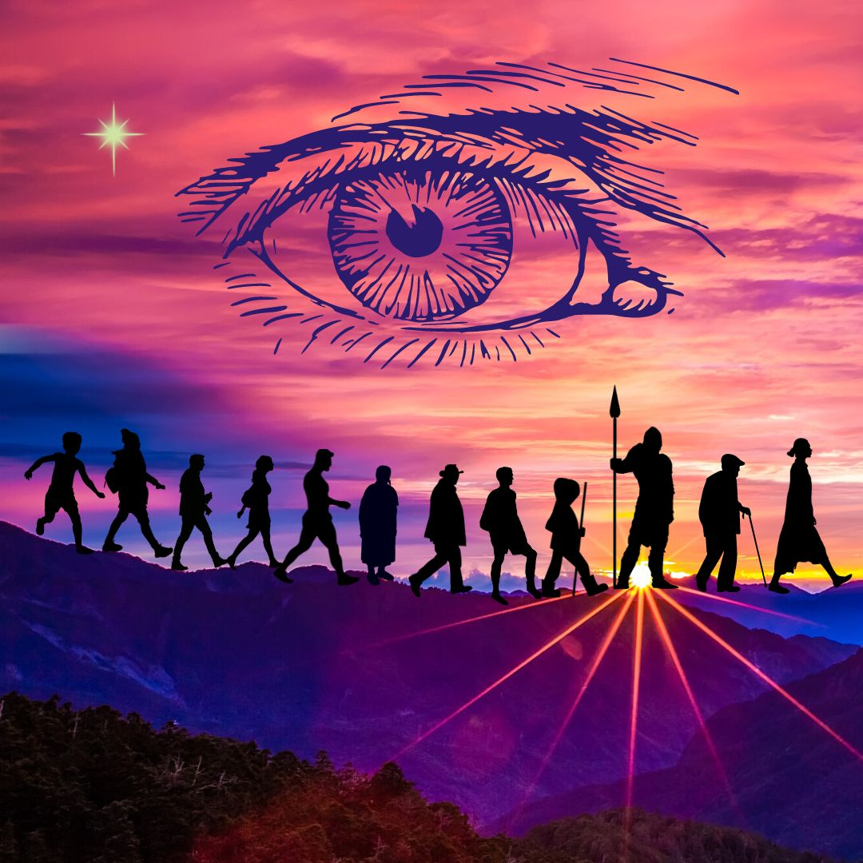

- Paralysis and Tremor in France
Hopelessness, Muscle and nerve stagnation on Right Side

I lived in Southwestern France around 1500 CE. At the age of nine I was stricken with a disease. It was caused by a virus from a bird in a cage in a nearby home and possibly made worse by a low immune function. I’m not sure of the name, but it was something like polymyositis. The disease affected the tendons and muscles on the right side of my body, and I was unable to walk or speak. I lived my entire life from the age of nine mostly paralyzed in a wheelchair. I was adequately cared for by my well-to-do family that owned considerable land. They hired a caretaker to look after me day and night, a person whom incidentally I know in my current life.

My brain and senses functioned normally. I could see, hear, taste, smell, observe, and understand perfectly. But I could not read or hold a coherent conversation. I could not feed myself and needed help to go to the bathroom. I made specific sounds to indicate I needed assistance. I stayed in the family home and rarely went outside. It was a loveless life, a helpless existence even though I received what one might call perfect care. I had a few acquaintances and neighbors, but no friends. My emotions were undeveloped, and I could not finish school. I sat quietly in my wheelchair all day. I did not feel sadness specifically. I felt empty, unloved, unlucky, useless and bored.
As the disease progressed a tremor developed in my right arm and my right jaw which was constant, and I could not control. At the age of 40 the shaking reached a point where my family and caretaker agreed it was best to end my life with an injection of opiates administered by my doctor. I was not aware of their decision and died peacefully.
- Three Bullets to the Head in Bordeaux
Anger, Cranial nerves, Dental Trauma, Fear

I was a young man 22 years old in Southwest France near Bordeaux in approximately 1735. For many generations my family had owned a parcel of land, about 40 acres, which we used for large-scale farming. Over a period of 12 years, our neighbors started cultivating our land, taking a little at a time, raising grain for animal feed to sell. Our numerous arguments were a terrible source of tension on both sides, leading to a pattern of worry, apprehension, fear, and dismay in me and my family. Three years earlier on his deathbed my father asked me to reclaim the land stolen by our neighbors and put an end to the strife. I was strong. I was very religious. I was determined to carry out my father's wish. I decided to confront my neighbor, a man of 42 years, in the nearby town. He was belligerent with me, pushy, and drunk. We tangled, and I shot him with a bullet to the heart. I was sorry to do it, I know it was a mistake, but he deserved it.
A few days later his three sons came for me suddenly, demanding justice, retribution, and were determined to kill me. They shot me with three bullets to the head. One bullet entered in the center of the upper palate above the lip. It didn’t go very deep, stopped by the bone and teeth. I probably would have survived. The second bullet entered the right side of my cheek through the upper teeth and gums. It went straight through the sphenoid bone, lodging deep in the cerebellum tissue, and was fatal. The third bullet entered my forehead and brain just above my right eyebrow. It penetrated deep into the frontal lobe of the brain. I died instantly. After my death there was no more dispute. They kept the land.

- Bone Marrow Cancer in China
Grief in skeleton, Chronic Low Energy, Weak Kidneys, Tired Blood

I was a monk in Western China, approximately 25 CE. I came from a noble family that lived in the royal court of the Emperor. I chose to be a monk at the age of 12 and my family agreed. They sent me to the best monastery, which was two days travel from my homeland by caravan. I was very well educated, handsome, and good student. I became a Qigong teacher in the monastery. I wore my hair long, tied back in a bun. In my monastery there were 350 monks, all men. We were not vegetarian. We supported ourselves with farming and animals. The monastery was very well endowed. I loved to read. I loved to pray, meditate, participate in ceremonies and rituals. Our practice was related to Bon Buddhism.
Shortly after I arrived at the monastery, I experienced a trauma which clouded my entire life. My homeland was invaded and conquered by a neighboring warlord expanding his territory from the East. The invasion was quick and premeditated. Within two weeks my family, the Emperor's family, and all nobility in the court we're dead. Both my parents, my two brothers and my sister were killed. Many other people died. After I heard the news, I felt so weak sad and sick. I was shocked and dismayed to hear of this terrible loss. I suffered anguish, anxiety, grief, hurt, sorrow, and wounding. I felt the stress of my family, the betrayal and loss of the entire kingdom in a terrible war. This sadness evidently entered my bones. I developed cancer of the bone marrow. I lived the remaining years of my life in the monastery, feeling diminishing strength, unable to visit my homeland or see my family ever again. I died of bone marrow cancer at the age of 51.

- Zapotec Priest Killed in Aztec War
Cranial pain, Dental Trauma, Fear, Skeletal Imbalance

I was a handsome young Zapotec priest in Oaxaca, Mexico in roughly 1230 CE. We had lived in peace for many years in this area, however recently the Aztecs came from the North with the desire to share their religion and their violent practices to appease the Gods. My tribal brothers and I experienced trauma which lasted for 17 years of my life. We experienced great fear, apprehension, dismay, exhaustion, and terror. We had to fight many battles with the Aztecs.
They killed many of my community of 2,500 people. In this particular battle they killed about 150 men. I died at 31 years of age.
I was very strong and handsome. I wore my dark hair long around my shoulders. I had beautiful strong legs which I liked to show off. I was not married and had no children, but I loved sex and had three secret girlfriends. I loved them all very much, however since this was against the rules, I was secretive. I was not only a priest, but also a warrior and a dancer. As a priest I performed ceremonies, blessings, and seasonal rituals. I gave blessings for new homes and projects. I had many friends and was very outgoing. I wore a strand of white shell beads around my neck.
Continuous strife with the Aztecs was very troubling. They felt compelled to dominate us with their beliefs and ways. Our gods were very different. Our traditional ways we're more peaceful, gentle, and life affirming. When the Aztecs invaded, they were very violent. They had scary, dangerous rituals, and sacrifices that we knew about. We wanted to avoid them at all costs.
In the battle I was killed with a knife to the corners of the mouth ripping my cheek and mouth from right to left end to end. It was a bloody, deep cut. I felt a sharp pain on my right cheek as the knife cut through my cheek and gums. The left side was cut the same but not as deep. I did not die immediately. I lay there bleeding as the battle ensued. I could not fight anymore. I bled to death in about 45 minutes.
The Aztecs caused a huge loss of life in our group, and many strong warriors died. At that time we lived in constant fear of attacks which came regularly several times a year and continued for several hundred years after my death. However eventually the Aztecs could not win because they had many enemies and other battles to fight on all sides. The Aztecs are gone now, and our tribe still survives.

- French Army Officer, Musket Shot to Brain
Trigeminal neuralgia-shingles, Right Cranium pain

I was a nobleman and officer in the French army in the year around 1657. I was killed in a battle as the French were advancing into territory controlled by Austria. This was a skirmish with the Austrians from the East. The battle was in Eastern France near present-day Germany. We said we were defending French lands, but the truth is we were claiming land long controlled by the Austrians in order to gain a position of power in the ever-changing landscape of Europe.
I was married, I had a beautiful wife and two boys. We lived on an estate in a large mansion. Although I was a devout Catholic, I had a girlfriend in town the whole time I was married. I loved her of course but I loved my wife more. I had inherited the land from my father. We owned beautiful hills, a large vineyard, and sold grapes to local wineries. I liked to drink liquor from time to time, something like bourbon or whiskey. Servants on our land tended the grape vines and kept a flock of about 40 geese. I had some relatives in Quebec. I liked to relax and smoke cigars.
We successfully won this battle and many others, but I lost my life. I was shot with a musket in the right side of the head. The gun was shot at my head by an Austrian from 50 feet away and smashed a hole in my head. The bullet exploded on my skull, damaging the zygoma bone, the right jaw, sphenoid, and the area around the ear. I sustained brain damage near the right sphenoid. It was a bloody mess. The right side of the sphenoid bone was simply blown away, but my right eye was not affected. Fortunately it was traumatic for only 15 minutes. I was taken into a tent because I was an officer, and I died 15 minutes later. There was no priest. Just blood. I was in shock, and I was aware that I was dying. I felt the emotion of grief as I faded out and my brain went fuzzy. I felt deep sadness to leave my family, my wife and two boys. Unfortunately, one other officer was killed. Thirty-two enlisted soldiers under my command were also killed. I was a good officer. I looked after my men. I was well organized, tall and handsome. In battle my uniform was blue. I was respected by my peers, and we often enjoyed a flask of booze together.

- Dental Torture in Tibet
Fear of dental work, Memory of pain in jaw and gums

I was a doctor and teacher of medicine in Tibet in about 1080 CE. I lived and worked in a monastery of about 1900 men and women in Western Tibet about one day north of Mount Kailash by caravan. The monastery still exists and functions in Tibet. We used Tibetan acupuncture points and manual activation of meridians, but we did not use needles. As a doctor I practiced bone setting, reading pulses, dispensing herbs, tongue analysis, and various shamanic tools. The monastery had an apothecary of many healing herbs, which I prepared in personalized combinations for the monks. I loved working with herbs.
We were a self-sufficient monastery several days West of Lhasa by caravan. I and everyone in our group suffered 24 years of violent disputes with Buddhist authorities. The trauma included the emotions of loathing, unforgiveness, hysterical hatred, and cruelty. This was a highly stressful period of religious strife between ancient Bon practices and newer Tibetan Buddhism. Government authorities and representatives of a King in Lhasa came to our monastery to encourage us to transition from the Bon practice to the new Tibetan Buddhism. The directors of my monastery resisted the imposition of Buddhism. Some of our people were killed.
Nobody wanted to accept the new Buddhism. We found it to be strange, silly, superficial, and hierarchical. There were new rules that did not make sense. New changes, a new language of Sanskrit, new written letters, a new daily schedule, and new statues to prostrate to. The King's men came to visit. These thugs met with our monastery leaders and insisted. When the leader said no, they began torturing the teachers. Since I was a teacher of healing, the Buddhists singled me out for torture, which lasted for six days. They put a siege on our monastery so that we could not go in or out and were trapped inside. It became violent.
Several of the leaders and I experienced brutal torture to the gums and teeth. Buddhist thugs used hot pokers and metal instruments in the mouth, pressing, and pounding into the teeth. My jaw was strained as they pounded inside my mouth on the gums and tooth surfaces. My mouth was bleeding badly. Two of my lower teeth were shattered. The pain was excruciating. There was a lot of screaming during the torture. These thugs were not dental experts. They were cruel. Most of the damage was done to my lower left teeth some lower right, and some upper left.
Eventually they did pressure our Rinpoche into agreeing to Tibetan Buddhism and giving over the monastery to the new ways. After the torture was over, I began to heal. But the experience had damaged my health irreparably, and I never recovered. For the rest of my life I suffered chronic TMJ jaw stress, scarring of the gums, sore teeth, and constant gum pain. I died three years later, but not from dental stress.
I was suddenly killed, murdered by several of my own students in a chaotic time and final dispute around the same issues. They put a poison in my food. I died in my sleep without knowing of the poison or suspecting that I was dying. Fortunately my death was not traumatic.

- Mary is Gone and I Miss Her
Removal of an unneeded entity, more like a friend
On night in this lifetime, as I lay down to sleep, I felt a sharp throbbing in the right side of my head near the cheekbone in front of my ear. “What’s this?” I wondered, since my right cranium has been a busy healing traffic place for a few years, especially recent months. I wanted to fall asleep. I tried to relax deeper into sleep, but the sensation grew stronger and became an intense intolerable pain.
I asked, “What is in my head?” I got the answer that it was an entity whose name was Mary and she had been with me for many decades. She was not harmful, in fact, we had become close friends. First, I began to use my pulling technique which can draw toxic energies out of the body with the hands. I worked on this for about ten minutes and noticed that she wasn’t budging. She was feeling exposed, unsafe. So I asked if it was necessary for me to get up and go into my healing room and say good-bye to Mary. I got a strong answer of yes. So I put my bathrobe and slippers on and stepped into the healing space where I could work quietly and focus.
First of all, who is Mary? It turns out Mary is a retired teacher in Woburn Massachusetts who used to teach 11th grade in the high school, in a building that was later transformed into an office complex. Rudi's Bakery moved into that office complex in 1981, a turbulent and emotional time in my life. In the lonely job of CFO and office manager, I worked late many evenings, and perhaps I needed a friend. Mary was wandering the halls feeling alone after her husband had died, and she had passed away at 78 years old. She was an excellent high school teacher. She taught something like Social Studies and was dearly loved by her students. Mary poured her life into that school, so it was natural that she might feel most comfortable there after leaving her body. She needed a place where she felt she belonged. I was lonely too. I felt unsupported, and my life at Rudi's Bakery, along with a stressful home living environment, was sleepless and friendless. For me, Mary always wore a fuzzy blue sweater over a white blouse. She was an excellent friend and companion. She never disturbed me. She was comforting. Now apparently it was time to say good-bye.
As I sat on the couch in my healing room, I reassured Mary and thanked her for being my friend. I used a technique that a colleague had taught me to remove an entity. I asked her if she wanted to go to the light where she could be free forever, protected, and even have a new body, a new life someday. Her other choice was to go down under. Mary practically jumped at the chance to go up to the light. And as I helped her, she gracefully moved upward out of my right cranium, out of my right chest and neck. I knew it was important for her to leave because it is better for her, and I do not need her anymore. Also I saw there were deeper underlying layers in my body that needed to be addressed. So they would be next in my clearing whenever they were ready - I sensed violent clashing of spears and Greek armies down inside there. Strange - but that is not important now.
I thanked Mary as she drifted softly up above my head and into her new world. Thank you, thank you. Then I asked my inner being if she was still here, and I understood that she was gone. I went to bed and slept well. The next morning I woke up and felt like crying. My cranium bones were shifting around even more, and the pain had moved to a new place. It was tolerable, so I have learned to be patient. This is all good. This clearing process is not easy. In a few days I was fine. However I miss my friend Mary. I am happy she has moved on. I wish her well wherever she is.

C. I Fall in Love, Move to Bhutan, My Teaching Expands

- Sexual Assault in Hong Kong
Sexual trauma, Root chakra blocked, Rigid Connective tissue, Terror
I was a 12-year-old girl in Hong Kong around 1780. I was the only child of a wealthy noble family. I was beautiful and young, but I had no knowledge of sex. I suffered a rape by the cook in my family home. The man was of Indian origin and had worked for my family for about 7 years.
He attacked me in the pantry near the kitchen and raped me violently. My parents were out, and no one else was around.

I felt totally ashamed. I tried to bury my shame, to forget it. I didn't tell anyone because I was so embarrassed. A plethora of emotions overwhelmed me including cruelty, loathing, shock, confusion, insecure, invaded, insulted, disrespected, and maligned. I was filled with low self-worth, anguish, despair, lack of integrity, self- judgement, wounded, terror, fear, loneliness, dismay, apprehension, remorse, humiliation, guilt. And especially I felt ungrounded. My root chakra was damaged. it was a lonely experience.

Later on I was married and had two children. It was not a happy marriage. I did not enjoy sex. I never told anyone about the rape. This experience was never resolved or totally digested.

- Tibetan Oracle Murdered
Anxiety, Food and Chemical Intolerances, Weak digestion
I was an oracle and advisor to a Tibetan High Lama, effectively the King in Lhasa in about 1390 CE. He was the political and spiritual leader of the kingdom of Tibet, like the Dalai Lama, but he did not use this title. For the last three years of my life I suffered enormous grief. I was anxious, despairing, sad, sorrowful, and wounded. My life ended when I was murdered by an Indian merchant and friend of the King. I was 50 years old.

I was born in the court of the king and lived my entire life there. I had a beautiful house in the royal complex in the city of Lhasa. Married with two wives and seven children, I worked as an advisor, astrologer, and one of two oracles to the king. The other oracle was a gifted woman. My talent was discovered when I was seven years old. This was no surprise because my father was also a royal oracle and astrologer.

I loved the King. I loved my children. While my family household and seven servants were harmonious, I did not love my wives. This was somewhat accepted, as the marriages were formally arranged and approved by the king when I was 13 years old. Both of my wives performed their marital duties very well.

I met with the King several times a week. He frequently consulted me with his other advisors about Royal decisions, finances, crops, weather, and defense. My job was to read the future as an oracle, consult the stars, and advise him. I suffered betrayal by an Indian merchant. He was a newcomer in the court for only three years, with an interest in control and money. This merchant sold imported teas and medicines from Northern India. His teas and medicines were excellent quality, popular in the court, and he grew to be a common associate of the king. They played games together and became close friends. Being charming and wealthy, he became an accepted person in the court. We all drank chai together in our meetings. We sampled his teas and medicines. In our meetings I quizzed him about his products, and this irritated him. He eventually came to hate me. Even though we all shared the common religion of Buddhism, I advised the king not to associate or do business with this man. His products were of the highest quality, but I advised the King not to buy from him because I suspected poor integrity and a primary financial motive.

For three years the merchant tried to malign me in various ways. One day on the grounds of the royal compound he suddenly killed me with a knife to the throat and jugular. I died immediately. Everyone learned and understood he had done it. He accused me of wrongdoing to explain his motivation for killing me. This was accepted at the time since he was a close friend of the court. I was buried in the family gravesite, but I was never exonerated. My wives and children were shamed, and they lost some face. However, they were not punished and not excluded from the court because of my high family lineage.

After my death, the King did experience betrayal. He placed two very large orders with the Indian man, prepaid in gold. The first order arrived perfectly. But the second order never arrived, the merchant disappeared, and the King lost the equivalent of 1.5 million US dollars. The King understood everything then. He remembered my warnings and my surprising death. However, I was gone. No apology was made, and neither I nor my family was ever exonerated.

- Sufi Priest Beaten to Death
Skull Trauma, Dental-Periodontal Pain
I was a Sufi priest in approximately 365 CE in Northern Iran. As a holy man I was peaceful and independent. I was not married, had no children and was celibate. I came from a wealthy family with six brothers and three sisters. I was a peaceful man, a poet, and slight of build. I loved perfumed teas, cookies, honey, and sesame candy. I was not a Christian, but I had many Christian friends.

My father was a landowner and trader of all types of goods. He also practiced money lending and was involved in some dirty practices. Sadly, he had many enemies. We lived in constant fear from numerous threats. I experienced years of apprehension, disillusionment, dismay, fear, loneliness, phobia, suspicion, terror, and isolation. My father kept guards around our home at all hours of day and night.
One night I was walking down the city street alone and was attacked by two men with bricks in their hands. They attacked me angrily, beating my head with bricks in both hands. My skull was crushed with nine blows with the bricks. I died instantly.

Our family had many enemies. I was known to be very clever, and I was born rich. I was singled out partly because of my father and partly because of jealousy for my role as a teacher and poet. I knew my attackers, two men who owed my father some money and were very angry.

- Death in the Arabian Dunes
Fear, Terror, Food Intolerances, Hysteria, Heartache
I was an Arabian woman in 1040 CE. I lived in East Oman on a large property owned by my father near the ocean. This was a time of great strife between two ethnic groups. I lived the last 15 years of my life in an environment of hatred, hysteria, loathing, mania, shock, unforgiving cruelty, and death threats. My family was everything to me. We were a noble family of Sunni Muslims. I had two brothers and three sisters. My father was a wealthy merchant and landowner. We cultivated a variety of wheat on a large fertile area near the ocean on the East coast. This was a period of strife between Sunnis and another ethnic group, but I don't know the name. Both these groups lived in the same area. The dispute was about lifestyle, control, politics, and land ownership. There was a culture of hatred and belligerence going on for generations.

I was a teacher in a college-level school. I taught surveying, mapmaking, and tools for land and geographical measurement. This was important not only for land ownership, but also because precious stones that could be mined. These were colored stones of very high economic value for jewelry. I had a great knowledge of gemstones, how to find them, and how to mine them. I was tall, highly intelligent, soft-spoken, a large woman with long black hair. I enjoyed colored stone jewelry. I was a discerning type, not beautiful, but not unattractive. I loved my family, and I loved to play with my nieces and nephews. We lived together in a family home with my siblings. I was known for my brilliant intellect and reliable teaching. I did not marry, as I was not comfortable with or interested in a subservient role or the traditional role playing of women. My best friend was a woman I went to school with. She was married and also from a good family. But we lived very far apart and saw each other only every two years or so.

One evening at sundown I was walking peacefully along the dunes with two family friends. We were attacked by three men. I was recognized because of my family’s wealth. I was strangled to death with a leather cord. The motive for the attack was anger, jealousy of my father's wealth, hatred, and ethnic historical disagreements. I was the only one killed. The others defended themselves and escaped. My family was horrified and dismayed. The funeral was attended by all my relatives, many school colleagues, friends, and the Sunni community.

39. British Violence and Death in India
Fear, Guilt, Cranium bone trauma
I was an Indian woman in West Bengal in about 1795. A noble member of the Brahmin caste living in West Bengal. I was married and taught Ayurvedic medicine at the University level, as did my husband. For 15 years I suffered grief, anguish, despair, hurt, nervousness, sadness, shame, sorrow, and wounding. It ended with my death at 39 years of age.
I spoke Hindi and English. We studied the Ayurvedic nadi energy channels of the body, performing treatments according to dosha body type with herbs, massage, and pressing points. I also practiced yoga postures with breathing and meditation. I was about 5’ 3” tall, somewhat fleshy, with a flexible body, large breasts, and beautiful skin. I loved my family. I had come from my family home in South India to live with my husband in West Bengal after our arranged marriage. I enjoyed cooking for my husband. I loved my husband, but he was quite reserved, older than I, not a passionate man, and I was not fond of sex with him. We had no children. I was the power in our marriage, and I was responsible for most of the decisions.

This was a time of great political upheaval, suffering, and violent uprisings because of the new British domination of India. I was worried that the British would force us to convert to Christianity. I found their disrespect and disdain for our culture shocking and offensive. We were undervalued, looked down upon by the British rulers. Some Indians even felt insecure about our traditional ways compared to more “modern” Western perceptions. I felt the British were draining the resources, culture, traditions, and spirit of my country. I was not politically inclined or identified with any particular group.

One day there was an incident on the street, a gathering or a kind of a rally in a public open area with people speaking their mind. It was a peaceful gathering, and I was an active supporter. Suddenly British soldiers came with clubs and guns, firing their muskets into the crowd. Many people were killed. There were about 650 people at the gathering. 140 people were killed with muskets and many more wounded with clubs. I died with two musket shots to the head. The first bullet struck on the right side of my head in front of the ear and entered the brain. The second shot was to the right side of the jaw, damaging the lower teeth and gums. My husband was also there but he was not hurt. He wept over me as I died in about ten minutes. After the incident there was deep grieving and a group funeral.

- Cantonese Warrior Battles Mongols

Anger, Rage, Trauma to right cranium, Skeletal imbalance
I was a highly skilled warrior in Canton, China in about 1125 CE. As a fighting man, I practiced white light meditation and personal discipline. My Cantonese people upheld a culture of high refinement, literature, art, painting, poetry, advanced medicine, and spiritual practices.
I suffered trauma, frustration, and anger because of the Mongol invasions. I found their habits disgusting and their attitude disrespectful. They came into our land, destroyed everything in their path, and had no value for life. The Mongols were vicious and unrefined. I was not afraid of them; however I was repulsed by their brutal aggression. Their vicious domination caused me frustration, hostility, humiliation, fury, irritation, rage, resentment, and every other type of anger for over 25 years.
I was a professional warrior, the captain of 100 men. We practiced martial arts every day, hand to hand combat, horseback maneuvers, and battle strategy with many weapons and means of defense. It was a violent way of life, fighting with swords, spears, and staffs. This was the Art of War. There were 2,400 men in my larger army. My section was 100 men on horseback, and we fought side-by-side together. We were highly skilled fighting battles on horseback. We wore helmets and leather armor. The generals were responsible for overseeing strategy from high on the hill. But I was in the thick of battle with my men. I was responsible for training them and preparing them for battle.
We dedicated our lives to protect our people and our culture from the cruel domination by the hostile Mongols from the North. They were barbarians. They took anything of value and killed everything in their path. The Mongols did not take easily to other cultures. Every meeting with them was a life-and-death matter. If they liked you, they would let you live - that was the greatest compliment. If anything bothered their sensibilities even slightly, they would kill you immediately.
I was 5 feet 6 inches tall, broad-chested, broad shouldered, strong and handsome. My main skills were martial arts and meditation. We used Qigong and martial techniques to train for strength, flexibility and balance. We trained constantly. My body had been slashed many times, and I endured many wounds. I was not married. I loved women very much but did not wish to marry. My greatest joy was to prepare for battle and train my men, to refine my inner skills. I taught them horseback archery, swordsmanship, hand-to-hand combat, how to keep the body healthy, how to stay strong. I was a good cook and I loved to eat bone broth from meat. I loved my men and they loved me.
My life-long anger with the Mongols was due to their constant threats and offenses. They were a terrible scourge of cruelty and violence, killing wantonly wherever they went. It was an intensely violent time. We endured constant tension, cruelty, and trickery from the Mongols. I was angry because I found their barbaric ways unrefined and abrasive. They lived only by the sword. Every meeting and every issue came down to a life-or-death moment. We did prevail and drove them back many times. We were successful to establish a more peaceful rulership, to send them back to Mongolia for a time. But it was not the end.

I was a fearsome warrior. To prepare for battle I went deeply into meditation. I went deeper and deeper until I felt the white light and utter stillness. I found power and light in that expansive emptiness, which allowed me to be completely one-pointed in battle, and to move beyond fear or pain. Yes, I was a fearsome warrior.
I had many battle scars on my face arms and chest. About my wounds, I had endured many broken bones, such as a right humorous bone, right wrist, and my left little finger was missing a flange where it had been cut off. My collarbone had been broken, my left shoulder dislocated, and my left bicep had a long scar. My left ankle and leg were twisted permanently. I had other scars on my face.
My final battle was vicious. I was formidable in fighting, utterly fearless, strong, and precise. I had successfully taken out 24 Mongols. We were winning. I was on horseback distracted with another opponent and didn't see until too late a heavy sword coming down on my right side. It struck me from above, fractured the skull, went deeply into the brain, the right side of the head, broke the clavicle and cut into the ribs and torso. It was an honorable death. I was a good captain. I was not sad to die. I was with a few of my men. I accepted it.

- Mercury Poisoning in Medieval Belgium
Mercury toxins in liver and bone marrow, Phobia, Hysterical fear
In about 785 CE, I was a woman living in Western Europe in what we now call Belgium. I was a noble woman responsible for the functioning of my feudal household. I lived on a country estate. I was married with two children and eight servants. My children were an older girl and a younger boy. We spoke a kind of Flemish. My husband was a landowner of a large plot of agricultural land where we grew various kinds of wheat. I was a strong and attractive woman of medium build. I was not educated. My role was to manage the feudal home and to control the finances for the estate. I did not read or write words, but I could write numbers and I kept careful records of our spending using pen and ink made from Cinnabar. I got the ink from the monks who also used it in their writings. I died of mercury poisoning. We didn't know mercury was dangerous, as it was used widely for many purposes.
I wore a blue dress, a white apron and a white cotton cap. I loved to keep everything running smoothly, managing the operations of the household and the estate. I was responsible for eight servants in the home and my two children. My husband took care of the workers outside the house on the land and the animals. We ate our own wheat and bartered for other goods, occasionally using gold coins for exchange. I was very good at keeping my books and calculating in my head. I was very skilled at multi-tasking to keep things running smoothly.

The source of the mercury poisoning seems to have been a combination of things, primarily my cinnabar red ink, however mercury also was used in making silver jewelry, silver dishes, candlesticks, tools, and hats. Mercury was everywhere. The average lifespan was about 45 years, because of hardship and poisoning. I had one sister who had the same malady. It was common and we had a name for it, but I do not know it. The illness starts with disorientation, a slight nervous imbalance and a tendency to be fearful. As it progresses it manifests as shivering nervous disorders, phantom or moving pain, phobia, fear, terror, insanity, and death. It happened mostly in well-to-do people. It seems most of the mercury in my body had accumulated in the bone marrow where it led to poor blood cell formation and blocked stem cell function in healing and regeneration, hence it often led to early aging and death.
Mine was not a traumatic life except for the last years of physical pain and slow, anguishing confusion until death. My health started to decline at 48 years and slowly I experienced more fear and disorientation. My servants took care of me until the end. My husband died four years later in an accident. He also had mercury poisoning, but his was less severe. My slow decline in health started with poor brain function, ultimately falling apart and withdrawing into a strange, inner world of fear, phobia, and confusion. This was a common death at the time.

- Chaos in Cantonese Imperial Court
Anguish, Grief, Musculo-skeletal imbalance, Sexual fear
I was a legal advisor and consultant to the Emperor of Canton, China in about 1100 CE. The empire was in transition. Although I had a secure position of responsibility and a duty to the Emperor, there was no clarity and no stability in my work. I lived in a small village near the Emperor’s royal court. My responsibility was to negotiate solutions to social problems such as land and property disputes between people and towns. I was respected for my integrity and my courage. All of my decisions had to be approved personally by the Emperor. Due to the constant upheaval, I felt completely unsupported by the Emperor and his government. As a result, I suffered enduring trauma for 25 years of sadness, frustration, sorrow, wounding, and anxiety.

I was known for being fair-minded. My way of working was to negotiate creative solutions to problems, land trades, and bartering, so that everyone got along. I took great pleasure in finding creative win-win solutions. But there were never-ending disputes in the Emperor’s court. There was pressure from invading Mongols from the north, from Buddhists in the West. And even though my job as minister for the Emperor was to resolve disputes, it was always difficult to find any common agreement.
Because I could read and write, part of my job was to keep written records of common disagreements. I was responsible to help people network, connecting them to solve problems in farmland ownership disputes and cultivation rights. I helped many people. I met and befriended hundreds of people.

I was born in Western China and came East with my wife to find a more peaceful life. She was a very strong-headed woman, so my home life was also challenging. I was deeply creative, slight of build, and a good horseback rider. I was married with three daughters. I loved my wife and children. I was a Taoist and I practiced meditation daily. I had no enemies at all. Just stress in my job. Terrible stress

My only desire was for peace, harmony, and smooth operations, but the problems in the Emperor's court never ended. Ultimately, I expired of natural causes, you could say. I died of liver failure and stress. It was a good life, just too much overwhelming strife and chaos.

- Balinese Child Bride Sold in Marriage
Anger, Mental anguish, Liver congestion
I was a Hindu woman in Bali, Indonesia in approximately 810 CE. I suffered 24 years of feeling trapped, angry, depressed, frustrated, hostile, humiliated, irritated, enraged, and resentful. When I was 13 years old, my family sold me in an arranged marriage to a man who was 32 years old. He paid them the equivalent of $4,000 USD. I was his first and only wife. We had no children. When we married, I moved to live with him in the country where we had a garden. I loved to work in the garden.

My husband did not love me, and he did not love anyone. He had no capacity for love, empathy, generosity, passion, or sharing of any kind. He was of thin build, a man of low energy that did not do any work in his whole life. I had to do everything. I worked as a teacher of children. I was religious as a Hindu and had many friends. But my husband gave me no support, emotional or economic. I endured great hardship both physical and financial to support his comfortable lifestyle, to cook his food, keep his home clean, and wait on him. He had no concept of relationship or support. I was a woman of medium build with large breasts. I loved gathering with my women friends. However I was mad at God, at my parents, and at my entire family. I felt trapped like a slave my whole life, and I died angry at the age of 38.

- Clan Leader Murdered in Caucuses
Anguish, Right chest trauma, Heart and Chest tension
I was a clan leader in the Caucuses mountains in about 200 BCE, in the area we now called Georgia. We had lived on our land for many generations, farming, raising animals, and trading. We were a settlement of about 90 people, 35 families. I was known as a wise man, storyteller, lineage holder, trader of cloth, grains, food, and beads. I was married with two wives and three children. We all lived together in earthen brick homes and spoke an ancient unwritten language that was a kind of distant derivative of Sanskrit. Our language was quite refined, although it was only oral. We used multiple verb tenses and conjugations similar to modern European languages. It was a rustic, mountainous area of very beautiful land. I loved the hills, the rocks, the waterways. Many traders passed through this area, and I came to love teas of all types.
Our religion was to the ancient Gods. We offered rituals at important times of the year as blessings of births, deaths and special occasions. We had many Gods, both male and female with different powers. Each person chose their special God. Mine was Ra.

For most of my life I suffered trauma and constant disturbance from the desert people to the Southwest. They came from an area we now call Iraq. They came from the desert to steal our animals, our food, and our land. They would steal one household at a time. We had to courageously fight them off. It was a lifetime of constant grief, anguish, anxiety, despair, discernment, integrity, sadness, sorrow, wisdom, and wounding. The invading nomadic tribes were jealous of our beautiful land and made constant encroachments to steal it. These people had no value for life. They had a different religion which allowed warlike behavior and stealing. They were even willing to kill women and children.

This had always been our land. The land made us strong. It was our life. We were vulnerable with no army, but we were willing to defend it to the death. In the end they did not succeed, and they had to stay in the desert. They came with horses and camels, fighting us with swords and spears. We banded together to protect each other. I was strong, a man of very few words, a lineage holder, with a full beard and a large frame. I died at 47 years of age defending my land. We were fighting on horseback. I suffered a heavy blow with a sharp sword to the right shoulder and neck from the front, and I died within a few minutes. My two wives and family buried me on our land. After my death, my blood descendants continued to live on that land for many generations until modern times. They were ultimately displaced by the discovery of oil and recent wars in Georgia. They now live mostly in Russia.

- Buried Alive in the Inquisition
Anger, Rage in spine, Tailbone junction blocked

I was a Jewish merchant in Portugal around 1545 CE. I lived in a city in the south of Portugal near the ocean. I was a well-to-do trader, married with two beautiful daughters. I made my living by importing spices and teas from the East. We had an international network of Jewish traders in Spain, Portugal, Italy, Tunisia, Greece, and Turkey. I was educated in the synagogue by the rabbis. I spoke Portuguese, Spanish, and some Hebrew. All the Jewish men I knew were able to read and write. I could read the scriptures pretty well and I celebrated the traditional festivals.

I was not particularly religious. I wore traditional Jewish clothing, long hair, and a yarmulke hat. I knew many Christians and Muslims as friends and customers. Especially I loved sweets, honey, teas, spices, and of course my daughters. For the last 24 years of my life I suffered constant stress of anger, bitterness, frustration, hostility, infuriated rage, and resentment, due to the Inquisition that was beginning in Portugal. Many of my friends and colleagues converted to Christianity. I did not. I was proud of my heritage and refused to succumb to the petty intolerances that pervaded government and religious circles. I expected it to pass.
The Christian authorities came to my house during the day and took me and my family to jail for detainment. It was a filthy center with a dirt floor and no windows. We were held there for a week with no food and water. During that time I was beaten, tortured with hot pokers, metal poles, and spears, along with the other men. They broke my spine in several places, and the sacral-coccygeal tailbone junction at the base of the spine was shattered. Fortunately the women and children were not tortured. After a week all 30 of us were pushed into a group hole that had been dug for the purpose, and we were buried alive. There was no trial and no discussion.

I was of medium build with brown, curly hair. My dark eyes often burned bright with anger to defend my family from the senseless fundamentalism of the time.

- Native American Acute Dissociative Stress
Phobia, Mental instability, Panic, Self-sabotage, Confusion

I was an indigenous woman in about 1390 CE living in what we call West Virginia. When I was 12 years old, I suffered a bear attack. A male bear suddenly entered the teepee when I was having my period and attacked me. I was badly wounded and almost died, left with scars on my face and body. The event left me in a permanent state of mental anguish and panic that never went away. My life was entirely conditioned by fear. Fear was my God. It was a type of mental disease where the nervous system feels so overwhelmed, so over-stimulated, then it shuts down, closing the mind and the nervous system. I never spoke again. I lived in my private state of anguish that was always with me.

We were a nomadic hunt and gather tribe living in the forest about one day's walk from the Atlantic Ocean. I remember the smell of the forest floor, of the deer, and I loved the smell of food cooking on the fire in our teepee. Although I was married, my husband did not love me, and I had no children. He tolerated and accepted me as his second wife. This was very kind of him, since he married my older sister, and she was my guardian.

My condition caused problems for the family and the whole tribe. Although I was not retarded, it appeared as so. I lived in a state of constant impending doom, a panic or fear that I could never come out of. My sister and her husband felt sorry for me. There were about 40 people in the tribe. I was the slow one. I was slow to learn, slow to adapt and to do basic chores. Sometimes I could sew skins or clean skins. I could not cook or gather food, prepare meals or store seeds. I could not care for the children. I was a burden to my family. I lived engulfed in worry and fear of another bear attack.

No one was able to help me in my condition. They didn't know how. I died of natural causes, heart failure. I loved the sunlight. I liked to huddle in safe places under trees, in crevices and caves. I felt as if I was drowning in terror all the time.

- Fear of Mother’s Insanity
Fear, Adrenal deficiency, Low Energy, Phobia-Impending doom
I was an indigenous woman living on the Caribbean on the island of Barbados in about 1495. I suffered 28 years of fear of impending doom. I had no siblings. My life was an ongoing trauma because of my mother’s insanity. My father was absent for my whole life. My mother was insane, mentally unstable. She was not a bad person, and I did love her. As her only child I was responsible to take care of her for my entire life. This was very stressful as her condition changed every minute. One day she had dementia and could not remember anything. The next moment she was hysterical. And after that schizophrenic. After that depressed and weeping uncontrollably. We had no names for these intense mental changes. Her good times might last two days. My mother's nervous system disorder was an emotional and chemical imbalance that gave her no peace. I tried everything. Literally I never gave up. But every few days she changed. Finally I passed into constant state of exhaustion and fear of doom, or fear that something terrible would surely happen.

We lived in a village of wooden palapas, open houses, on a hill near the ocean. I loved getting out of the house and feeling the wind across my face and ears, looking out and imagining how I might somehow go far, far away. I was never married and never had sex. I loved to eat roasted sweet potatoes from our garden. And I loved fresh fruit.

My mother treated me terribly. She did not love me as she was incapable of this. But she did not hate me either. I was all she had. She treated me according to her inner state. Her emotion was alternately hysterical loathing and attacking, or suspicious fear. I understood and forgave her, however my heart suffered.

At 28 years of age my heart stopped. I had not been harmed in any way. I was simply so exhausted that it stopped beating. After I was gone no one wanted to look after my mother. She suffered alone and died soon after.

- Self-hatred and Arrogance in China
Brain Congestion, Depression, Lymph stagnation, Self-hatred
I was a Taoist man, a wanderer-beggar in the Western hills of China in approximately 1190 CE. I was of slight build and weak physical constitution. I had been poorly nourished as a child. I was not married, and I had no children. I was arrogant, cruel, loathing, manic, changeable, unforgiving, selfish, devious, sour, and manipulative. This was a life of self-hatred and a kind of self-poisoning.

I was not religious. All of my trauma was caused by myself. It was just my way. I was born this way. My mother was the same. She had a very difficult life. Unlike me, she became this way in response to hardships in her life. My father was absent for my whole life. I loved the smell of pine needles on the forest floor and the sound of footsteps walking through them. We lived in the forested hills of Western China. My mother gathered wild plants, berries, nuts, seeds, and roots to live on.

My younger brother was not normal. He was emotionally bruised and could not function. I had to be both father and mother in the family, and it was impossible. At 17 years of age I left and never went back to see my mother or my brother. After that I had no friends and no family.

Whatever I touched or ate seemed to putrefy and turn bad. As a result nothing nourished me. This is self-poisoning. The lack of nourishment, without love, forgiveness, or stable home life, I suffered sour digestion, poor self-esteem, low self-worth, leading to an unbalanced and ungrounded life. This was my pattern. I hated myself.
I died at 45 years of age in the forest, strangled by an acquaintance. I had just finished gathering some food and was preparing to eat. He came to me and said he was starving. He asked me to share it with him, but I refused. I told him arrogantly that it was my food. But he was very hungry, alone, and stronger. He killed me so that he could live.

- Phobia After an Earthquake in Turkey
Digestive Trauma, Self-hatred, Phobia of Impending Doom
In about 450 BCE I was a young woman living in central Turkey near the Black Sea. When I was 17 years old a devastating earthquake destroyed my home and town. My entire nuclear family, mother, father, and two brothers lost their lives. Many people died in the earthquake. Rocks were falling everywhere, homes collapsing, huge boulders. I was hit by a stone and knocked to the ground. My shoulder and the right side of my body were pinned to the ground for about 12 hours until a neighbor was able to free it. My organs were partly crushed. My hand and fingers were wounded and permanently disfigured. The combined shock of the earthquake, my accident, and loss of my family were overwhelming to me. I never spoke again.

I was a middle child, short in stature with dark hair. I was not married. After the earthquake I lived alone in silence in a kind of a makeshift lean-to dugout house. It was a tiny space, and I could barely stand up. I loved the smell of the earth around me. However it was a life of petrified fear. I had only one functioning arm. I suffered poor digestion and poor nutrition. The shock to my nervous system was permanent. I lived in constant fear of another earthquake. I died of natural causes, organ failure, at the age of 42.

- Babylonian Strategist Conquers Aramaeans
Self-rejection, Self-poisoning, Neck Pain, Entitlement, Superiority
In this very unusual healing, I began with a big question. Instead of asking my usual question, to request the next priority trauma to be lifted, I asked to find the root of ALL my illnesses. Although I am glad that I asked this question, the answer that came shocked me to the core. What I found filled me with horror. And it helped me to understand with compassion the self-hatred and unworthiness I have held inside myself for so long. This was a major discovery that I see as a turning point in my existence across many lifetimes. After the session, it felt like a black poisonous mass had been removed or rather exploded inside me. And the shards of debris from this explosion were so huge, they would take some time to clean up. Yes, there was great discomfort after this session, physical, mental, emotional, spiritual. However within six months after the clearing, my present life had been utterly transformed for the better. This was the most important transformational clearing of my life.
I was a Babylonian man of royal birth descended from the Gods in roughly 3,700 BCE. My role was that of a brilliant strategist working hand in hand with a cruel King. We were a team of three, the King, his brother and me. They were 1/4 God. I was 1/8 God. Hence, they were taller and of a higher rank than I was. My name was something like Yuri. I was handsome, very strong, almost seven feet tall, and my role was to be the mastermind of death and destruction.

My father had been a powerful man in the Babylonian noble court, and my mother was a commoner. Since my father was 1/4 God, I was 1/8 God. He taught me the ways of the Gods, that we were destined to rule the world. Anyone who did not follow was to be eliminated. I was raised with the belief that I was entitled, powerful, that it was my divine right and the destiny of the Babylonians to rule the world. I loved our land. We lived in a place called Uruq, which in modern times is called Iraq. I was married with three wives and six children. I was very fond of my four sons and taught them the ways of my father. This was important because my sons were part God as well, although they were only 1/16 God. We worshipped, or more accurately, we drew our energy from the Gods, our forefathers. Therefore we felt empowered and entitled in our lineage of rulership.

Our Babylonian civilization consisted of about 1.5 million inhabitants in the area we call Iraq and parts of Turkey. We were a unified kingdom for most of my life. Our goal was to expand to the West to enjoy the ocean for seafaring voyages into Greece, Turkey, and the islands. I loved my three wives and treated them well. I provided everything they needed - homes, food, servants, animals, land, water.

As masterminds of war and destruction, the three of us set out to eliminate our neighboring province, their culture, and all their people. This was a religious disagreement that could never be resolved. They said we were worshipping evil, by honoring our God Baal. Perhaps this group was the Arameans. They were native farmers and herders in the area we now call Syria. These were not Hebrews. They had their own language and culture similar to Hebrew to the West of Babylon, along the Mediterranean coast. Their culture is not widely known in modern times. They worshipped the God Ra and had religious practices similar to the Egyptians.

We did everything possible to destroy them. We sent armies of killers, we raped their wives and daughters, we blockaded their cities so they could not get water or food. This was not a righteous war of faith. This was not hatred or fear. It was a calculated, systematic extermination. The Arameans could not and did not retaliate. It was a total ethnic purging. We did this for 20 years until finally they were no more. Some of them escaped into the area we call Lebanon, but we were unaware, or we would have gone after them.

The Babylonian King and his brother were my best friends throughout life. Together we believed it to be our destiny to cleanse the earth of these people. As descendants of the Gods, it was our divine right and duty to wield our power over men. We had powerful armies trained in the use of weaponry, spears, knives, horses, torches, and poisons. Oh yes, we sent spies to infiltrate their leaders’ homes and into their kitchens to poison their food. We destroyed their houses with torches that were fed with a kind of burning tar from the ground. My brilliant work as a military strategist was to find their every weakness and to take advantage of it at their most vulnerable moment. We gave them no rest. Working as a team, the King, his brother, and I were the architects and designers of destruction. We worked diligently with pleasure.

We traveled over a wide area of the Middle East in our war maneuvers. Before an important battle, we prayed with special chants to our God. We used ancient implements from our forefathers. We made sacrifices to Baal of the most beautiful children, to send them into other dimensions for the God’s pleasure and enjoyment. We ceremoniously ate the children sacrificed as part of the sacred blessing. When he reciprocated with victory, it was a huge celebration, an intoxicating high as if we were on drugs. We pillaged, sacked, and raped everything in sight. We were even convinced that these women enjoyed the pleasure of being with a God. During the celebrations, all of us including our soldiers raped women and children singly and in gangs. As descendants of the Gods, we were destined to rule the world. This was our right. We did not use mass graves. We left the dead bodies for the survivors to dispose.

I was directly and personally responsible for the deaths of over 450,000 people, men, women, and children. I loved the emotional high of winning. Victory over others excited me sexually, and I felt my masculine power flow through me like an electrifying divine power. I personally killed over 100 people with my own hands, and I personally raped over 110 women and girls. Our God was the most powerful. He protected us, made us powerful, and could not be chastised by a weaker God.

After the victory was complete, some of our new Babylonian leaders in the royal court disapproved of our actions, and our war was seen in a negative light. A new group took control of the country, and we were slowly ostracized. The new King and his colleagues were of our same lineage, 1/8 God, and I knew them as acquaintances. When I was 61 years old, the former King, his brother, and I were sentenced to death by hanging.

Our new rulers spoke to us patiently and tried to explain our errors to us. They were fierce, determined, and also compassionate. At the end of my life I saw my error in the destruction and terror I had caused. I felt great remorse and sorrow, and I accepted death as a small payment for the violence I had inflicted. But my friends the King and his brother were resolute right to the end. The three of us, the former King, his brother, and I were publicly hung from the neck. The sons of the King and his brother were banished, forced to leave our country forever. My sons were not banished, but they lived with the stigma for one generation. My physical seed is still alive in many parts of the world even after many generations. It is primarily found in the Slavic countries, Turkey, India, Greece, the Americas, and all European nobility.

I’d venture to guess about 1,750,000 people living today come from this genetic lineage, who share a similar past life pattern, if they choose to find it. I speculate that many of them continue to live out the same games of fear, control, raping, killing, and satanic possession. For the mess that continues today, perhaps we can “blame the Gods”, who were maybe just extra-terrestrials that lived here for a while and bequeathed us their selfish ways. For some reason I dropped out of the club and had a change of heart at the end of that fateful lifetime. The fact that I felt tremendous regret and shame for what I had done, I believe was a lesson learned, a turning point in my over-arching existence. Perhaps my remorse before death helped to make me a better person, kinder, and more compassionate in subsequent lives, with possible hope one day to attain true spiritual virtue.

- Stigma of a Bastard Part-God
Arrogance, Heartlessness, Fear, Loneliness, Hypersensitivity, Grief
I was a hybrid part God living in the area we now call Syria in around 3,000 BCE. I was born into the Hebrew community of my mother but lived as a total outcast. I was 1/4 God. My father was 1/2 God, also the son of an illicit relationship between a God and a Hebrew slave. As a result, both my father and I were rejected by both communities. We were outcasts, hated by the Gods and Hebrews alike. Yet at the same time since we were descendants of the Gods, we were considered physically, mentally, and spiritually superior. My grandfather the pure God bequeathed to my father a piece of land and a village of about 1,400 inhabitants to rule and to be the lord of the land. I was an only child and my father passed this on to me. I was tolerated with some compassion, but I was not liked, in fact I was strongly disliked. My father was very cruel to me as a child and spoke harshly to me. My mother died when I was 12 years old. After that my life became even more difficult.

I was married with three wives and seven children. Even though I was part of the Hebrew community of my mother, I was not allowed to go to school or to attend religious services. So I was illiterate. I had approximately 150 slaves and servants that worked for me. On my land we cultivated crops, primarily barley and pomegranates. The other residents of the community were allowed to plant their own gardens and required to give me a part of it. We did not use money. We traded in goods.
I was cruel and hated, just like my father. I carried a pattern of arrogance, brutality, cruelty, and entitlement. I treated people badly and I was feared. I beat my wives, my children, and my slaves. But my primary area of focus was psychological manipulation to limit the lives of the people in the community. Because of this my family lived in a shadow of fear. Although I did not treat my children or my wives well and I did not love them, I demanded the greatest respect and service from them. In the community I handed out punishments frequently. Not always death, but beatings and public humiliation. I did not do this personally but had a few close associates carry out my orders. They were the type of people eager to dominate, not particularly loyal or obedient. The fact that I was 1/4 God made me irreproachable in everyone’s eyes and mine.

There was no love in my life and no joy. I wanted above all to be deferred to, to be obeyed. I lived my whole life like that, stubbornly rejecting any opportunity to change. My children bore this stigma in the community and were also disliked. I was not trusted. I controlled the value and exchange in the community. The citizens paid goods to me for the right to live there and for the right to cultivate their gardens. We exchanged household goods, food, animals, beads, and services, but not money. I was miserly and stingy, for no other reason than to control. Since everything in the community belonged to me, I went to the market every day and asked for what I needed. It was always given to me. I did not care what people thought of me. When I was 38 years old my father died, which was a great relief to me. After that I followed in his footsteps completely.

I was 6 ½ feet tall, hairy, with a very powerful body. I felt no self-love and my heart was closed. My primary interest was not to accumulate wealth, only to control and be obeyed. It was a pointless life. I learned nothing and benefited no one. I was a womanizer. I raped over 60 women in the community. Since everything in the community was mine, I believed it was my right to enjoy the women especially since they were commoners. Doing this made me feel good and strong.

When I was 42 years old the community suffered a severe tsunami, which caused great destruction and hardship for the people. I did not lift a finger and did not consider it my responsibility to help them. I let them fend for themselves. During the high water, I fell and hit my head on the right side. It was a bad fall, with tissue damage and broken cranial bones including the zygoma and frontal lobe. I lost my eyesight in the right eye, and soon after in the left eye. The people in my community took care of me kindly, out of duty. My children took over operations in the village but behaved no better or kinder than I had. I became confused, developed dementia, and grew mentally unstable, fearful with a constant phobia of foul play, fear of revenge and retribution all around me. Still I felt no remorse, no shame. Just fear. I died completely blind at the age of 44 of organ failure. After my death my sons carried on in the same way that I had.
.
- Monk Uprising in Burmese British War
Phobia of impending doom, Rage, Anger, Nervous Anxiety
Four lifetimes ago I was a Burmese monk around 1842. I lived in a monastery where I taught meditation and chanting. I lived a celibate life outside a small town in Southern Burma.
I was born in a well-to-do family, but when I was 10 years old my parents were killed in the strife with the British, and I moved to the monastery at that time. Most of my family died in the upheaval. I had just one brother, married with a family.
My life was conditioned by 60 years of traumatic fear. In Burma there was great political and social upheaval due to the British presence. The British wanted to depose the King and end the monarchy, which actively supported and promoted thousands of monks living in monasteries. Buddhist monks became a target of the British because we were not Christian, yet we held together the education system and economy in many ways. The monasteries were actively involved in resisting the British and supporting the traditional ways of life.

The British purposefully disrupted all monastic life for the Monks. We lived in constant fear of annihilation of our way of living. This was my experience every day until my death. Finally I was shot by a Burmese supporter of the British, along with a group of eight other monks. I received three bullets, one to the side of the head, one to chest, one to the organs, and died immediately.

- Jewel Thieves from Palermo
Terror, Lymph congestion, Abdominal organ trauma
I was a queen living in Persia in around 1455. I was the third wife of five wives to an important King, and I had three children. I lived at the court, in our separate quarters where I lived with my children and servants. My husband was the head of a very large kingdom and a respected warrior. He loved people. We had many friends. He liked to entertain in the court, and we often had foreign guests.
During this period of time there was a group of men from Palermo, Sicily that came to visit the court. My husband took a liking to them and helped them get settled. Even though they were Christians and believed us to be infidels, some of the men took Persian wives and made their homes in our community. These were high-class robbers who liked to socialize, drink, and enjoy fine food while engaging their clients and victims. We did not know that their main reason for coming was to get jewels and gold to take back to their home. Some of them remained in Persia, and some of them went back and forth to Palermo carrying the stolen goods they acquired. The trips were quite dangerous because of the risk of encountering robbers in the desert.

I was medium height, with gentle features and smooth light skin. I had a beautiful figure and large round breasts. I came from a noble family with three brothers and one sister. I did not read or write, as this was unnecessary for women. The royal court was a harmonious place. I enjoyed the gardens and I loved to help the servants make delicious meals for my family and for guests.

One day I was out in the streets of our town alone on some errands and I happened to see these men. They were packing some goods in a cart for a trip, apparently doing something on the street they did not want me to see. They were clearly disturbed to see me, as they knew I would have to tell the King, and probably feared it would blow their cover. There was hardly time to say hello. Five men immediately attacked and killed me. They did not touch me sexually. They stabbed me with a knife three times in the upper and lower abdomen. I died instantly. The perpetrators were never found, and my death remained a mystery to my husband and family.

- Hildegard Von Bingen, Persecution, Perseverance, Poison
Anger, Wariness, Fear of betrayal, Painful Heart and Throat
During the 12th century CE I was in Catholic nun in Germany not far from Belgium. My name was Hildegard Von Bingen. I managed a large nunnery and was well-loved by the local community. I taught music, healing, and spiritual ecstasy. We used music and prayer to go into trance. I was teaching them psychic vision in order to see the divine. The Roman Catholic church leaders were threatened by my abilities and feared my power with the nuns. I suffered persecution by the leaders, and I was killed, poisoned at the age of 81.
As a nun and leader I was brilliant, courageous, wise, and impossible to argue with. I channeled God's will without ego and built a fine nunnery in the face of terrible repression, superstition, fear, and control. In many ways I was more knowledgeable and more devout than the men who tried to persecute me. My real and true visions rendered them speechless, so that they could not respond or argue. This was my gift and became an effective tool which forced them in many cases to honor my requests.

Although my spirit and my determination were strong, my body was frail and sensitive. Every new challenge felt insurmountable to me and caused me great pain. The church leaders believed me to be very strong but had no idea the internal suffering that I endured physically and mentally. This stress took a great toll on my body. As a result I suffered from heart problems, sadness, and emotional fatigue. But my spirit was indestructible, so that I could never be discouraged from pursuing what was right. This was perhaps my greatest strength, the ability to invoke higher inspiration which gave me the tenacity to keep going in spite of the difficulties.
I loved to read the scriptures and to study healing herbs, which we prepared and used in the nunnery and surrounding community. I had a fine singing voice. I taught the nuns how to breathe, and how to sing beautifully. My music was loved by all – far more uplifting than rigid Gregorian chants of our fellow monks. Yes, it was mesmerizing, designed to promote a higher state of being that is beyond words. In spite of overwhelming odds, I became more and more successful over time. I acquired property in the name of the church, expanding my own school.

But I became a target of jealousy and humiliation by church leaders. For 25 years I suffered almost constant anger, infuriated rage, and resentment. I was very polite, humble, and I tried to be a true servant of God. However, I frequently felt intense, seething wrath, which I always restrained inside myself. My anger was never directed at any particular person, but at the complex event in which I was embroiled. Vicious backstabbing and powerful control motives on the part of the Vatican leaders imposed ever more rules designed to tie my hands and make it difficult or impossible for me to carry out my dreams. I did not blame them. I felt I had no choice but to continue working for divine goodness. God always gave me the necessary inspiration and means to continue to create divine truth and beauty.

A faction within the church administration had been trying to poison me for many years. The final event was an internal dispute among the church leaders regarding a community nearby that I knew and loved. It came down to a question of whether to follow church policies to the letter or to view the particular situation with compassion. My view was to be somewhat understanding, as I knew the individuals and roots of the problem. It was a hotly debated topic and there was much dissention within the top leadership. Once again, I was a thorn in the side of those who wished to impose harsh rules and punishment.

They finally found a way to poison me through one of our trusted workers, a middle-aged man who cared for our animals. He was a fine boy, intelligent and hard-working. But he was deaf, dumb, and had the emotions of a child. His uncle, a monk from a distant monastery, came to give him a vial of tasteless poison. The worker crept into our kitchen when no one was looking and poured it into my drink. The nuns brought the drink to me in my room, and I did not taste anything strange. I fell sick immediately and died three days later. No one was ever held accountable, assuming it was a natural death, as I was very old. My closest friends and allies knew what had happened and we discussed it. After my death the school continued very well for about 20 years because of the strong traditions of love and discipline that we had cultivated.

The worker’s uncle, the monk, felt I was wrong in my views, and the worker was deeply bound by his family ties of loyalty. The disputed issue was finally decided according to the strict laws of the church, and the community was punished. Over ten people were put to death by hanging.

I loved the other nuns. I loved food, good nourishing food. Our cooks were the very best. They gathered ingredients and prepared our meals with loving care. We ate sparingly but very well. It was known that we had the best food of all the monasteries and nunneries in the area. I loved our gardens and especially the orchards, where we grew pears, peaches, and plums.

My music and healing were divinely inspired and very unusual for the time. I wrote my music for the nuns to sing and to allow listeners to enter a state of spiritual ecstasy, however I was limited in my compositions to what was admissible within the limits of social norms of acceptability. Even so I hope that modern people can hear it for what it is, to feel even a little of the joy we experienced in making it.

Final Suggestions:
- You can do this! Have courage. Take the first step.
If you think you can’t do this, you’re wrong. Imagine my fear on the first session. Take your time with patience and self-compassion.
- Trust that you have ALL the tools you need. Keep going!
If your life is hanging by a thread, maybe you WILL find the courage to look deeply into your own past and find your highest destiny. Trust your life process.
- Use whatever tools you already know to do your healing now.
If you know Reiki, use that. If you know anatomy, use it. If you’ve studied computers, use it. If you trust your religion, use it! We are all 100% ready to jump into self-healing.
- INTEGRITY. Your #1 intention is to heal your trauma. NOT to explore the past.
Your pure, sacred intention to HEAL will protect and guide you. Stay in highest integrity.
This is a warning: Do NOT use these tools for any other purpose. Do NOT do a session on another person without their conscious awareness and full permission. Not only will you ultimately fail, but you will suffer greatly. The universe has rules we must follow.
- Ask to dissolve the worst traumas first. Start with the top priority to heal.
What will heal your life most? If you don’t know – just ASK. Our most traumatic lives are the ones begging to be healed first, because they had long-term suffering or violent deaths. In my healings I ask to remove or dissolve the highest priority trauma for well-being. The most effective way is to focus on the deepest trauma first. Ask to dissolve the trauma that left the most negative subconscious memories affecting your life now.
- Do not compare yourself to any other person.
Your unique blueprint IS your highest integrity. Do NOT hope for a certain answer. Remove all other wants or wishes except to know the truth and heal yourself completely
- Look for patterns that give you hints to understand yourself now.
After you finish several healings, notice what those lifetimes have in common. What overarching patterns do you see reflected in your current life? For example, my past lives showed frequent themes of betrayal in groups, persecution by authorities, superhuman perseverance, religious disputes, and digestive weakness. It is not surprising that these themes also show up in my present lifetime. This technique helps you remove the “Achilles Heel”, the weakest points within your very being, to reduce your burden of emotional “stress” that you carry every day. Healing these tendencies is humbling and beneficial work, definitely worth the effort.
Remember, if you need assistance or support, I’m as close as your Instagram, email, or phone. Best wishes for global healing for us all! Sri Jana

Resources for Further Study:

Past Life Clearings with Sri Jana
Sri Jana offers individual past life clearings in person and remotely. This is also an excellent way to observe first-hand how the technique is done and to develop your own self-healing skills.
To schedule a session, contact Sri Jana on her website FiveSeasonsMedicine.com.

Trainings with Sri Jana
How to Heal Your Own Past Life Trauma, 3 Web Seminars, FiveSeasonsMedicine.com
- Level One – Step by Step Instructions, How to go into trance, Formulate accurate questions, Focus the healer’s mind, Identify emotions, Vitalize meridians to clear trauma.
- Level Two – Psychic safety, Practice on subjects, Overcoming common pitfalls.
- Level Three – Review, Emotional anatomy, Sexual clearings, Courage to change.

For Professional Healers, How to Heal Past Life Trauma FiveSeasonsMedicine.com
An intensive advanced 7-day workshop for practitioners with Sri Jana in Bali, Indonesia. Contents includes all materials in above courses, plus a detailed journal of clearing links, hands-on practice, and personal Q&A with Sri Jana. Daily classes allow time to relax, go out, and enjoy the beauty of Bali and beaches. You’ll leave physically and mentally refreshed with a deeper grasp of past life concepts and a new arsenal of techniques.

IBA International BodyTalk Association - bodytalksystem.com,
The BodyTalk System provides a complete training system to heal. It gives insights to the areas of the body that need attention, and in what order best to unravel any issue. BodyTalk respects the body's own needs and determines your body's priorities for healing. Using non-invasive techniques and tapping, it refocuses your body's natural healing response to establish better communication within the body. BodyTalk looks at the whole-person, emotional, physical and environmental influences to reveal the true underlying causes of dis-ease. Start with Modules 1 and 2, called BodyTalk Fundamentals.

The Body Code, the Emotion Code, Dr. Bradley Nelson, https://www.drbradleynelson.com, In Renowned holistic physician Dr. Nelson skillfully trains practitioners how to use muscle testing and meridians activation to remove the charge from past emotional events that inhabit your body in the form of “trapped emotions”.

Accunect, https://drkaimi.com, https://accunect.com, A brilliant healing system developed by Dr. Don Ka’imi Pilipovich, to release emotions, beliefs, and physical symptoms using principles of Traditional Chinese Medicine practiced energetically.

Biodynamic Craniosacral Therapy (BCST), https://www.craniosacraltherapy.org
BCST is a healing art that works with the energies that create and maintain health in the human system. Not a manipulative therapy, it has its roots in osteopathy and has evolved to include influences from human development, pre and perinatal psychology, trauma resolution, and recent advances in neuroscience. BCST supports nervous system regulation and allows the resolution of conditions resulting from stress and trauma. Practitioners use an educated, gentle, non-invasive touch to engage with the expressions of craniosacral fluid expressing total health.
Srijana, aka Jane Barthelemy, is an intuitive with over 50-years’ experience in Buddhist meditation. An American by birth, she grew up in a family of teachers and independent thinkers. She began her spiritual journey with Swami Rudrananda, or Rudi, and lived in his ashram for 35 years, where daily discipline included Buddhist meditation, breathing, holistic medicine, yoga, and conscious business practice. She received her BS in Opera & Italian, her MBA from Indiana University, and worked for 10 years as CFO of Rudi’s Bakery.

Personal illness led Srijana to a deep interest in physical health and its intimate relationship to past trauma. Her self-healing journey from cancer, food allergies, chronic fatigue, total adrenal failure, digestive collapse, and shingles, led to a 360° shift in diet and lifestyle to organic, unprocessed foods. Her two cookbooks: “Paleo Desserts” and “Good Morning Paleo” were published by Hachette Books, featuring hundreds of non-glycemic recipes to restore metabolic balance.

She practices Energy Medicine, BodyTalk, Usui Reiki, and teaches Qigong-Taichi classes.
Her healing consultations and workshops help many people achieve extraordinary life goals by dissolving trauma, conscious mind-shifts, and behavior modification. Srijana lives in Bali with her Bhutanese husband, a Buddhist Dharma teacher. Her websites are www.JanesHealthyKitchen.com and www.FiveSeasonsMedicine.com.

