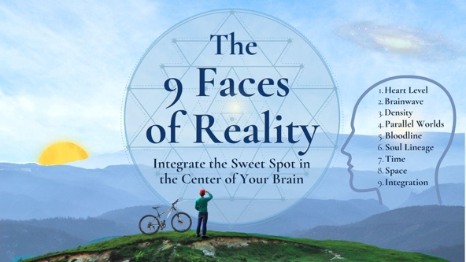
Today we will talk about nine faces of reality in this multidimensional universe. It sometimes feels like we live a “Hall of Mirrors”, each face being an infinite world. But if we examine each face one at a time briefly, we can embrace them all to make sense, and somehow integrate them into our lives.
The 9 Faces of Reality appear to be separate facets, but they are all one universe that is OURS. To claim possession of our world, we need to ask ourselves: What’s My Heart Level? Brainwave Frequency? Density? Parallel Worlds? What is your Bloodline? Soul Lineage? Time? Physical Space? Can we assimilate this awareness in the Sweet Spot in the center of the brain and the belly? INTEGRATION is a key to upgrading our consciousness into a new reality. When I finish, Lama D will reveal the structure of Samsara from a Buddhist perspective, and how to achieve enlightenment.
Our world is shifting and we’re beyond the tipping point. As tour Earth ascends, the veil between worlds gets thinner. Some of us are clinging to old concepts, only because we haven’t yet figured out how to use the new frequencies. Every day, our reality is so new we must invent ways to put it into words. In this greatest shift of the ages, we are discovering we can assimilate and integrate many other states of consciousness in the body innate wisdom. As the old blueprint of false light matrix now auto-destructs and dissolves, we are free to choose our direction in a global bifurcation of humanity, into a new paradigm of our highest destiny.
The word “UNIVERSE” implies it is “UNIFIED” by vibration. So, our every thought and action impacts all others. And every one of us is a fractal in the universal reckoning.

1. What's Your Magnetic Heart Frequency?
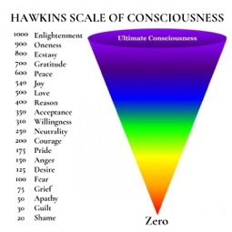The Hawkins Consciousness Scale Measures Heart Frequency and Emotion. Where are you today on a scale of 1 - 1000? This is a reliable, hypothetical scale based on kinesiology muscle testing.
According to Dr. David Hawkins, philosopher and psychiatrist, every thought, every emotion, every intention and action has a specific energetic frequency. your “magnetic energy field”. What level of consciousness do you express today?
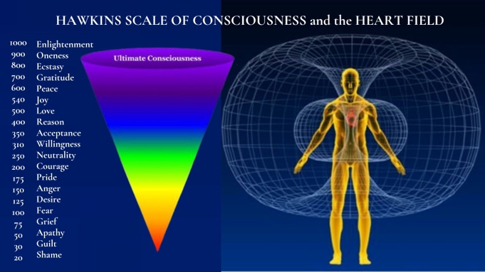
Dr. Hawkins noticed his awareness evolving from an ego-based or left brain-focus into a completely heartful state of pure bliss. He created a way to measure these energy fields using applied kinesiology or muscle testing.
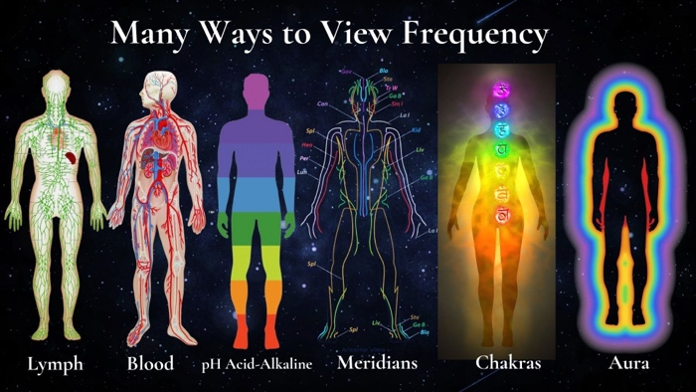Emotions are Chemicals in the Bloodstream.
Emotions are part of the Hawkins Scale. Originating mostly in the endocrine system, emotions relay chemical signals via the blood stream. How do Emotions give rise to awareness, thoughts, and actions? Some say emotions are our greatest resource as humans, if we can harness our passion into positive action.
There is no judgment in this frequency scale, nor is the scale fixed in any way. At the lower levels of consciousness, we find important core lessons.
Your Level of Consciousness Radiates Out to Others
VIDEO SHARE

2. What's Your Brain Frequency?

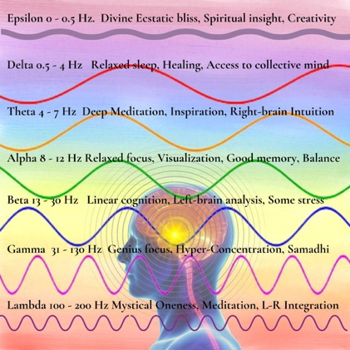
Brain waves are states of consciousness.
We can measure brainwaves by EEG using electrode connections on the scalp. Brain waves are one indication of your level of awareness, health, happiness, and are relevant to higher states of awareness.
What Are Common Brainwaves?
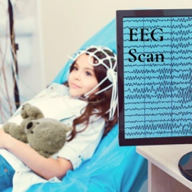

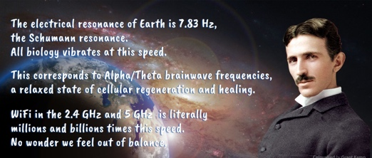

All higher frequencies and elevated states of consciousness are associated with synchronized electrical activity balancing right and left brain hemispheres.
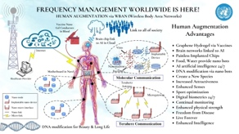
Defense Department Funding for an Advanced Research Project called ElectRx, conducts experiments to send impulses to brain neurons to turn then on, off, as well as implanting V2K "Voice to Skull" thoughts and emotions that can penetrate the brain and be used for various purposes.
For that reason, it's a good idea to be AWARE of our own brain waves. I believe we all move through states of consciousness, natural "brain-frequency gymnasts"! We enjoy many states of awareness.

3. What's Your Density? What is 3D?
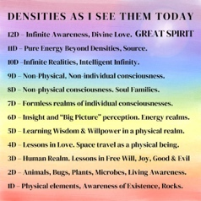A "density" is a layer of reality in this multi-dimensional universe.
Some experts say there are 7 densities, others say 12, and others say 15. One common 7-Density model comes from the Law of One Books. The 7 densities are said to be for physical embodied beings, and the 12-density model includes 5 more higher NON-physical realms, such as angelic realms and plasma or spirit hierarchies all the way up to the GREAT SPIRIT or SOURCE or God and creator of densities at the top.
These days hear talk about ascension from 3D, to 4D, and 5D But what does this really mean? Are areas in space/time really numbered? Does the universe have veils and demarcations, with levels clearly compartmentalized. Maybe Fourth and fifth densities aren’t exactly destinations but collective awarenesses and stages of self-discovery along a souls’ evolutionary journey back to Source.
What is 3D?
Third Density (3D) includes human beings like us, who possess a physical body with DNA, blood, Qi energetic meridians, chakras, micro-biome relationships, and requirements for biological life, like food, water, and oxygen. Those of us living in the 3D density can see only the lower physical densities. We learn that the physical world is a REFLECTION of the larger energetic world.
In 3D we reproduce sexually by combining the lineages via sperm and egg of a male and female. We communicate in language and audible words. We use an exchange system of money. We also possess free will and seeds of self-awareness. Hence, we can make a choice between two paths: to serve the self or serve the ALL.
We interact with animals and plants. We can see the lower densities, but not the higher ones, unless they choose. Like mini gods, we can create our own smaller reality in 3D using our mind, imagination, thoughts, and actions. This is our layer of creation the universe.
Fourth Density (4D) A density of Love. It includes beings that straddle the boundary between spacetime and the higher ethereal realms. In 4D physicality is more responsive to thought, but still hidden from 3D behind a dimensional curtain. There are said to be two Fourth Densities, one is positive, the other negative. This is based on Love of the ALL (Positive) vs. Love of SELF (Negative. Telepathy and supernatural abilities come more easily in 4D.
Fifth Density (5D) is a physical and etheric level of existence, inhabited by beings dedicated to accumulating and sharing perfection in themselves and their society. Fifth Density beings are said to observe humans in 3D, and can observe our thought processes. These beings are allowed to assist when asked, but are not allowed interfere with our collective evolution.
8th through 12th are said to be Non-Physical Densities.
If you've felt the pull towards your intuition or have glimpses of telepathy or drawn towards a spiritual life —these are all signs of change. Maybe we’ve already transcended this level of existence, and our duty is to witness these shifts without judgment.
Carl Sagan explain density in this hilarious video.
Cosmos – Carl Sagan – 2D vs. 3D – a Video

4. There are Many Parallel Realities.
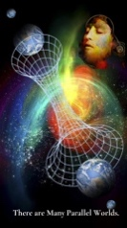I am no expert in parallel realities, however I believe infinite Simultaneous Worlds can exist. Since we are living through the dissolution of a kind of shared fantasy, this makes us keenly aware of parallel realities.

Quantum physics suggests there’s no such thing as objective reality. It must be consciously observed in order to exist.
The important takeaway is that we live in a vast multi-dimensional world that presents huge opportunities for conscious evolution.
Bashar Video Parallel Realities

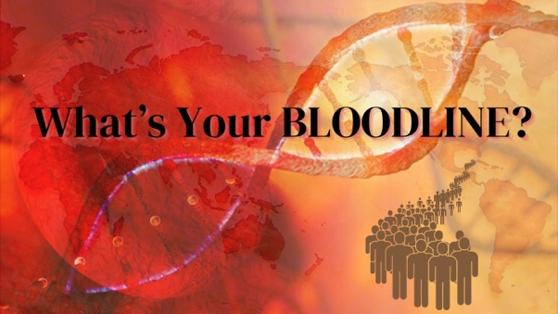

5. What is Your Bloodline?
Your bloodline is your physical lineage, your DNA, blood type, and inheritance from your mother and father and all your ancestors. Biological blood lineage is not the same as soul lineage otherother incarnations. DNA and blood a the huge rabbit hole of creation and evolution, as we now discover our true bloodsong may reside in the “junk DNA”.
What Determines Blood Type?
Your blood type is based on your DNA blueprint at conception, with DNA representing your physical link to the infinite.
New blood cells are constantly created in the bone marrow, located mostly in the flat bones. Bone marrow produces many types of 1) new red blood cells, 2) white defensive cells, and 3) generic stem cells for healing and regeneration. The bone marrow is also an area where toxins can accumulate, which can shorten your lifespan, so it’s important to keep your bone marrow system vital and free of toxins. We use the ABO blood type system to read the presence or absence of antigen molecules and categorize blood into four types (A, B, O, AB). In addition, each blood type is either positive "+" or negative. "-".
Genetics and Blood Type is a Rabbit Hole today, and I am no expert.
A great deal of information has been hidden. No wonder so much secret research focuses on the blood. Nowadays we have novel AI nanotech graphene particles in our blood from vaccines, also from food and water. Essentially these are electrical bioweapons that we all possess, as we move into a fascinating future never seen before. For more details on blood history and bioweapons, I invite you to consult the experts like Stewart Swerdlow, David Icke, Elena Danaan, Alex Collier, Eddie Page, and Dr. Robert Young.
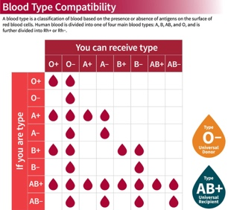
Blood types are not all compatible. To avoid reactions, it is safest to transfuse only matching blood types. In emergency situations, blood from a universal donor of type O− blood may be used.
How does Humanity Have So many blood groups?
According to Alex Collier and Elena Danaan, The human genome is a collection of 22 or 23 distinct races of extraterrestrial origin. There have been many genetic changes over time in human history.
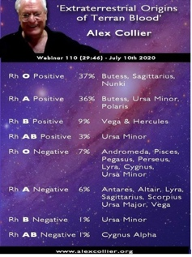
Your blood type may be an indication of your bloodline celestial origin. Many scientists have spent their entire lives tracing genetic changes that affect our DNA. As the Bible clearly states, there has been a mixing with Elohim extraterrestrial visitors. Many people say there is evidence of reptilian genetics from Anunnaki or Draco races in O negative blood.
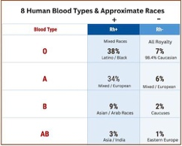
There is much discussion about Rh-Negative Blood that may from a lineage of the Draco origin in the Carpathian Mountains of Eastern Europe. O-Negs have a Cauda (tail) or an Extra Vertebra (Tail Bone). O-Negative people are said to be Hybrids. But then maybe we all are hybrids.
ALL Royal Families Have Rh-negative Blood.
Some say royal "Blue Bloods" are a hybrid human combining reptilian bloodline with Neanderthal DNA. Maybe the Royal "Blue Bloods" can be tracked back to the Tribe of Dan and Cain in the Old Testament This "Serpent Bloodline" or said to have migrated from Babylon into Europe and Caucuses and Asia via the Scythians, Turkic Mongolian tribes, who were also light-skinned with red hair and green eyes.
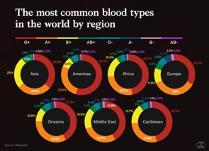Every country in the world has a database of blood types for all inhabitants. Even Wikipedia shows blood types by country here. Notice the higher concentrations of O- in Northern Europe and strangely, Somalia (Biblical tribes?).

Bloodline is something like a caste system for humanity, although we don’t call it a caste system. As Carl Jung suggested: “History is not contained in thick books but lives in our very blood.”
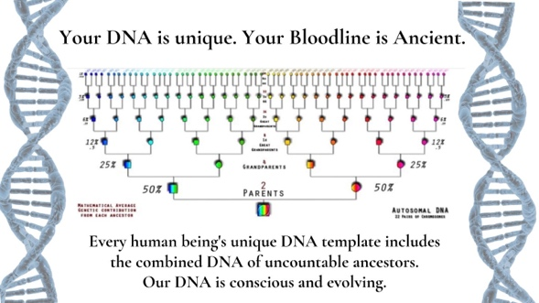
In just 50 generations, you’d have over 500 trillion ancestors, if they were all unique beings and no crossed lineages, That’s a lot of ancestors, and a lot of lovemaking.
What is the Star-Seed Bloodline of Jesus Christ?
According to Eddie Page, Pleiadian source, there was a creation of the El-lohim, or “those who came down”, who created a Star Seed blood line in their own image. This O negative is a bloodline of King David, and Jesus stated he was from the royal lineage of David, a Nazerite tribe. The shroud of Turin samples tested years ago showed that the blood was O negative.
The Holy Grail that the Knights Templar so fiercely protected in the Crusades, was the blood line of Jesus Christ, carried through Mary Magdalene. This is sometimes called the Sangreal or “True Blood” Maybe our only duty is to carry our particular bloodsong and be witness the vast changes in the world without judgement.

Stewart Swerdlow, , says that although the battle on 3D Earth seems to be between two opposing alien races or bloodlines, our modern struggle can be more accurately described as a "trans-humanist" battle between left brain vs. right-brain cognitive function.

By balancing the two brain hemispheres, we can integrate detailed rational thinking with intuition to reclaim our fully expanded Whole Brain intelligence.

6. What's a Soul Lineage and Soul Purpose?
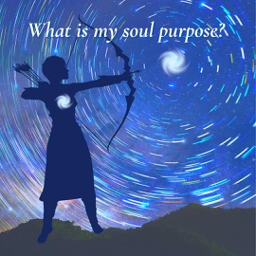
Soul Lineage is your timeless blueprint, essence, and origin of your soul. We all come from Source energy / God energy. The soul exists beyond time, space, or density. The SOUL activates our human body with life, as the "Atman", that vital essence that is eternal, unchanging, and the source of the universe itself. Although we may have many physical lifetimes in which we are born, live, and die, the soul is indestructible, it sees all our existences as it can never die.
Maybe the transition we feel in 3D is an instantaneous upshift in the stillpoint of the NOW. Maybe it’s a reflection of the Buddhist concept of impermanence, meaning all that is physical will soon perish.
What we do matters. Every soul has a lesson, a purpose. Our life is an opportunity to balance and heal all dissonances.
We are all travelers, visitors in a multidimensional universe.
Maybe you have been here on Earth for many lifetimes. Or maybe your soul recently came to Earth from another space-time. Our job is to learn our soul lessons, dissolve dissonance and move to the next level of our existence.
We can do this by simply going inside to accept ourselves deeply in contemplation, listening, in a deep state of surrender, and asking to penetrate layers of misunderstanding and confusion. When we do this work in ourselves, our families also benefit, and all of humanity benefits.

7. What Physical Space to you Live in?
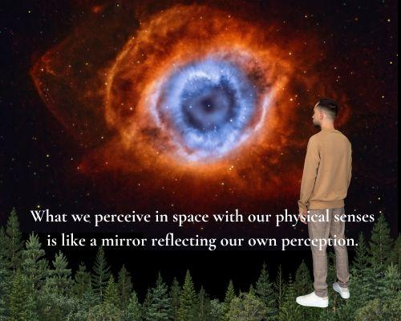

Physical space is closely tied to our Body Senses and Perceptions. “Our world radiates out from our physical body, based on perceptions from which we see, hear, touch, taste, and smell our world”

What are the Six Senses with which we Perceive?
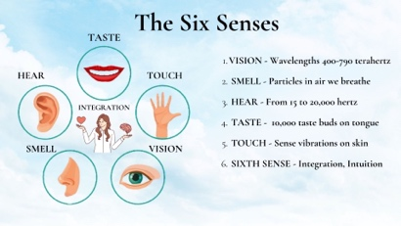

The senses work together to confirm and enhance each other, to gain awareness and act on information gathered. What we experience through our senses is mostly BASED on our previous experience, our expectation, our integration and interpretation of the senses.

Nikola Tesla believed that sound and resonance have the power to manifest physical form and shape the world around us, so THESE are responsible for our reality.
Maybe our material reality isn't physical at all.
We perceive SPACE as height, width, and depth. Yet quantum physicists find that MATTER is mostly an ILLUSION. And everything in the Universe is spinning energy.
Has Mainstream Science Missed the Boat? Lost the Thread of Expanding Consciousness?
According to Dr. Edward R. Close mathematician, physicist, and cosmologist, Mainstream science has become stagnant in a false belief system of dualistic materialism, and devolved into “scientism”, a well-organized atheistic religion, relegating consciousness and spiritual evolution to the realm of mythology and fantasy. And modern education is the antithesis of expanding consciousness.
He says our current battle represents the struggle between Left brain AI transhumanist materialism and Ego vs. Right Brain expanding intuition. Will we choose balanced multi-dimensional Whole Brain Awareness?

8. What is TIME?

TIME is Movement of Celestial Bodies in Space Around us.
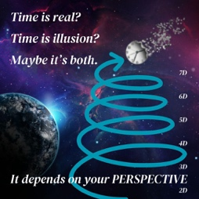
We measure time in planetary orbits. Some of our TIME Concepts are REAL, But Some are FICTIONAL
REAL Concepts: Days, Years, and Moon cycles are Real. These are orbits of the Earth, Moon, Sun.
FICTIONAL Concepts: Minutes, Seconds, Weeks, our 12 Months, centuries, and counting years from the birth of Christ are fictional. They’re just Made-up.
TIME itself is both real and an Illusion. In higher densities above 3D, it is said that all of TIME is one.
Timelines toward a positive shared future can be observed and controlled consciously.
by Multidimensional beings and our collective consciousness. Much information about Time Travel has been gleaned from the Secret Military including proof that our space force can travel through time, and from Project Looking Glass that indicates all timelines converge and move toward planetary ascension.
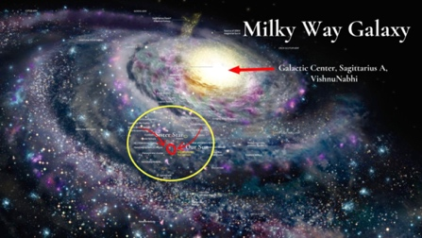
What's the Great Year Precession Cycle?
Earth's next larger orbit is the ‘Great Year’ of 26,000 years, which is our Sun's binary orbit with a sister star, sometimes called the "Precession of the Equinoxes". This mini-orbit through the Milky Way brings us closer to the Galactic Central Sun on the expanding half 13,000 years, and further away from it on the contracting 13,000 years. This cycle has a huge impact on the level of consciousness on Earth, which rises and falls based on how close we are to the galactic Center of Consciousness. Right now we are in the expanding side of the orbit, and energetic forces in our galaxy and planet are heating up. There is growing awareness, excitement, and polarization on Earth. Maybe THIS is fueling the shift of the ages.

How do we Integrate the Faces of Reality in the Brain Center
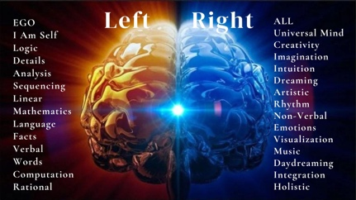
In conclusion, now that we’ve looked at the many faces of reality, Heart Level, Brainwave Frequency, Density, Parallel Worlds, Bloodline, Soul Lineage, Time, and Physical Space, I’d like us to bring our attention back to center. Take a few breaths and gather yourself back into your heart and body in the present moment. Because when we INTEGRATE the hall of mirrors, we can embrace a higher level of awareness in the body.
I’d like to do a brain balancing to INTEGRATE in the Sweet Spot of in the Center of the Brain. This is a 2-minute technique to synchronize the left-right brain hemispheres and integrate your Pineal Gland into your body Qi.
The two hemispheres of the brain have very different abilities. The right hemisphere looks at the whole picture, the similarities, and what we share in common, creating benefit for ALL beings. The left hemisphere has the awareness of separation, of the EGO, of Me as separate. It can handle, details, numbers, words, and measure time. It’s mind-boggling. How can we integrate and embody these diverse gifts? There’s no BEST brain hemisphere, each side is limited. We need both the left and right brain in order to live in perfect harmony.
We can choose how we want to live. We have three choices: 1) We can live in binary logic and details in the EGO-based left brain, 2) We can live in Right-brain intuition and emotion, 3) We can merge them to live in the WHOLE INTEGRATED BRAIN.
This exercise helps to improve memory, calm emotions, sharpen your senses, and heighten awareness balance body meridians and organs.
Do this Brain balancing exercise every night before bed.
In modern society the balanced nature of our brain is suppressed through education and cultural norms, which teach us a rigid scientific materialism, words, concepts that are limited.
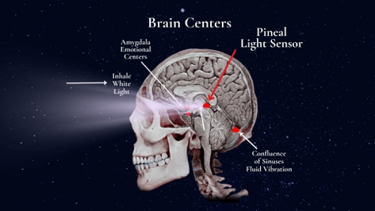The Pineal Gland is the Antenna Third-Eye Receiver of the Human Body
The Pineal Gland sits in the third ventricle of the brain, a large fluid bubble.
It contains tiny crystals that respond to piezoelectric frequencies. The Pineal gland secretes hormones such as melatonin to conteol biorhythms. and Dimethyltryptamine (DMT), as we sleep. DMT is said to be a psychedelic substance and a key to accessing divine realms, used in Ayahuasca ceremonial healings. Maybe those Ayahuasca shamans are on to something important.
Pineal Gland Calcification Can Damage Your Qi, your Meridians, and Body Energy Connections.
Primary causes of pineal damage are WIFI, EMF-smog, cell phones, Glyphosate herbicide, fluoride, aluminum, chlorine, mercury, and pesticides. It helps to keep your attitude positive, eat clean food, drink pure water, walk in Nature, and practice Qigong.
Every polarity in nature represents a basic dualistic energy such as Yin-Yang, Service to Self vs. or Service to the ALL, Male vs. Female, and Electric Positive-Negative, When these dual energies are in balance, there is maximum intelligence, freedom, and flow.
When we balance the brain hemispheres, the left and right meridians align. The Pineal Apex in the Brain center naturally moves into binary orbit with the Xia Dantien Seat of Power at the navel, sometimes called the Sacral or Sexual Chakra, seen in this ancient Buddhist diagram, of the body Microcosmic Orbit. Thus we return back to contemplating the navel, the seat of our conscious power, by consciously aligning it to the brain hemispheres and the pineal.

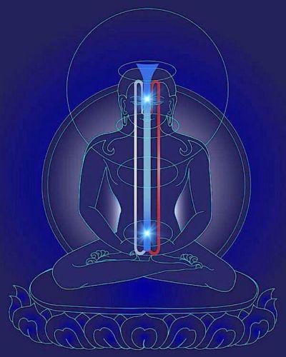

Brain Balancing is our final battlefield to conquer trans-humanist AI false matrix. What path do we choose? Service to the EGO and SELF on the Left hemisphere? OR Service to the ALL on the Right? Or will you choose to live in the center, to embrace your expanded destiny as a WHOLE MULTIDIMENSIONAL BEING?
Let’s do it now. Place the tip of your tongue behind your upper teeth and relax it there, to connect the meridians. Breathe white into the pineal gland, swallow and bring your breath down to the heart and belly. Place one hand on the back of your head so it touches both sides, like this….

Thank you for listening.
Now I’d like to hear what Lama D has to say about the 6 Realms of Samsara. His way of forming thoughts and words is utterly different from mine, thankfully, coming out of a very pure Buddhist monastic training from Bhutan, where they learn only meditation, higher philosophy, and chants, in the Boddhisattva path to enlightenment.

